**IMPORTANT INFORMATION ABOUT**

**Next Steps of Exploring Shared Ministry**

**This Saturday, October 2nd**

**9:30am to noon**

**What will Shared Ministry look like? What skills are involved in leading the ministries?**

At the workshop we will be reviewing the proposed models and consider skill sets desired in new Ministry staff. It is an important next step toward calling a minister as we seek to meet our proposed timeline objectives.

If you haven't had the chance to find out yet what we have been working on, Saturday will be an opportunity to catch up on the proposed Models of Ministry and seek clarification. If you have been involved all along, Saturday will be an opportunity to continue to work on shared ministry as we name skill sets for the ministry staff we will call.

Bring your questions/concerns. You may join by Zoom:

<https://us02web.zoom.us/j/89971535726?pwd=eXl1dDAzbGUxVkNxUDk2d3NBejR1QT09>

Meeting ID: 899 7153 5726    Passcode: 683856

Or attend in person at First United.

(Vaccine passport required or proof of Negative test result for in person)

Be a part of the discussion. We want to hear from you!

**Here’s what you should know about Sunday Mornings going forward!**

**You are welcome to attend in-person at First Church – still 10:30am!**

**Please enter through the Accessibility door**

**in the parking lot.**

**Our Music Ministry (by Jody 😊),**

**the Opening & Announcements and the Prayers (as well as other aspects)**

**are the responsibility of each Church.**

**The Family Worship Time & the Message are shared between Central & First.**

**Church School is not shared, but we**

**share the curriculum. The Congregations and Church Schools will follow**

**the same themes.**

**We are experimenting with the format**

**and the technology. The service will be tweaked as we learn and grow.  This is in preparation for sharing Ministry**

**staff with Central UC.**

**We are so excited to share**

**all of this with you!! See you Sunday!**

**Here is the link to join online for this Sunday, October 3:**

[**https://www.youtube.com/watch?v=LTYd9dfaP_8**](https://www.youtube.com/watch?v=LTYd9dfaP_8)

Note: Sunday is

Worldwide Communion

If you are joining us online please remember to bring some juice/coffee/tea and a cookie/cracker/ piece of bread with you for our Communion time.

**Join Members of Central United for a bike ride!**

This week, we’ll meet at Central on Monday at 5:50pm leaving at 6:00pm (Weather permitting)

It’s getting darker earlier now so the times may change each week.

All ages are welcome.

**

**Happy birthday to:**

**Elly Jackson**

**Barb Watterworth**

**Treana Fellows**

**Lillian Anderson**

**Happy Anniversary to:**

**Rachel & Jeremy Gorman**

**Bert & Betty Lou Donaldson (60 years!)**

**Gerdy & Noel MacKay (40 years!)**

**Youth Group meets**

**at First Church on**

**Wednesday evenings**

**from 7-8:15pm.  
  
All Youth are welcome!**

**Youth Group Leader:  Chris Ross**

**‘Coffee & Curious Spirituality’   
Monday, October 4th @ 10:30am**

We skim the surface this week on Fake News/Disinformation and Misinformation in our Coffee and Curious Conversation.

The video resources add up to just under 1.5 hours, but will generate some good conversation about the role of media in our own lives and our children's lives. Join in on a lively conversation and hopefully some good java!

Vashi from CBC offers a brief conversation on fake news Misinformation and disinformation and where it appears. (7 minutes long)

<https://www.cbc.ca/player/play/1601512003616>

Documentary- Fake: Searching for Truth in the Age of Misinformation (57 minutes) Offers a very comprehensive overview of the ideas and issues that arise for our day when it comes to how we consume media.

<https://www.youtube.com/watch?v=PMv4Mbdf9HA>

All who can get connected are welcome to join us Monday mornings at 10:30am online.  
[​https://meet.google.com/pjg-zbez-nax](https://meet.google.com/pjg-zbez-nax)

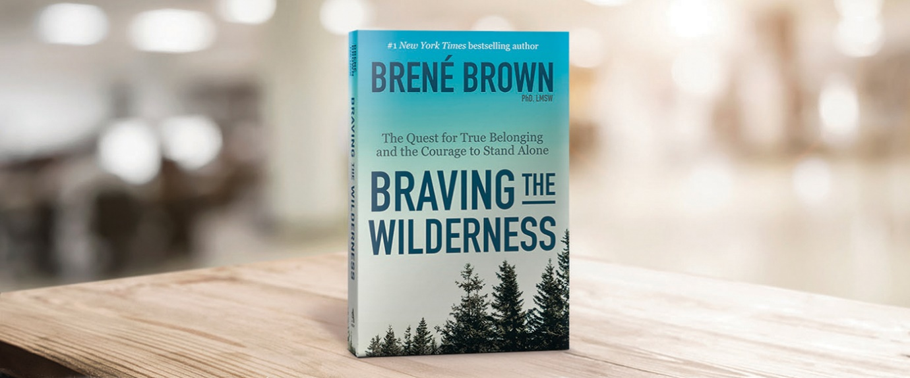**

If you feel like you are traversing a wilderness and want to share with others how to find courage and belonging in this scary time, please join Susanna Suchak in the Fall (well after Labour Day) in an online book study of Brené Brown’s book, *BRAVING THE WILDERNESS*.

You could form your own group and gather together to participate in the discussions with others who are also venturing into new territory as we reopen our churches. Sneak peek here:

<https://brenebrown.com/blog/2017/09/07/braving-the-wilderness-excerpt/>

There will be activities (mere suggestions) as well as discussions, so put on your best pilgrim gear and take a chance…

Curious, but still wondering exactly what this might look like, email susanna suchak – [susanna.suchak@gmail.com](mailto:susanna.suchak@gmail.com) to ask your questions.

A Game of Chess anyone?

Wednesday, Oct. 13th @ 6:30pm – 8:30pm

To reserve a spot contact Terry Lanning 519-637-0988 or e-mail Terry at [terry_lanning@sympatico.ca](mailto:terry_lanning@sympatico.ca)

 Please, bring your chess board (sets) and ‘Proof of Vaccination.’

All are welcome young, old, beginners and masters.

**Join members of Central UC for:**

**“Moses, In the Footsteps of the Reluctant Prophet”** is a 6-session bible study exploring Moses’s journey and what that means in our lives today.

**Afternoon sessions:** Pinafore Park (across from the main washrooms) Wednesdays at 1 pm. If able, bring a lawn chair, bible and paper or electronic device for journaling.

A study guide is available as well.

**Evening sessions:** Please contact Kathryn Fletcher at [fletcherfamily@rogers.com](mailto:fletcherfamily@rogers.com) or 519-633-1902

to consider a suitable night or if you have questions.