**IMPORTANT INFORMATION ABOUT**

**‘Coffee & Curious Spirituality’   
Monday, September 27th @ 10:30am**

This week our country wears orange shirts to honour Residential School survivors. In this week’s video we’ll listen to Justice Sinclair share about residential school survivors and how we start working toward reconciliation. Justice Sinclair chaired the TRC and brings deeper reflection on Orange Shirt Day.  What does reconciliation mean?

<https://www.youtube.com/watch?v=YVFGj-nCUdU>

All who can get connected are welcome to join us Monday mornings at 10:30am online.  
[​https://meet.google.com/pjg-zbez-nax](https://meet.google.com/pjg-zbez-nax)

**Here’s what you should know about Sunday Mornings going forward!**

**You are welcome to attend in-person at First Church – still 10:30am!**

**Please enter through the Accessibility door**

**in the parking lot.**

**Our Music Ministry (by Jody 😊),**

**the Opening & Announcements and the Prayers (as well as other aspects)**

**are the responsibility of each Church.**

**The Family Worship Time & the Message are shared between Central & First.**

**Church School is not shared, but we**

**share the curriculum. The Congregations and Church Schools will follow**

**the same themes.**

**We are experimenting with the format**

**and the technology. The service will be tweaked as we learn and grow.  This is in preparation for sharing Ministry**

**staff with Central UC.**

**We are so excited to share**

**all of this with you!! See you Sunday!**

**Here is the link to join online for this Sunday, September 26:**

[**https://www.youtube.com/watch?v=x-v1FSC3dy0**](https://www.youtube.com/watch?v=x-v1FSC3dy0)

**Happy birthday to:**

**Vicki Loucks**

**Edith Nimmo**

**Barbara Welch**

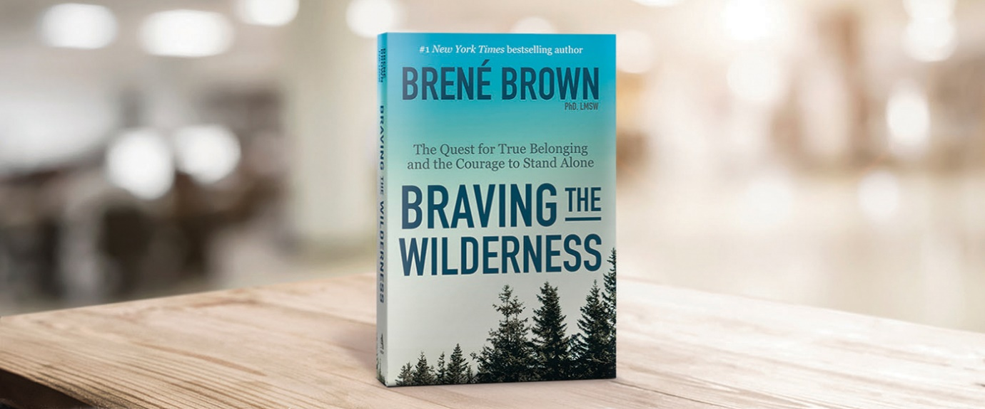**

Chess Club at Central United Church  
All welcome!  
  
Wednesday evenings from 6:30-8:30pm  
in the Fellowship Hall  
  
Call Cathy in Central's

Church Office for more

Information!

519-631-3503

**Join members of Central UC for:**

**“Moses, In the Footsteps of the Reluctant Prophet”** is a 6-session bible study exploring Moses’s journey and what that means in our lives today.

**Afternoon sessions:** Pinafore Park (across from the main washrooms) Wednesdays at 1 pm. If able, bring a lawn chair, bible and paper or electronic device for journaling.

A study guide is available as well.

**Evening sessions:** Please contact Kathryn Fletcher at [fletcherfamily@rogers.com](mailto:fletcherfamily@rogers.com) or 519-633-1902

to consider a suitable night or if you have questions.

If you feel like you are traversing a wilderness and want to share with others how to find courage and belonging in this scary time, please join Susanna Suchak in the Fall (well after Labour Day) in an online book study of Brené Brown’s book, *BRAVING THE WILDERNESS*.

You could form your own group and gather together to participate in the discussions with others who are also venturing into new territory as we reopen our churches. Sneak peek here:

<https://brenebrown.com/blog/2017/09/07/braving-the-wilderness-excerpt/>

There will be activities (mere suggestions) as well as discussions, so put on your best pilgrim gear and take a chance…

Curious, but still wondering exactly what this might look like, email susanna suchak – [susanna.suchak@gmail.com](mailto:susanna.suchak@gmail.com) to ask your questions.

**Join Members of Central United for a bike ride! Mondays at 6:30pm**  
  
**Meet at Central’s parking lot (off Moore Street) and then go for a leisurely bicycle ride around the paved paths of St. Thomas.**  
**All ages are welcome. For more information contact Cathy @ Central’s office (519) 631-3503.**

**Youth Group meets**

**at First Church on**

**Wednesday evenings**

**from 7-8:15pm.  
  
All Youth are welcome!**

**Youth Group Leader:  Chris Ross**