Happy Thanksgiving!

The Church Office is closed for Thanksgiving on Monday, October 11th.

**IMPORTANT INFORMATION ABOUT**

**Happy birthday to:**

**Kim Hughson**

**John Anderson**

**Bob Scott**

**Happy Anniversary to:**

**Arnold & Natalie Catt**

**Lyle & Dorothy Cameron**

**Sharlene & Bob Scott**

**Tracey & Murray Medhurst**

**You are welcome to attend in-person at First Church – still 10:30am!**

**Please enter through the Accessibility door**

**in the parking lot.**

**Our Music Ministry (by Jody 😊),**

**the Opening & Announcements and the Prayers (as well as other aspects)**

**are the responsibility of each Church.**

**The Family Worship Time & the Message are shared between Central & First.**

**Church School is not shared, but we**

**share the curriculum. The Congregations and Church Schools will follow**

**the same themes.**

**We are experimenting with the format**

**and the technology. The service will be tweaked as we learn and grow.  This is in preparation for sharing Ministry**

**staff with Central UC.**

**We are so excited to share**

**all of this with you!! See you Sunday!**

**Here is the link to join online for this Sunday, October 10:**

**https://www.youtube.com/watch?v=Fdq411ifVBA**

**Join Members of Central United for a bike ride!**

This week, we’ll meet at Central on Monday at 5:50pm leaving at 6:00pm (Weather permitting)

It’s getting darker earlier now so the times may change each week.

All ages are welcome.

**‘Coffee & Curious Spirituality’   
We’re taking a break on Monday, October 11th for Thanksgiving!**

**Join us the following Monday, October 18th @ 10:30am**

We take a break from Coffee & Curious Spirituality for Thanksgiving. If you like, pour yourself a cup of java and watch these videos. They are about 40 minutes in total. In our time together October 18 we will consider what the values we hold together as followers of Christ at First Central and New Vision. These are videos to help us think about and unearth our motivations and what is most authentic to us about being spiritual beings. Consider too the values that we have explored in previous conversations. What has staying power for you? Enjoy and join us!

The value of discernment and reflection

<https://www.youtube.com/watch?v=nZFnxH4IKNE>

Presence Coaching; the value of presence, and the move from habit.

<https://presencebasedcoaching.com/about/mission-values>

Discerning the Spirits, a look at Jesuit values through St Ignatius. 33minutes

<https://www.youtube.com/watch?v=jzYN2hMqLI4>

All who can get connected are welcome to join us Monday mornings at 10:30am online.  
[​https://meet.google.com/pjg-zbez-nax](https://meet.google.com/pjg-zbez-nax)

**Youth Group meets**

**at First Church on**

**Wednesday evenings**

**from 7-8:15pm.  
  
All Youth are welcome!**

**Youth Group Leaders:**

**Chris Ross & Jean Fletcher**

****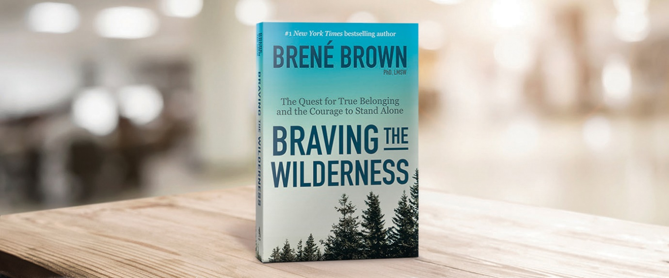

**Join members of Central UC for:**

**“Moses, In the Footsteps of the Reluctant Prophet”** is a 6-session bible study exploring Moses’s journey and what that means in our lives today.

**Afternoon sessions:** Pinafore Park (across from the main washrooms) Wednesdays at 1 pm. If able, bring a lawn chair, bible and paper or electronic device for journaling.

A study guide is available as well.

**Evening sessions:** Please contact Kathryn Fletcher at [fletcherfamily@rogers.com](mailto:fletcherfamily@rogers.com) or 519-633-1902

to consider a suitable night or if you have questions.

If you feel like you are traversing a wilderness and want to share with others how to find courage and belonging in this scary time, please join Susanna Suchak in the Fall (well after Labour Day) in an online book study of Brené Brown’s book, *BRAVING THE WILDERNESS*.

You could form your own group and gather together to participate in the discussions with others who are also venturing into new territory as we reopen our churches. Sneak peek here:

<https://brenebrown.com/blog/2017/09/07/braving-the-wilderness-excerpt/>

There will be activities (mere suggestions) as well as discussions, so put on your best pilgrim gear and take a chance…

Curious, but still wondering exactly what this might look like, email susanna suchak – [susanna.suchak@gmail.com](mailto:susanna.suchak@gmail.com) to ask your questions.

A Game of Chess anyone?

Wednesday, Oct. 13th @ 6:30pm – 8:30pm

To reserve a spot contact Terry Lanning 519-637-0988 or e-mail Terry at [terry_lanning@sympatico.ca](mailto:terry_lanning@sympatico.ca)

 Please, bring your chess board (sets) and ‘Proof of Vaccination.’

All are welcome young, old, beginners and masters.