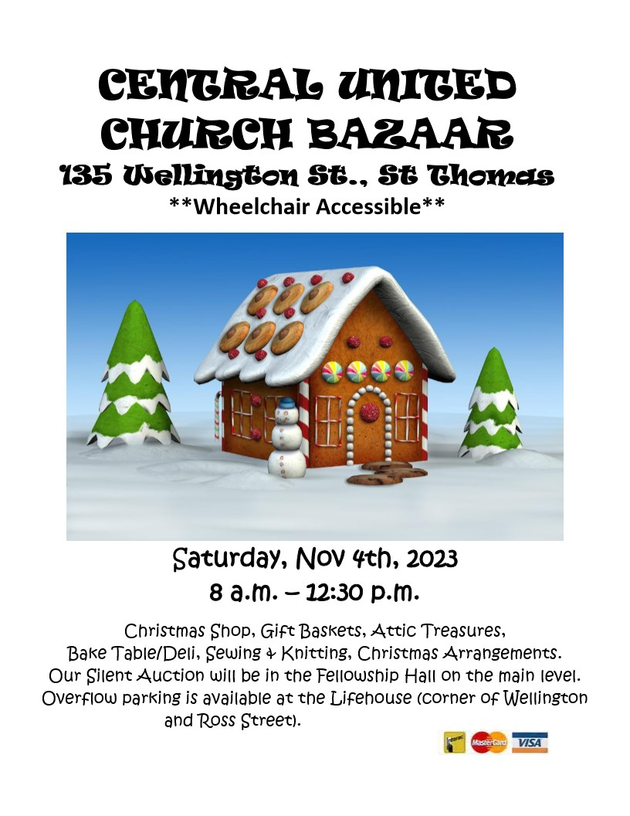

**MARK YOUR CALENDARS!! Grab some friends and bring some quarters!**

**This will be a fun filled evening bidding on some great items from 10+ vendors (Our vendors so far are: Color Street, Just Whip It Up, Mr. Amish Pepperettes & Cheese Curds, Norwex, Say It Your Way, Scentsy, Teena's Cards & Albums, The Celtic Pony, Thirty One, Tupperware,**

**Wishful Tree Healing).**

**We will also be having a 50/50 draw and a raffle table.**

**All proceeds go to First United Church’s Youth and Outreach programs.**

**