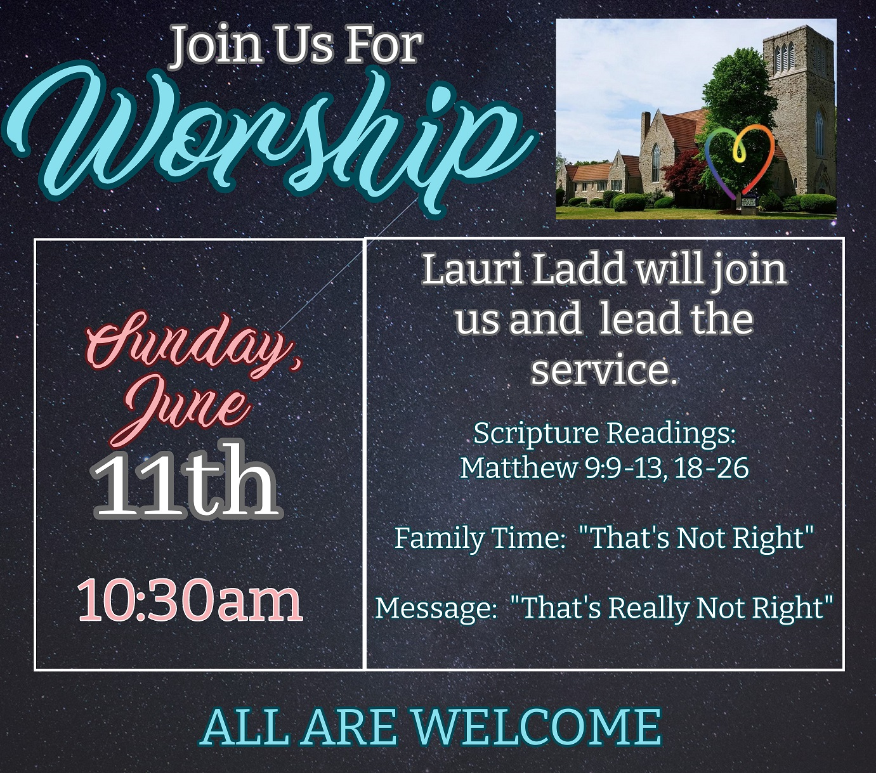

Our Friends at Central United Church are hosting a KIDZ KARNIVAL in August!! Mark your Calendar!!

**Check out our Website & follow us on all our Social Media platforms!**

**Website:** [**www.1stunitedchurch.ca**](http://www.1stunitedchurch.ca)

**On Facebook: firstunitedchurch**

**On Instagram: @firstunited1834**

**On Twitter: @FirstUnitedStT**

**On YouTube: First United Church, St. Thomas**