FIRST WITH THE NEWS
Seeking to be a welcoming community of Christian faith,
proclaiming and celebrating the love of God in Jesus Christ
through the Inspiration of the Holy Spirit. We strive to accept each
other as we are and welcome the ministry and participation
of all persons regardless of age, gender identity, health, race,
sexual orientation, differing abilities, religious or ethnic background
or economic circumstance. We hope that in all we do,
including worship and community life, God’s unconditional love is experienced.

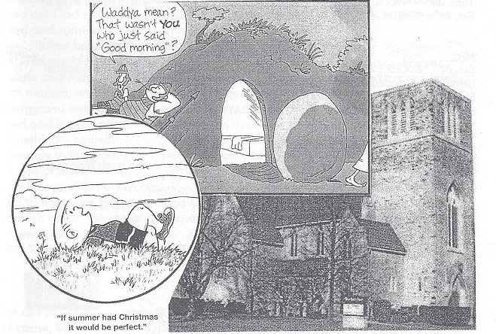

SPRING/ SUMMER 2017 EDITION

Delivered by: ______________________________________________________


UPCOMING DATES & *SERVICES

APRIL
Sun. 9th – *PALM SUNDAY WORSHIP @ 10:30am
*‘FIRST YOUTH – YOUTH FIRST’ meets in the CD office with Chris Ross
Thurs. 13th – *MAUNDY THURSDAY COMMUNION SERVICE @ 7pm

Fri. 14th - *GOOD FRIDAY WORSHIP @ 10:30am Hot cross buns & cider following worship
Sun. 16th – *EASTER SUNDAY WORSHIP @ 10:30am
Tues. 18th - *WOOL DRYER BALL CLASS (Intro) 6:30-7:45 in Room 3 (pg 8)
Sun 23rd - *‘FIRST YOUTH – YOUTH FIRST’ meets in the CD office with Chris
Tues. 25th - *WOOL DRYER BALL CLASS (Decorating) 6:30-7:45pm in Room 3 (pg 8)
Sat. 29th - *SPRING RUMMAGE SALE from 8:30-11:30am in the Gym (pg 7)



MAY
Sat. 6th – *EUCHRE NIGHT! 6:30-9pm in the Assembly Hall. All skill levels welcome! Babysitting provided in the Gym. (pg. 9)
Sun. 7th – *SPRING VISITATION (pg 9)
Sun. 14th – *MOTHER’S DAY / FAMILY SUNDAY – Worship @ 10:30am

JUNE
Sat. 3rd - *EUCHRE NIGHT! 6:30-9pm in the Assembly Hall. All skill levels welcome! Babysitting provided in the Gym. (pg. 9)
Sun. 4th – *PENTECOST / COMMUNION – Worship @ 10:30am
Sun. 11th – *ROGER’S RETIREMENT CELEBRATION (pg 11) – Worship @ 10:30am

Sun. 18th - *FATHER’S DAY / FAMILY SUNDAY – Worship @ 10:30am

*ACTIVITY ROOM BEGINS (pg 10)
*Guest Preacher from June 18th to July 30th : Rev. Ken Taylor


AUGUST
Mon – Fri. 21st -25th *VACATION BIBLE CAMP (pg 12)


SEPTEMBER
Sun. 10th – *RALLY DAY– Worship @ 10:30am
Sun. 17th – *CHURCH SCHOOL REGISTRATION

*Sunday worship times are 10:30am throughout the year

FROM ROGER’S DESK
Friends,
I write this final letter from the Pastor’s desk, amazed at how 17 years have flown by. We have shared joy, challenge, sorrow, growth, the ordinary and the extraordinary. This First faith community has been an important place for me to serve God with you, my third Pastoral Charge in my 40 years as a pastor in the United Church. Janess and I celebrate our 47th anniversary in May; my kids are settled in Toronto, my 3 granddaughters are in school and I am in my 70th year. We have laughed, cried, prayed, sang, baptized, married, confirmed, shared communion and meals, and reached out. In sickness and in health, we have lived out God’s call on our lives, working to make First welcoming, safe, spirit-filled and spirit-led; seeking to make a difference.
It has been a gift and a blessing to have been your minister. You have allowed me to be myself and affirmed my gifts for ministry. You have received Janess and Maya and Matt’s families with open arms. Your ability to make music that matters, and sing from your heart touches all who gather here. You have energy and enthusiasm, a zest for life and a faith far beyond that of a mustard seed and it makes saying goodbye even harder. I keep dealing with the something – something deep down in all of us – that resists the move from presence to the great gap called absence. Leave-taking is never easy. The words we use at leave-taking, though now secularized and emptied of religious significance, still harken back to a day when departure meant a time so painful and threatening, that we needed God to help us do it. The English goodbye, the Spanish adios, the French adieu all imply that when we part, in the moment between the here and not here, presence and absence, we best give someone to God when we can no longer hold them ourselves. Goodbye. God be with you.

“Parting is such…sorrow.”

But as Paul said…we weep but not as those without hope, so I’m hoping you will all come, because you are all invited, to my Goodbye “Party” on Sunday June 11th. It will be my final Sunday worship and de-covenanting at that day at 10:30am. After this service, we will have a new relationship… As a retiree
I will now be a guest at weddings, not the minister, a mourner at funerals not the presider. This is important for me to name, and for you not to look for loop-holes or ask me to do these things, knowing of course I will want to.
This understanding is practiced across the United Church of Canada because it will allow you to make room for your next minister, and to make them as welcome as you have me. It is impossible to share with someone else, if you haven’t made some space to let the person go who has held a place in your heart. Please honour that I will keep this commitment.

* There are three other things you can do to make this transition go well.*
#1. KEEP COMING TO CHURCH - you need each other, higher attendance reminds people how good a place it is to be, and excitement will build. Pray!
#2. KEEP GIVING – your new minister needs to arrive without financial worries, now is the most important time to give generously, so that God’s possibilities can be known for the future in ministry. Don’t be afraid. Pray!
#3 DON’T BE AFRAID TO PRAY!

The Search Committee is hard at work; soon updates and information will be communicated regularly.
This scripture reminds me about letting go, and making room for the new things God is doing, that the future is bright, Jeremiah 29:11
For I know the plans I have for you," declares the LORD, "plans to prosper you
and not to harm you, plans to give you hope and a future.
With love and deep gratitude for this ministry we have shared, may God continue to bless you Big Time!

Your fellow servant,
Roger

NOTES FROM JODY

What is it in human life that cannot do without a song? What is it in our Church tradition that cannot do without a hymn or a chorus? The answer lies close to the heart of our identity. We sing out of who we have become as people and spiritual beings, yet that singing can take on new forms as our identity and sense of belonging expand over time. We sing what we belong to and feel at home in. But we also sing in order to become part of a larger social reality. What some call spirituality- a way of being fully alive-is shaped by both of these pulls. The Senior Choir, Children's Choir, soloists, instrumentalists, Jerome and congregation all represent this Church tradition that is a reality here at First. We worship together in song every Sunday bringing us together to sing our faith! Thank you for being a part of this with me and sharing your time and gifts.
Musically yours,
Jody

Our Search Committee seeking to find our next minister is made up of the following people: Ray Bosveld, Rachel Rayner, Rosemarie Johnson-Clarke, Ruth Zions, Bill Beamish, Gerdy MacKay and Richard Auckland. If you have any questions, comments or have heard an amazing minister, please let one of our committee members know!

Looking Ahead to the Summer
Our Presbytery Supervisor will be Ellen Palmer 519-769-2245
On Call for Pastoral Emergencies:
June 12 – July 9 - Rev. Jim Evans 519-860-1161 or 519-631-7096
July 10- August 1 – Rev Ken Taylor 519-686-1377
August 2 – September 3 – Rev. Jim Evans 519-860-1161 or 519-631-7096
Coverage for Sunday Worship following Roger’s Retirement:
Sundays from June 18-July 30: Rev. Ken Taylor

The Renewal Leadership Team at First United Church encourages your feedback as we consider three questions:
Who is God calling us to be as a congregation?
Who is God calling us to be in our communities?

Who is God calling us to be in our home life?
The committee consists of:
Ray Bosveld (rbosveld14@gmail.com)
Richard Routhier (richard.routhier@rogers.com)
Cheryl Muma (cmuma@sympatico.ca)
Justin Chute (justinchute@msn.com)
Sharlene Scott (sharlene.scott@sympatico.ca)
Clare Beamish (clare.beamish@sympatico.ca)
Gus Langley (519-633-8419)
Please feel free to contact any one of us with your thoughts and ideas.

FROM JASON DYKSTRA /RENEWAL VISIONING CO-ORDINATOR
In Exodus 3, we see Moses attending to a regular task. He was shepherding his father-in-law’s flock, walking through the wilderness when he came across a bush in flames. There was something different about this bush though, it was blazing away but it didn’t burn up. You can imagine what Moses was thinking – “What’s going on here? I can’t believe this! Amazing! Why doesn’t the bush burn up?” (Ex. 3:3 MSG). When God saw that Moses had stopped to look he called out to Moses from the bush.
Can you imagine Moses’ surprise when God started talking to him? Over the past few months, First has been actively asking God, Where should our focus be in our congregation? Where should our focus be in our community? Where should our focus be in my relationship with God? First has been actively seeking the voice of God to speak wisdom into the church’s future.
The voice of God speaks to us in many different ways. For some of us it is similar to Moses, where we can audibly hear the words of God. For many of us though, we don’t have the same experience. We might see God in the way the leaves move on the trees, or when we’re watering our flowers, cooking supper, in line at the grocery store, or even speaking to our friends. One thing that Moses teaches us in the story about the burning bush is that he only needed to be paying attention. After all, Moses was simply attending to a regular task that he did quite regularly! And it was when he stopped to look at the bush that God revealed his thoughts.
On April 2nd, we met to talk about some of the thoughts we have had over the past few months regarding those earlier questions. There may be some feelings of anxiousness over this – I haven’t heard God’s voice yet! Are these really my thoughts or are they from God? I don’t like speaking in groups. What will people think about what I might share? All these anxieties are normal. It’s what you do with them that really matter.
This last part of the renewal process is really about engaging in a conversation. Where is our focus going to be on our congregation, on our community, in my personal relationship with God? This is only something that only you, as congregants of First United Church, can answer.
When Moses heard God’s voice he offered every single excuse he could think of as to why God should choose someone else to talk to Pharaoh. Through the grace of God though, Moses eventually accepted God’s call and spoke. I would encourage you as well to face any fears or anxieties that you might have regarding our upcoming conversation and come and speak with us around your thoughts on where First United Church is heading. I would also encourage you to consciously stop and notice the burning bushes that are present in your life. I look forward to you continuing the conversation and am excited to hear your thoughts, and the thoughts that God has laid on your heart to share with your fellow brothers and sisters of Christ.


With gratitude, Jason Dykstra, L3 Group/Renewal Visioning Project

WE NEED YOUR HELP….
Sorting & Pricing Rummage has begun!
Anyone with an hour or two to spare once a week is welcome!
No training necessary – just come out for some fun & fellowship.
Watch the bulletin for dates & times or call Lois Whiteman @ 519-631-3777.

SPRING RUMMAGE SALE
Saturday, April 29th from 8:30-11:30am!
Spring cleaning time! Help make our spring rummage sale a success. Bring in your clean and gently used spring and summer clothes and shoes. Remember your extra special women's clothing for our "Ladies Boutique." Always popular are purses, jewellery, knic knacs, home decor, china, dishes, glassware, pictures, bedding and towels. (please no TVs, microwaves or computers) Don't forget your toys, puzzles and games. Books for all ages sell very well so clean off your shelves at home. We need more help to sort and price to prepare for the sale. Please call Lois W. 519-631-3337. Donated items may be left inside west accessibility door Mon.-Thurs. 9am-2:30pm. Thankyou!

HOLY WEEK WORSHIP

PALM SUNDAY, April 9

MAUNDY THURSDAY COMMUNION SERVICE, April 13 @ 7pm

GOOD FRIDAY, April 14 @ 10:30am
Hot cross buns and cider following the service.

EASTER SUNDAY, April 16 @ 10:30am
Please bring a butterfly or two to add to the Butterfly Cross.

Seeking donations: Please leave donations in the box in the Library. Thank you!
- wool yarn of any length (full or part balls, or abandoned needlepoint sets) and any colour. It is important that it is wool - not polyester, other synthetics or cotton

- pantyhose or knee highs (clean but do not need to be run-free).

WOOL DRYER BALL CLASSES
Dryer Balls are an eco-friendly alternative to dryer sheets and liquid fabric softener. They also decrease dryer time saving money on utility bills. While basic wool dryer balls are fully functional, they can also be further enhanced to be beautiful art pieces for functional use every day. If you would like to come learn about wool dryer balls and make a set of your own wool dryer balls to take home, please contact the church office to pre-register.
Please bring wool and pantyhose as outlined in donation request above - if you are able. In an effort to reduce; please do not buy new items - check your stash, thrift stores, friends. Some supplies will be available at the class. Contact Lois BT with any questions. loisbt@icloud.com
Class 1: Tues., Apr.18 6:30- 7:45 p.m. Intro & background. Make basic dryer balls.
Class 2: Tues., April 25 6:30-7:45 p.m. Dryer ball embellishment.
Classes will be held at First Church in Room 3. Class size is limited - register early

EUCHRE NIGHT AT FIRST
Please join us for a fun Euchre Night at the church!

Saturday, May 6 from 6:30pm to 9:00pm
in the Assembly Hall.

Skill level doesn’t matter – it’s all about having fun!

Babysitting will be available in the Gym.

*There will be another Euchre Night on Saturday, June 3



MEMBERSHIP COMMITTEE SPRING VISITATION
Sunday, May 7
There are wonderful members of this church who are unable to come out to worship. Our hope is to have each one of them receive a spring plant and a visit from First Church. We want them to know in their absence they are not forgotten.
Would you consider delivering a plant to one of these members?
Simply come up to the tables under the pulpit after worship, and you will be given a plant, a name and an address.
The visits are to bring happiness, joy and greetings from First Church. They do not have to be long … just cheery!
Our hope is that enough people come forward so that each visitor only has one plant to deliver. The Membership Committee

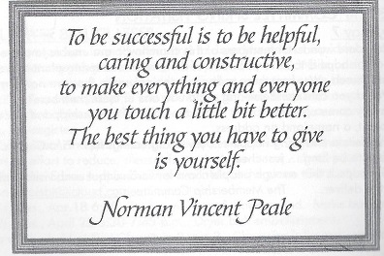
Information for Families about the Summer CHILDRENS’ MINISTRY

For Babies – 3 year olds… All summer long the nursery will be staffed by adults. (if you receive an invitation to help, please consider saying yes to one Sunday morning, approximately 45 minutes).

For children 4yrs.& older…Church School closes for the summer, with our special Sunday, June 11. The Activity Room opens Sunday, June 18 with games, crafts and videos. Adults will supervise. Older children and youth are welcome to help out any Sunday they are here! The children will begin the morning with their family in the sanctuary. From there they will be invited to leave with the leaders of that day, to the Activity Room – which is beside the nursery. (handy!!)

All children – who would rather stay with their parents/grandparents are more than welcome to remain in the sanctuary. The basket with etch a sketches will continue to be available to them.

VACATION BIBLE CAMP – August 21-25 (see next page)

CHURCH SCHOOL REGISTRATION – Sunday, September 17th

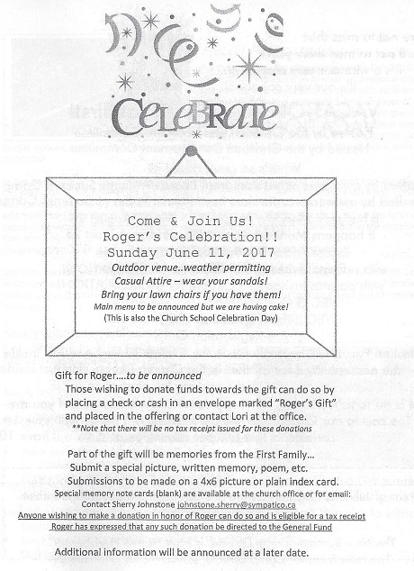


Be sure not to miss this!
It’s a winner every year!
It’s our very cooooool….

VACATION BIBLE CAMP at First!
Hosted by the Christian Development Committee

What’s so great about it?
It’s staffed by awesome counselors from Pearce Williams Summer Camp

It happens Monday, August 21 - Friday, August 25
9:00am to 3:00pm
Except Friday it is 9:00am to 12:00 noon
with parents invited at 11:30am for a CELEBRATION!

VBC IS FOR THOSE 5 – 12 years old
Pre-Registration Only!

Registration Forms will be available in the Church Library and just inside the accessibility door off the parking lot, starting in JUNE.

There is no registration fee, however, donations are welcome if you are able. The cost to our Church is $170 per counselor, and we will have 10 counselors this summer. Thank you!
Pearce Williams Christian Centre has Summer Camps throughout the months of July and August. For more information check out their website at www.campisbetter.com

The New Summer Camp Director is Matt “Iscus” Honsberger
Holly Fair Report…
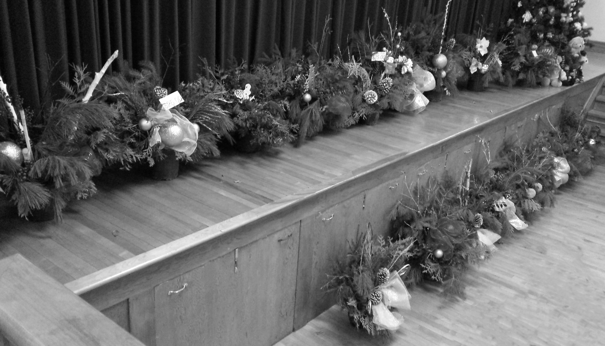
For those of you who attended our Holly Fair 2016 you share as my witnesses as to what an awesome day it was. As I watched the day unfold, it began with such an excitement of seeing smiling and anxious faces of not just the people standing in line outside, but from the volunteers awaiting the day to begin and that was a great way to start the day. Months, days and hours of preparation, so many people working together, had come down to this one day. Just based on those things alone, the day was a success!

As the doors opened I was met with smiling faces anxious to see what First United had in store for them this year. Due to the weather we had people lined up inside this year. But without the many months, hours and days of many special people this great day would not have been a reality. We continue to try and make our Fair a shopping experience and not your typical Holiday Bazaar….. So we say to all of those people that we want to express our appreciation for the many ways you contributed to the success of our First family event.
Congratulations to all of you…This event raised $6507.85 for the General Fund.

2016 marked the year of a 4 person Convenor Team made up of Sherry Johnstone, Lois Smith, Lois Whiteman and Kim Hughson. A huge thank you to the Holly Fair Team whose support and friendship worked well in this new team format. To the staff and volunteers for the many ways you all helped, we thank you.

Sherry Johnstone, Lois Smith
Lois Whiteman, Kim Hughson
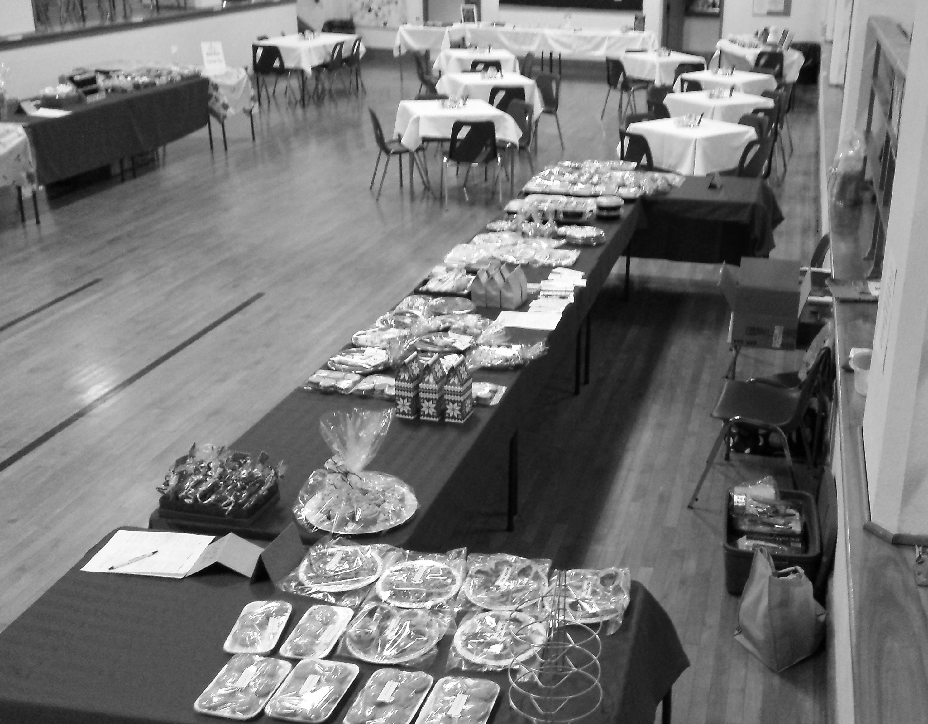
2016 Holly Fair Convenor Team

Special Thank yous:
- To those who helped set up and tear down…
Lois Whiteman/helpers.. such a valued team effort
- First United staff…
Couldn’t have done it without you!
- Thank you to Marlene Smith for her
musical entertainment in the Café!
- Thank you to Elizabeth (Biz) and Wade Thompson
for the donation of greenery for our arrangements

New for 2016 was …
- Crafter’s Market back in the Gym
- Book Store in its original spot.
- Coffee Shop/Lunch Area now the Holly Fair Cafe

Holly Fair Team 2016

Sue Moore Holly Fair Cafe
Lois Whiteman Bake Shop
Cheryl Muma Deli
Dorothy Cameron Holiday Entertaining
Edith Nimmo/ Sharon Hutchison Book Store
Clare Beamish Children’s Corner Store
Kim Hughson/Ruth Zions Children’s Activity Centre
Leslie Pipes Attic Treasures
Sherry Johnstone Crafter’s Market
Sheryl Haaijema Silent Auction/Draw Prizes
Jacqui Travis/Sara Miron Finances
Mark Snowsell Parking
Kathy Nicli/Congregation volunteers Beautiful Overall Decorating
Sherry Johnstone Signs & Bulletin Boards
Mark & Vicki Snowsell Publicity

Some Thoughts for Spring/Summer (Items needed for Holly Fair 2017)
- Christmas items for attic treasures
- Children’s books – (gently read) Sticker books/coloring books in unused condition
- Paper Gift bags – of any kind
- Jellies/Jams/Preserves/Pickles/Chili Sauce/Antipasto
- Gently used games/toys/stuffed animals/any dolls/hot wheels (dinky cars)
- Jewelry/Crystal for Attic Treasures
- Home Décor items/garden items
- FUN, FUN Novelty kids items like purses, pillows, blankets, mittens, booties
- Items for early – mid teens
- Many and any handmade Christmas ornaments for our ornament tree (we’ll take good ideas too)
- Mittens/Hats- all ages

These are just some item ideas to get you started………….

Some highlights of the event:
- 23 fresh arrangements –gone by Sat. 9:30 am WOW!
- Great meat/turkey pies
(Team headed by Cheryl Muma and joined by ladies from the congregation)
- Silent Auction raised $255.00 (Great auction donations!)
- Great children’s craft and ice fishing in Children’s area
- New Holly Fair Café a great success!

Holly Fair Note to the Congregation for 2017

As we had such generous donations of many kinds from several in the congregation, of which we are so thankful for…we also have noticed a decline in donations over the past couple years in all store areas of our event…
This event continues to be a popular event in our congregation as well in the community and this event will only continue to be the success it is, with the support of the First Families and the community. So we ask you to reflect from now until fall of this year, on how you can be a part of that vision. As great as this event is, we need everyone’s help to make it happen..in whatever way you can..

2017- Help Specific
Need additional help for set up and tear down.
New Convenor for Country Store (maybe??)
New Convenor for Holly Fair Café
Donation of embellishments for our fresh arrangements
We could reuse items from any 2016 arrangements as well..

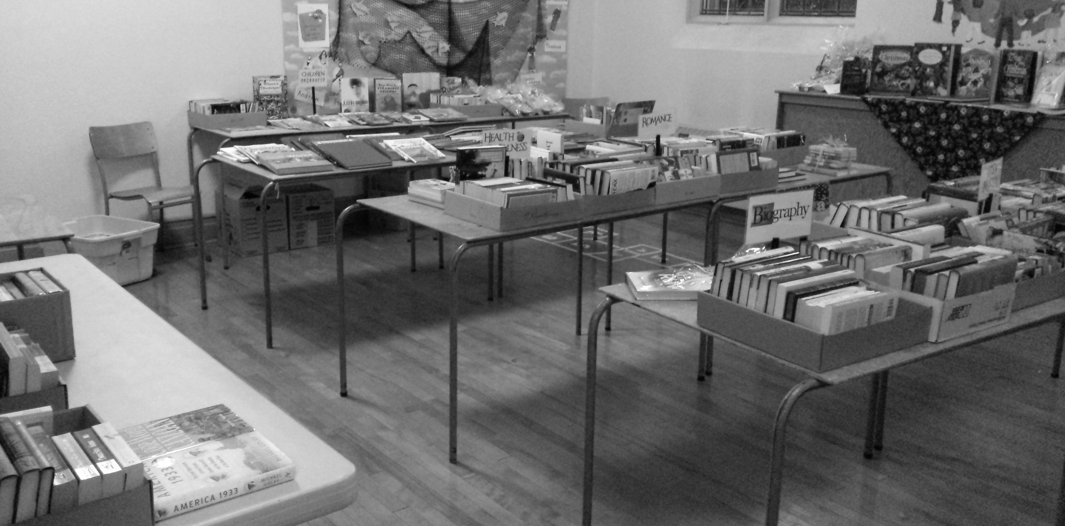

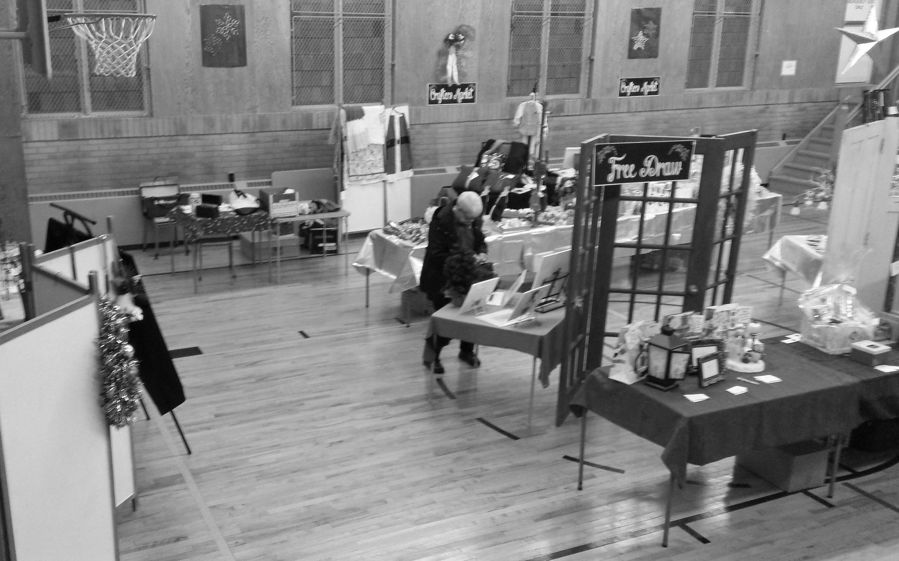

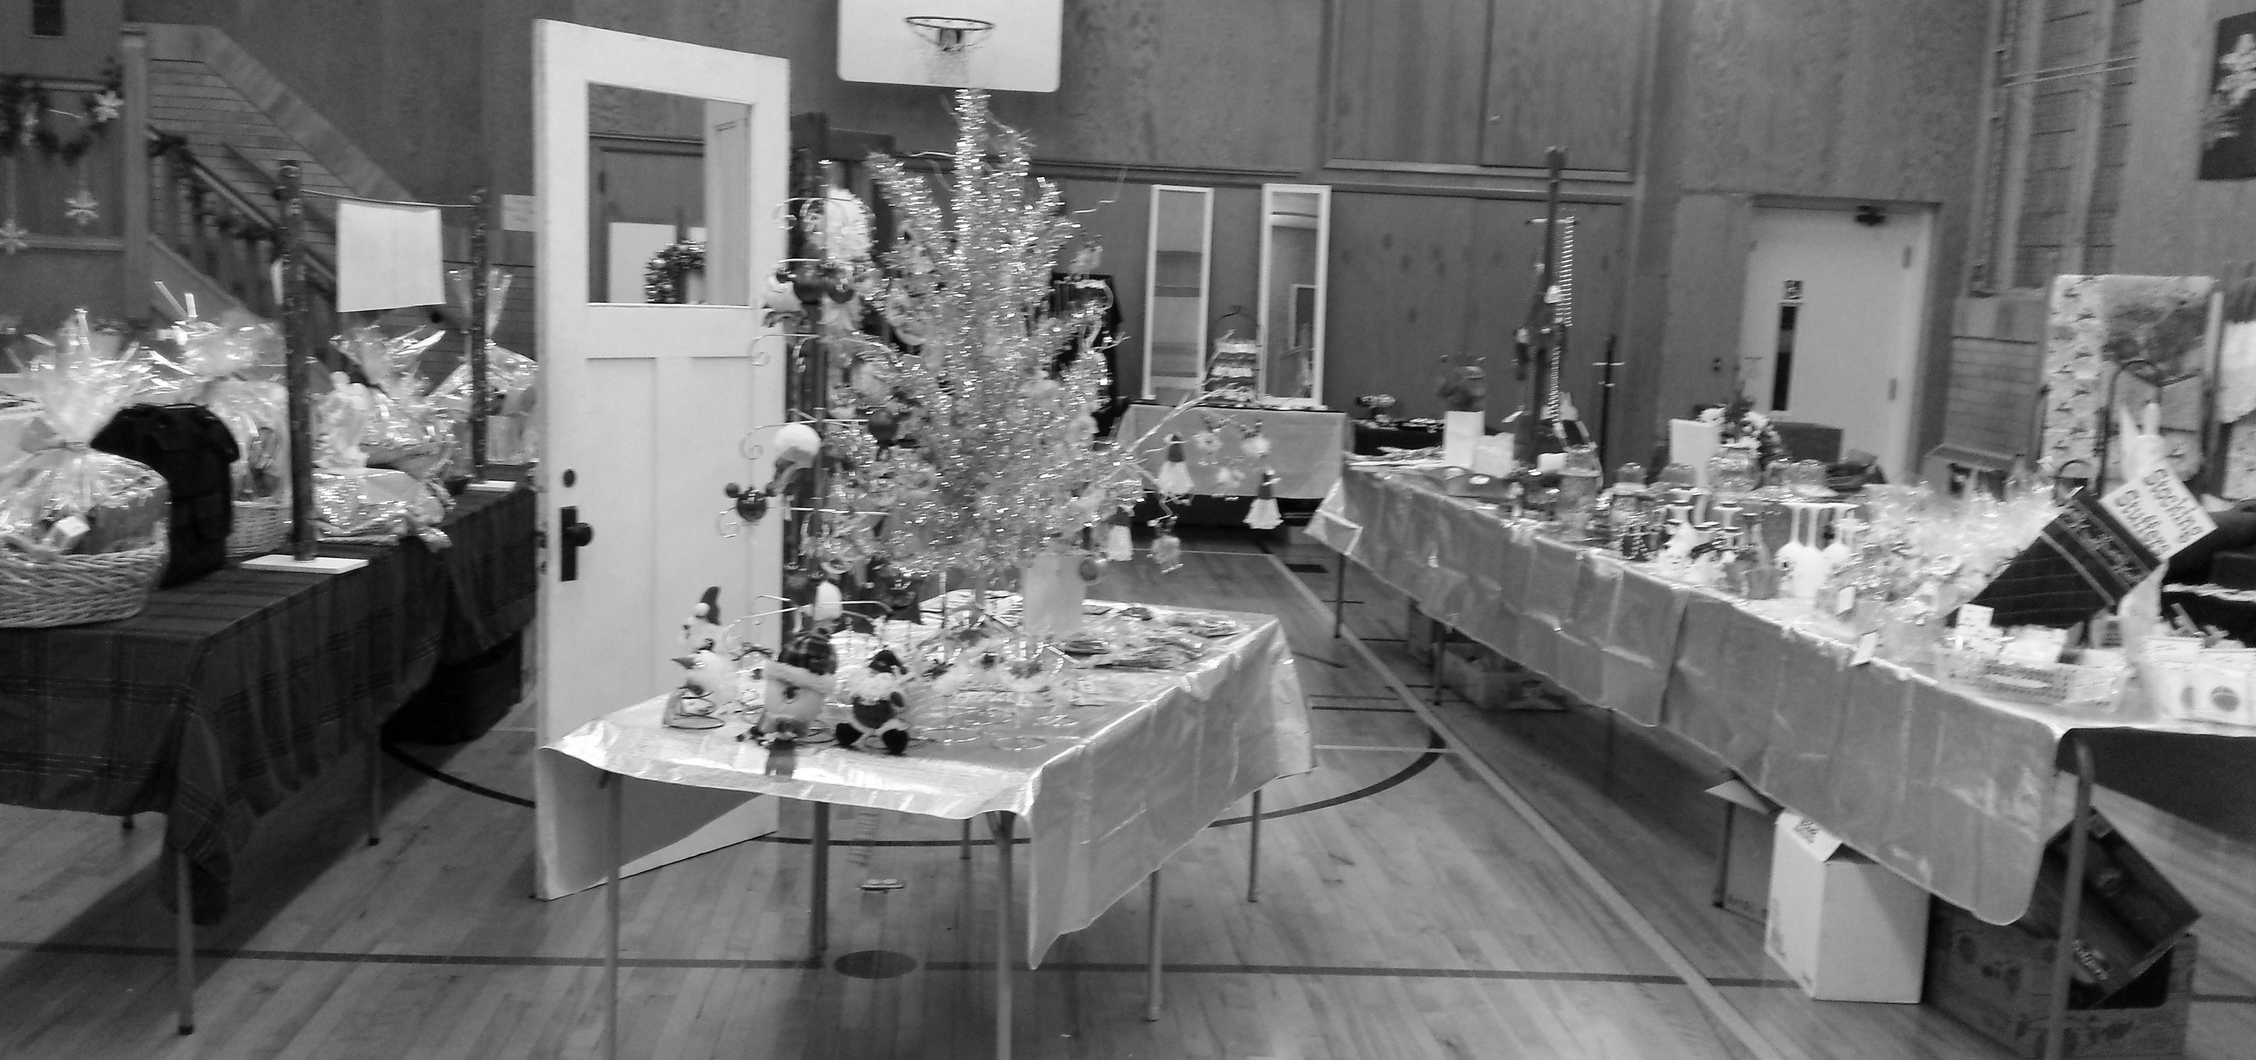

Hamad/Kiwan Family Celebrated First Anniversary as Canadians
(excerpts from service March 26, 2017)

Do you realize that it was just over one year ago that First United Church opened our hearts to the thought of sponsoring a refugee family? Today, we are celebrating the Hamad/Kiwan first anniversary as Canadians!
I am honoured to speak today on behalf of a wonderful group of people who have worked together to support the Hamad/Kiwan family’s arrival to Canada from Syrian via Jordan. We have supported their needs in their first year as Canadians and we truly understand that, “It takes a village”. We have worked, laughed and loved together as a church family. Through this experience, we now know people of our congregation and community at a whole new level. This experience has reinforced for each of us that we belong to an amazing community of faith. We are thankful.
When we started this journey, we were unsure of what “our” family would be like, what they might need, and how we could best support them. While we were very unsure of how best to proceed, we did what churches do when we are called to do something - we struck a committee. We met to explore what we might need to do. We had great guidelines from both the United Church of Canada and also government agencies. We talked about what was in our control and what was out of our control. We knew approximately when they would come, but did not know exact dates.
We found them a house, set up The Giving Tree, and asked for your help and prayers. You were so generous with your gifts and your time. When we got that telephone call that told us we had two days to make it happen - you responded. Thank you!
The day came and the van left for Toronto with a translator aboard. After a bit of effort to find them amongst the many refugees awaiting their hosts, the ride home from Toronto to their new home in St. Thomas was memorable for all - Ahmad, who was 7 months old, cried quite loudly all the way.
We came to learn that the Hamad/Kiwan family had escaped Syria to Jordan about three years prior and they had been in Jordan for the last year. When they made the choice to secure a safe environment for their children, they started their journey from Syria on foot. Amer carried what he could in a single back pack and Rahma bringing the two older boys while carrying a small bag of items for the boys. There were hills to climb and it was a treacherous journey. They left the only life they had known and their loving family behind. Their new life in Jordan was also very difficult; however, while in Jordan, Ahmad was born.
Once in Canada, interesting challenges arose. Imagine being in a new country with a new language and culture! Communication, or should I say miscommunication, was most often the challenge. Let me give you some examples.
In their early days, on one of our frequent visits, Rahma showed us a box of baking soda and asked what it was. You know the one with the cow on the box, that we left open in their refrigerator to catch smells? Amer had assumed it was a milk product - there was a cow after all and it was in the fridge - so he had put it in his coffee! Even though it was bubbling out over the rim of his coffee cup - he drank it. He thought it was strange that Canadians liked their coffee like that!
They received a very brief orientation to Canada and the English language in London, the Hamad’s started their education in ernest in St. Thomas. Shahin and Yousef began at John Wise Public School. Initially Amer studied at English as a second language at Balaclava - then he was joined by Rahma after Ahmad turned one and was able to start at Robin’s Nest Daycare.
We have also learned to communicate in the shared language of music - mostly classics like “6 little ducks”, “the wheels on the bus”, and “Head and Shoulders, knees and toes”!
Communication has been simplest in the shared language of food! The Hamads are gracious hosts and always offer tea and food when you visit. As for me, I have learned to love makdous. Makdous is a Syrian staple food, made seasonally each year with baby eggplants, with the water pressed out through a rather complex process, then stuffed with walnuts, and peppers; all persevered in olive oil and stored in mason jars. The process to make it takes well over a week. When you eat makdous, it wakes up your tastebuds. By the way, makdous is great alone on toast or with eggs!
There have been other lessons as well:
- Amer has learned to wear long pants or slather on sunscreen when going out on a boat for the day.
- Google translate can help - but it doesn’t always translate very well and can give rise to more miscommunications.
- We have learned that charades is often the best way to communicate.
- You should clarify if the appointment is 6:00 am or pm. so no one ends up standing at the Doctor’s office in the cold and dark early morning hours prior to the office opening
- That we associate red skies at night with good weather tomorrow but the experience of these children is that red skies may mean impending danger.
- I have learned that gasps from children in the backseat aren’t necessarily a reason for concern - it may just be that the fall leaves are changing colour and they have never seen it before and are awestruck

There are so many lessons and stories - but what else would you expect - we are family after all!

The Hamads express extreme gratitude to our church family, and the Canadian people.

We would like all the people here today who helped support this wonderful family. You have donated your time to help ready their home, taught English, driven to appointments or school, donated to the Giving Tree, made financial donations, filled out forms, helped build their fence, connecting with the school or helped with homework, supported at appointments, travelled for groceries, visited the Hamads or were involved in so many other activities! Thank you.

In the last year, we have learned that Canada is so fortunate to have this wonderful family.
- Amer is a hard working, expert ceramic tile installer who is looking to do work in his field
- Rahma is exceptionally bright, an amazing mother, and is a fantastic cook,
- Shahin is very bright, musical and athletic,
- Yousef is a wonderful artist and an animal lover, and
- Ahmad is growing quickly and is learning to speak in both Arabic and English. He has gone from crying at the sight of snow to sitting down to eat a snowball in his snowsuit.

We are so happy that you are here, safe with us in Canada.

We have received from you so much more than we have given - thank you Hamad family.
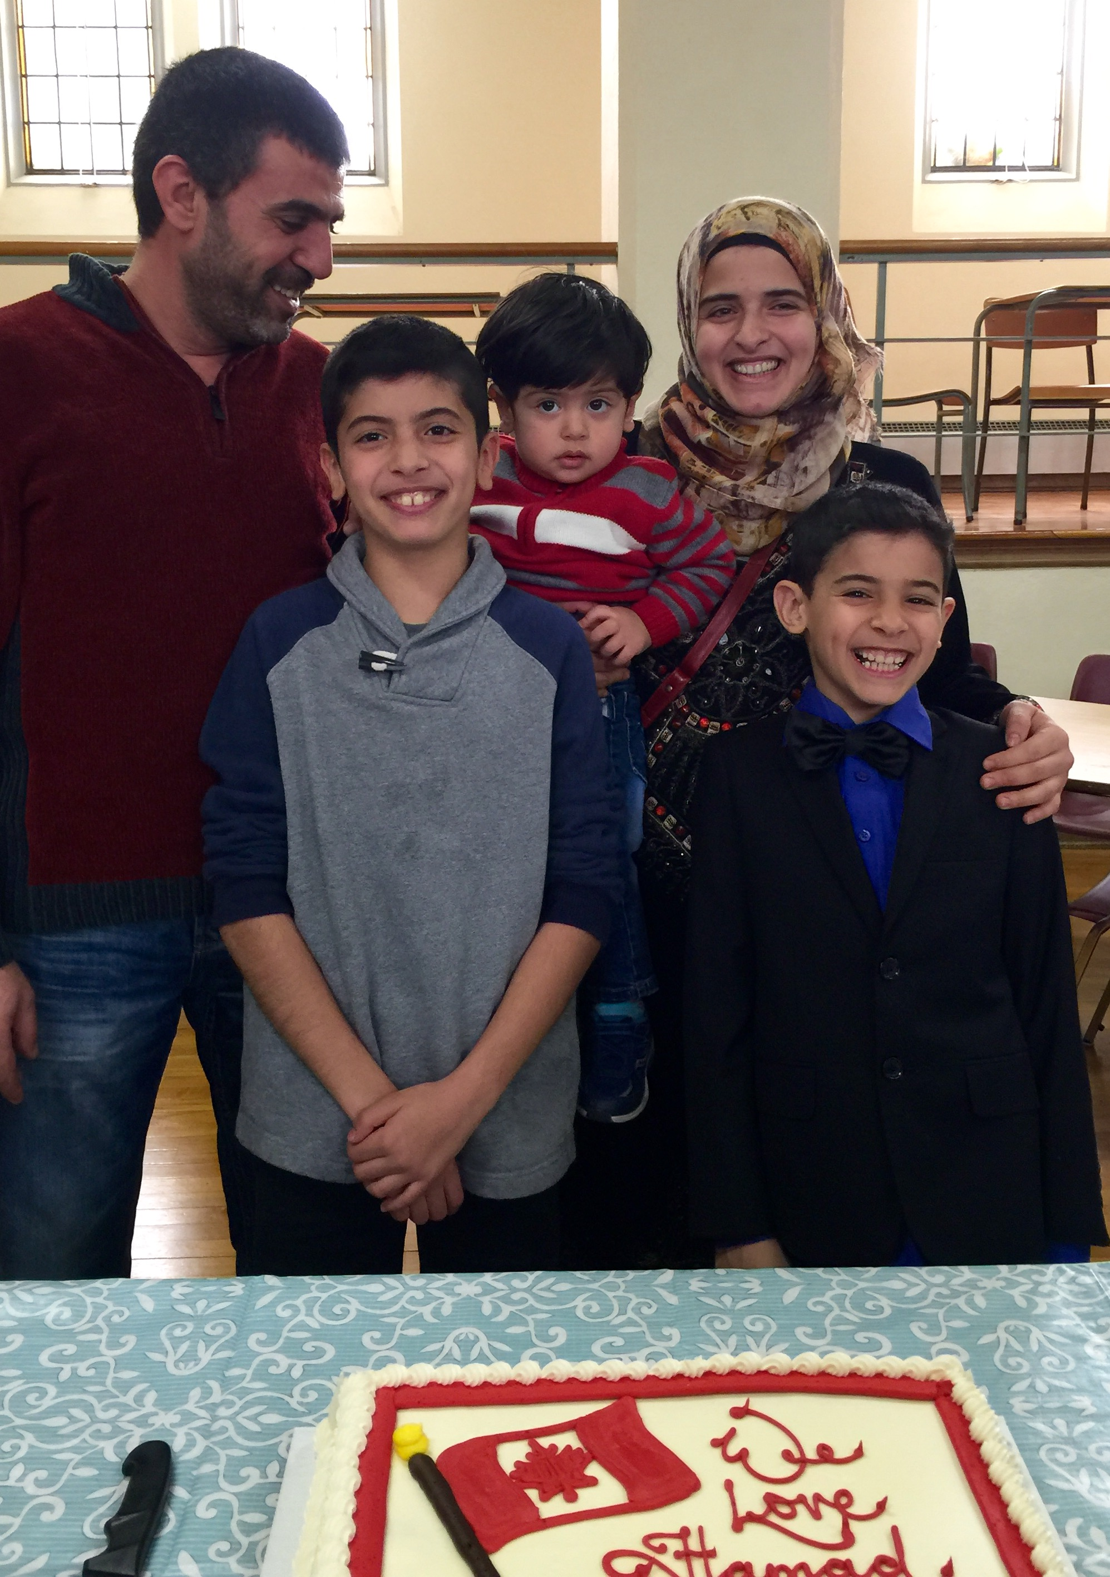

Photo taken March 26, 2017
at the Happy One Year in Canada
Celebration!!

FROM THE CHURCH LIBRARY
Children’s Department
Our Easter & Spring children’s books are on display – waiting to be read and enjoyed.

Other Books that deserve special mention are:
“What I Believe” – It is intended for elementary school age children, but I would recommend it to all ages. It covers 8 different religion, plus 4 other faiths in less detail. There is a glossary at the back of the book which is useful for children.

“The Invisible Boy” – This book was donated to our library by Kristi, Grant & Gene Whiteman. The author is an active member of the International Bullying Prevention Association. It is a gentle story showing how small acts of kindness can help children feel included and allow them to flourish. It focuses on helping children cope with & thrive in their social world.

Adult Department
“Mutant Message Down Under” donated by Rosemary Underhill, and highly recommended by her. The author Elisabeth Kubler-Ross states, “we need to get back in touch with nature, to trust & have faith in our inner knowledge & guidance.”

“God Never Blinks” donated by Maureen Turner. 50 lessons for Life’s Little Detours. Most are short, sweet, wise and moving – a remarkable testimony to the power and love of God. One lesson is entitled “Read the Psalms, No Matter What Your Faith. They Cover Every Human Emotion.”


Submitted by Edith Nimmo

FINANCE COMMITTEE
The Finance Committee extends our sincere thanks to everyone for their continued support of the Ministry here at First United Church.

To cover our expenses we need approximately $22,300 in General Fund Givings EVERY month. In January, our General Fund Givings were $14478; in February they were $13,388; and in March they were $15,700. That is a shortfall of $23,334 in General Fund Givings in our first quarter.

The summer is fast approaching and we begin the challenge of meeting our financial needs from June to September. We ask you to consider the needs of your church and if possible, help us to meet our financial commitments over the vacation period. We appreciate your generosity!

Respectfully submitted by the Finance Committee

FOR YOUR INFORMATION
Ways of Giving accepted for General Fund donations:

Cash

Cheque

Post-dated cheques

Pre-Authorized Payment
and ONLINE through PAYPAL!
See our website (www.firstunitedchurch.weebly.com) for info!

When making a donation to the General Fund, please record your envelope number on the envelope. If you do not have one, be sure to record your name and address on all donations to ensure a tax receipt at the end of the year. If you would like information on any of these forms of payment, or would like a set of envelopes or information on PAR, please call Lori in the Office @ 631-7570.

VIEWS FROM THE PEWS – submitted by John Surmacz
What is faith?
Scripture gives us a definition.
Hebrews 11:1
Now faith is assurance of things hoped for, a conviction of things not seen.
Let me enhance that definition.
Faith is the eye that sees the invisible.
The ear that hears the inaudible.
The hand that feels the intangible.
The power that works the impossible.
Why do we need faith?
Because it’s by faith that we are saved. It’s by faith we are healed.
Scripture says we can’t please God without faith. (Hebrews 11:6)
God operates in the spirit realm and we need faith to operate in the spirit realm.
We might think we don’t have enough faith.
Scripture says that once you’re born again, you are given The measure of faith.
Not a measure but THE measure. The exact amount of faith required to accomplish
anything you ask of God.
How do we use faith? This is answered in …
Mark 11:24 Therefore I say unto you, All things whatsoever ye pray and ask for,
believe that ye receive them, and ye shall have them.
First you pray!!
What can you pray for? It says whatsoever!!! That means anything or everything that
lines up with God’ Word.
Second you believe!!! Not hope but believe! Believe before you receive!
Thirdly you act upon your request! Act like it is already accomplished.
James 2:17 So it is with faith: if it is alone and includes no actions, then it is dead.
Accept gods Word as written. Don’t add or subtract from it.
I finish with this…
When faith and Spirit come together there is an interaction.

There is a movement of God.
There is a divine explosion.
That’s when your faith is answered!!!!

FIRST OFFICIAL BOARD / **ELDERS 2017

CHAIR: Bill Beamish VICE CHAIR: Richard Routhier
SECRETARY: Lois Whiteman TREASURER: Lori Hoffman (ex officio member)
Presbytery Supervisor: Ellen Palmer 519-769-2245

CHRISTIAN DEVELOPMENT - Richard Routhier (Chair)(17); Erin Chute (17); Justin Chute (19); Rosemarie Johnson-Clarke (17)
FINANCE - Karen Rick (Chair) (18); Bill Beamish (18); Ray Bosveld (18); Mike Muma (18); Don Renaud (18)
MEMBERSHIP - Edith Nimmo(Chair) (17); Elly Jackson (17); Sharon Hutchinson (17); Bill McMillan (19); Ruth Zions (18)
PERSONNEL - Mark Traichevich (Chair) (17); Bert Donaldson (17); Lance McAdams (17); Sue Nicol (17); Carole Watson (17)
PROPERTY - John Surmacz (Chair) (17); Richard Auckland (17); Lyle Cameron (17); Bill Richardson (17)
WORSHIP AND MUSIC - Mary Virginia Towers (Chair) (17); Rachel Rayner (19)

OFFICIAL BOARD meets 2nd Tuesday of January, February, April, June, September and November

* * * * * * * * * * * *

OFFICIAL BOARD EXECUTIVE (*Also acts as Stewardship / Nominating Committee)
Consists of Official Board Chair; Vice Chair; Secretary; Treasurer; Minister(s) and the Chairpersons of the above committees. The Official Board Executive meets the 2nd Tuesday of March, May, October & December

* * * * * * * * * * * *

Congregational Chair: Richard Auckland
Congregational Secretary: Lois Whiteman
Elgin Presbytery Rep – Richard Auckland
Trustees: - Bob Floyd (Chair); Allan Johnson (Treasurer); Richard Auckland (Secretary); Lyle Cameron; Graham Sanderson; Bob Upsdell.

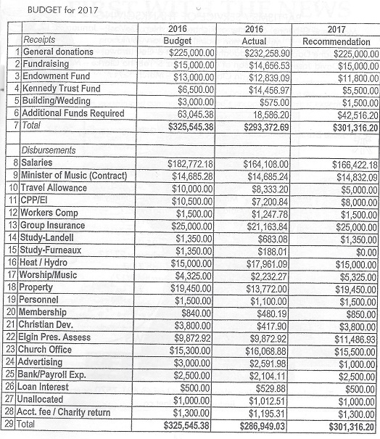
BUDGET for 2017


BAPTISMS / SERVICE OF THANKSGIVING
Maci Irene Gibbons, daughter of Richard & Ashlen (DeVos) – January 8/17
Miki Whitman (adult) – February 19/17
Charli Jane Daphne Cook, daughter of Robert & Cali (Brown) – March 12/17
Exavier David Joseph Moniz, son of David Moniz & Tabitha Clarke – March 12/17
Tabitha Lynn Clarke (adult) – March 12/17


WEDDINGS
Jesse Daniel Nahmabin & Tonya Eva Maria Stillitano – January 28/17

IN MEMORY
Rebecca “Becky” Marie (Fife) Wheatley – January 4/17

Roy Donald Fowler – January 16/17
Betty Norine Jones – January 17/17
Cameron “Wayne” Slaght – January 27/17
Edna Rieger – February 25/17
James “Jim” Howard Davis – February 27/17
Donald A. Graham – March 7/17
Peter Douglas Palmer – March 17/17


FIRST WITH THE NEWS

To make a submission, please contact Lori @ 631-7570 or email to firstunited@bellnet.ca

