First United Church
Seeking to be a welcoming community of Christian faith, proclaiming and celebrating the love of God in Jesus Christ through the Inspiration of the Holy Spirit

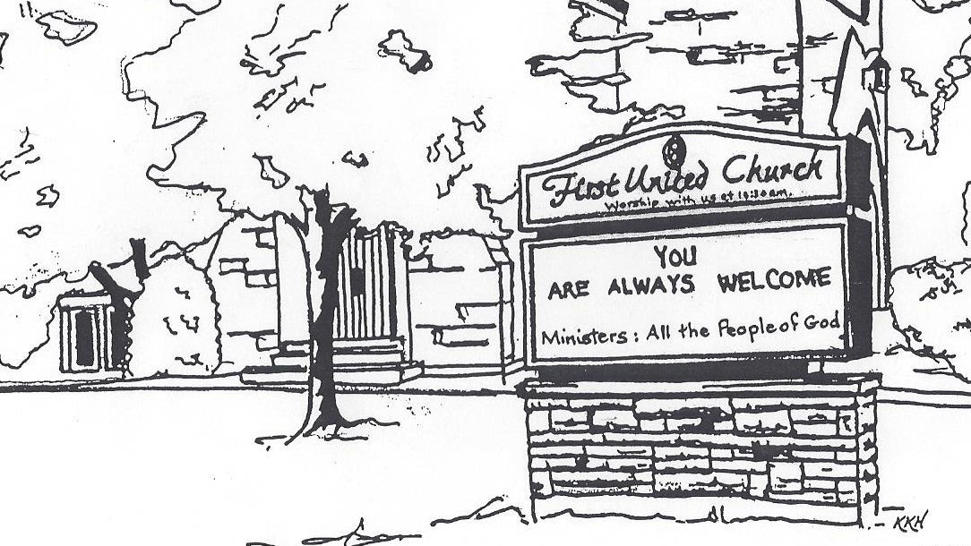

Rally Day
September 8, 2019 @ 10:30am

7 Curtis St., St.Thomas, ON N5P 1H3 Phone: (519) 631-7570
e-mail: office@1stunitedchurch.ca
web: www.1stunitedchurch.ca
MINISTERS: ALL THE PEOPLE OF GOD
Music Minister: Jody McDonald-Groulx
Secretary/Treasurer: Lori Hoffman
Custodian: Dave Luftenegger

Order of Service
* You are invited to stand if comfortable doing so

VU = Voices United MV = More Voices

Musical Prelude

Choral Musical Prelude
- “I Just Want to Be a Sheep”
CHORUS: I just wanna be a sheep, baa, baa
I just wanna be a sheep, baa, baa
I pray my Lord my soul to keep,
I just wanna be a sheep, baa, baa

I don’t wanna be a Pharisee , I don’t wanna be a Pharisee
‘cuz they’re not fair you see, I just wanna be a sheep, baa, baa
CHORUS

I don’t wanna be a hypocrite, I don’t wanna be a hypocrite
‘cuz they’re not hip with it, I just wanna be a sheep, baa, baa
CHORUS

I don’t want to be a Sadducee, I don’t want to be a Sadducee
‘cuz they’re so sad you see, I just wanna be a sheep, baa, baa
CHORUS

I don’t wanna be a goat, nope, I don’t wanna be a goat, nope
‘cuz there’s no hope for goats, I just wanna be a sheep, baa, baa
CHORUS

- MV#92 “Like A Rock” (2x)
Like a Rock, Like a Rock, God is under our feet.
Like the Starry night Sky, God is over our Head.
Like the Sun on the horizon, God is ever before.
Like the river runs to Ocean, Our home is in God ever more.

Opening Prayer

Call to Worship: Psalm 111
One: Praise the Lord.
All: I will extol the Lord with all my heart in the council of the
upright and in the assembly.
One: Great are the works of the Lord; they are pondered by all
who delight in them.
All: Glorious and majestic are his deeds, and his righteousness
endures forever.
One: He has caused his wonders to be remembered; the Lord is
gracious and compassionate.
All: He provides food for those who fear him; he remembers his
covenant forever.
One: He has shown his people the power of his works, giving
them the lands of other nations.
All: The works of his hands are faithful and just; all his precepts
are trustworthy.
One: They are established for ever and ever, enacted in
faithfulness and uprightness.
All: He provided redemption for his people; he ordained his
covenant forever— holy and awesome is his name.
One: The fear of the Lord is the beginning of wisdom; all who
follow his precepts have good understanding.
All: To him belongs eternal praise.

Lighting of the Christ Candle
I am the light of world, you people come and follow me.
If we follow and love, we’ll learn the mystery
Of what we were meant to do and be.

Passing of the Peace (VU #958 “Halle, Halle, Halle”)
Welcome/Life and Work of the Church
Hymn of Praise: “Awesome God” (2x)
Our God is an awesome God, He reigns from heaven above
With wisdom, power, and love, Our God is an awesome God.
Prayers of the People/The Lord’s Prayer
Hymn: VU#356 “Seek Ye First”
Commissioning Sunday School Teachers and Youth Group Leaders
One: God of Creation, you have gifted these men and women with teaching skills, creativity, and curiosity. We pray you would fill them with the power and compassion of your Holy Spirit. Fill them with energy and insight into your Word, the story of Your faithful heart.
Teachers: You have not called us to be perfect You have called us to be faithful. You have not called us to be all-knowing You have called us to believe. We dedicate ourselves to the call and task of teaching. Grant us wisdom, patience and joy in our preparation and teaching of your Word.
Congregation: God of hope, Guide each teacher as they study your Word. Strengthen the gifts you have given them, and energize their compassion, Remind us to find ways to support and encourage them throughout the year. May we share in their joy and times of difficulty.
ALL: We commit ourselves, each to our part, in this joyful task. May your steadfast, faithful, covenant love guide all we do. Amen.

Conversation with the Young People
Children please meet with the Teachers in the Gym

Offering Ourselves, Tithes & Gifts: Solo - Alvin Epp
Dedication Hymn: (tune “Eidelweiss”)
God of Love, hear our prayer. Bless this offering we bring you. May our lives do Your will; guide and guard us forever. Give us courage to stand for truth; help us give to others. God of Love, hear our prayer, Bless this offering we bring you.

Scripture Reading: Hebrews 13:8

Hymn of Preparation: “Because He Lives”
- God sent His Son, they called him Jesus.
He came to love, heal and forgive.
He lived and died to buy my pardon;
An empty grave is there to prove my Saviour lives.

Chorus: Because He lives, I can face tomorrow,
Because He lives, all fear is gone.
Because I know, He holds the future
And life is worth the living just because He lives.

- How sweet to hold, our newborn baby
And feel the pride and joy he give
But grater still the calm assurance:
This child can face uncertain days because He lives.
(Repeat Chorus)

The Message: “Jesus Never Changes” Chris Ross

Hymn of Response: VU#884 “We Shall Go Out With Joy” (2x)

*Commissioning/ Benediction
Closing - Sing: MV #209
Go make a diff’rence. We can make a diff’rence.
Go make a diff’rence in the world.
Go make a diff’rence. We can make a diff’rence.
Go make a diff’rence in the world.

* Musical Postlude

The Life & Work of the Church – September 1

Please join us for ice cream in the Assembly Hall
following worship. All welcome!

Happy birthday to: Arnold Catt, Harold Lake, Alvin Epp, Liam West, Marion Bennell.

Happy Anniversary to: Mark & Debbie Traichevich

This week:

Tues., Sept.10 - FIRST YOUTH GROUP 7:00-8:15pm
Grades 5-12 with Chris Ross. All welcome! Come join us!

Tues., Sept. 10 - OFFICIAL BOARD MEETING @ 7pm

Thurs., Sept. 12 - SENIOR CHOIR @ 7:30pm!

Don’t be shy – singing’s great for the soul – come and give it a try!

Sun., Sept. 15 – WORSHIP @ 10:30am Guest Speaker: Kevin Abell
CHURCH SCHOOL RESUMES!

Upcoming Dates & Events
Sun., Sept. 22 – WORSHIP @ 10:30am Guest Speaker: Helen Keenliside

Thurs., Sept. 26 - Elgin Theatre Guild presents Sandy Toes and Salty Kisses at the historic Princess Ave. Playhouse. Tickets can be purchased for this date through First United Church for $20, with $8 from every ticket sold going back to the church! This is a great opportunity to invite friends, family and neighbours for a fun evening out, and raise money for First! Here is a brief summary of the play:
Event type: All Ages / Licensed.
A play full of mistaken identities and a mix up of room numbers this fantastic play will have you wondering what on earth could go wrong
next. The Lovers Landing Beach Hotel on the Gulf of Mexico has been promoted as “The home of Sandy Toes and Salty Kisses:” becoming a popular wedding destination. Mayhem ensues when the eccentric

Wedding Planner, Madame CoCo, suddenly elopes leaving the position
vacant to be filled by the owners Uncle Bubba who is actually the Handyman. When Beatrice Rutherford-Smythe arrives with her daughter to check out the place, things start to go awry. With unlikely encounters and total chaos. Will love win through?
Tickets are available through the church office.

Sun., Sept. 29 – WORSHIP @ 10:30am Guest Speaker: Janine Lunn

Sun., Oct. 6 - WORSHIP @ 10:30am Guest Speaker: Justin Dimoff

Sun., Oct. 13 THANKSGIVING SUNDAY

Sat., Oct. 19 – RUMMAGE SALE 8:30 – 11:30 am
We hope EVERYONE will take some time in the next few weeks to clean out their closets, attics and basements and donate your gently used items to our sale! Looking for fall and winter clothing, special ladies wear for our popular boutique, shoes, boots, hats, mittens, china, glassware, vintage items, fall and Christmas decorations, jewellery, luggage, small household items (please no TVs, microwaves or computers), books, games and toys. Donated items may be left inside west accessibility door Mon. - Thurs. 9am-2:30pm. Please call Lois Whiteman 519-631-3337 if you are able to help sort and price the weeks before the sale or if you would like to work sale day. Thankyou!

We need your help to know who is sick, in hospital
or just wishing a visit. Please let Lori know in the
Church Office at 519-631-7570 ext 21. Thank you!

