First United Church
Seeking to be a welcoming community of Christian faith, proclaiming and celebrating the love of God in Jesus Christ through the Inspiration of the Holy Spirit

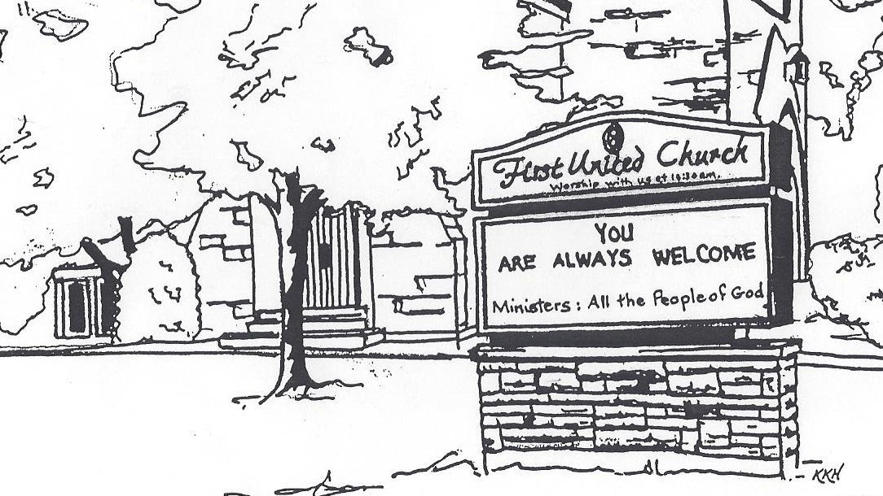

September 29, 2019 @ 10:30am

7 Curtis St., St.Thomas, ON N5P 1H3 Phone: (519) 631-7570
e-mail: office@1stunitedchurch.ca
web: www.1stunitedchurch.ca
MINISTERS: ALL THE PEOPLE OF GOD
Music Minister: Jody McDonald-Groulx
Secretary/Treasurer: Lori Hoffman
Custodian: Dave Luftenegger

Order of Service
* You are invited to stand if comfortable doing so

VU = Voices United MV = More Voices

Musical Prelude

Welcome

Choral Musical Prelude
- “Bless the Lord” (4x)
Bless the Lord, O my Soul,
O my Soul
Worship His holy name,
Sing like never before
O my Soul
I’ll worship your holy name.

- MV#7 “Gather Us In” (2x)
Gather us in, ground us in you.
Gather us in, ground us in you.
Gather us in, gather us in
ground us, ground us in you.

Opening Prayer

Call to Worship
One: Arise, shine; for your light has come
Many: The glory of the Lord has risen upon us.
One: Come, worship the Lord of glory.
Many: Proclaim God’s praise among the nations.

Lighting of the Christ Candle
I am the light of world, you people come and follow me.
If we follow and love, we’ll learn the mystery
Of what we were meant to do and be.

Passing of the Peace
The Peace of Christ be with you.
Response: And also with you!

Halle, Halle, Halle, lu jah!
Halle, Halle, Halle, lu jah!
Halle, Halle, Halle, lu jah!
Halle lu jah! (clap) Halle lu jah!

Musical Offering: Senior Choir
Life and Work of the Church
Hymn of Praise: “We Are the Church”
Refrain:
I am the church! You are the church!
We are the church together!
All who follow Jesus, all around the world!
Yes, we're the church together!
1. The church is not a building;
the church is not a steeple;
the church is not a resting place;
the church is a people. (Refrain)
2. We're many kinds of people,
with many kinds of faces,
all colours and all ages, too
from all times and places. (Refrain)
3. And when the people gather,
there's singing and there's praying;
there's laughing and there's crying sometimes,
all of it saying: (Refrain)

- I count if I am ninety,
or nine or just a baby
There’s one thing I am sure about
And I don’t mean maybe. (Refrain)
Prayers of the People/The Lord’s Prayer
Hymn: MV#40 “Never Ending Joy”
Refrain:
Never ending joy, every ending joy, never ending joy,
never ending joy, never ending joy, never ending joy!

- God of every tribe, every language, God of every river and sea.
God of every mountain and island, you bring joy to me. (Refrain)

- God of every hill, every valley, God of every leaf, every tree,
God of every cloud, every raindrop, you bring joy to me. (Refrain)

- God of every song, every story, God of every captive set free,
God of every dance, every footstep, you bring joy to me. (Refrain)

Conversation with the Young People
Children & Youth may leave for Church School

Offering Ourselves, Tithes & Gifts

Dedication Hymn: (tune “Eidelweiss”)
God of Love, hear our prayer. Bless this offering we bring you. May our lives do Your will; guide and guard us forever. Give us courage to stand for truth; help us give to others. God of Love, hear our prayer, Bless this offering we bring you.

Scripture Reading: John 3:14-21

Hymn: VU#289 “It Only Takes a Spark”
- It only takes a spark to get a fire going
And soon all those around can warm up in its glowing
That’s how it is with God’s love, once you’ve experienced it:
You spread God’s love to everyone, you want to pass it on.

- What a wondrous time is spring when all the trees are budding,
The birds begin to sing, the flowers start their blooming;
That’s how it is with God’s love, once you’ve experienced it:
You want to sing, it’s fresh like spring, you want to pass it on.
- I wish for you, my friend, this happiness that I’ve found
On God you can depend, it matters not where you‘re bound;
I’ll shout it from the mountain top; I want my world to know:
The Lord of love has come to me, I want to pass it on.

The Message: “It Only Takes A Spark” Janine Lunn

Prayer

Hymn: MV#214 “May God’s Sheltering Wings”
May God’s sheltering wings, His gathering wings protect you.
May God’s nurturing arms, His cradling arms sustain you,
And hold you in His love, and hold you in His love.

*Commissioning/ Benediction
One: Go forth in the grace of Christ.
Many: We rejoice in his grace.
One: Go forth in the light of Christ.
Many: We walk in his light.
One: Go forth in the love of Christ.
Many: We serve in this love.

Closing - Sing: MV #209
Go make a diff’rence. We can make a diff’rence.
Go make a diff’rence in the world.
Go make a diff’rence. We can make a diff’rence.
Go make a diff’rence in the world.

* Musical Postlude

Thank you to Janine Lunn
for sharing her message with us today.

The Life & Work of the Church – September 29

Happy birthday to: Edith Nimmo, Barbara Welch, Elly Jackson.

First Church is hosting an Epicure Fundraiser! There are 3 “specials” and 40% of all of the proceeds go directly to the Church. Check out the flyers posted around the Church or contact Erin Chute (erinchute@hotmail.com) or Liza Visser (lizamikevisser@gmail.com) for more information (or to order!!)

This week:

Tuesday - *EarlyON Playgroup 9:30-11:30am in the Gym

*First Youth Group 7:00-8:15pm Grades 5-12 with Chris Ross. All welcome! Come join us!

Wednesday – *Sorting for Rummage Sale @ 9am. If you can spare an hour or two come out and help
*Transition Committee Meeting @ 7pm

Thursday - *Pathfinders / Rangers Group meets at 7pm

*Senior Choir practice @ 7:30pm

Next Sunday – *WORSHIP @ 10:30am Guest Speaker: Justin Dimoff

Upcoming Dates & Events
Thurs., Oct. 10 *Committee Reports for Board due in the Church Office to be emailed out.

Sun., Oct. 13 *THANKSGIVING SUNDAY -Guest Speaker: Mark Sargant.
God has blessed us, as a community of faith, that we may be a blessing to others. Once again, on Thanksgiving Sunday, we invite you to bring GIFTS OF HEALTHY FOOD for those who do not have enough! There will be baskets out in the Chancel to accept your donations prior to the service.
From the fields & orchards: Potatoes, squash, turnip, brussell sprouts, apples, beets, cabbage, carrots, oranges, onions, corn on the cob.
(foods with a little staying power)

From the grocery store: Healthy canned goods (low sodium),

spaghetti & tomato sauce, beans, lentils, tuna, salmon, soup,
juices, mac & cheese, peanut butter, coffee, tea, sugar, crackers
peanut butter, dry pasta, rice, salt, pepper, Cereal and hot cereal, granola bars, etc. for lunches, garbage bags, saran wrap, sandwich bags.
Personal Hygiene Products: Tooth Paste, dental floss, hand soap, shampoo, conditioner, deodorants sans aluminum, dish soap, laundry detergent, toilet tissue, razors, diapers, baby lotion, and Women’s Hygiene Products. Thank you for sharing!

Tues., Oct. 15 – *Youth Group is going Bowling at Park N Bowl 7-8pm. Please let Justin or Chris know if you can go!
*Finance Committee Meeting @ 6:30pm in the Fellowship Room
*Official Board Meeting @ 7pm in the Music Room

Sat., Oct. 19 – *Rummage Sale 8:30 – 11:30 am
Donations of gently used fall and winter clothing for all ages needed! Send along your extra special ladies clothing for our Ladies Boutique room. Looking for fall and Christmas home decor, knic knacs, pictures, china, glassware, bedding, towels, luggage, small appliances but please no microwaves, computers or TVs. Childrens and adult books, puzzles and games are needed as well. Remember toys toys toys for all ages!
Please bring your donations to the west accessibility door Mon-Thurs 9am-2:30pm. Call Lois W. 519-631-3337 to help sort, price or work sale day. ALSO – NEW THIS YEAR – We will be having a Bake Sale at the Rummage Sale!! Donations of Bake goods are needed!! Please contact Lois W for drop off times. Thankyou!

Mon., Oct. 21 – *Once again, First Church is hosting a Boston Pizza Night! A great ‘fun’raiser for the church. Cost is $20 per person –
but $10 of that comes back to the church. An opportunity to
visit and best of all – NO CLEAN UP! THE BUFFET includes: Pizza, Pasta and Caesar Salad (drinks not included) There will be DOOR PRIZES too! So be sure to write your name on the back of the ticket before you turn it in at the restaurant. Tickets will be drawn that night! Children can order from the ‘Children’s menu” instead of paying $20 for each child. Bring a friend or two! It’s a great & affordable evening out!
Tickets are available from the office!
*Holly Fair & Vendor Market: Saturday, November 9 from 9am to noon (please note the change in date). At the 2019 Holly Fair we have decided to open up some of our space to host a Vendor Market!! We will still have our own amazing areas: Attic Treasures, Bake Table, Book Room, Cafe, Crafts & Holiday Entertaining (so we're still counting on your donations First Church Friends!!! (See our website of the wish list!) but we will be opening up space to some of your favourite Vendors just in time for Christmas Shopping!! MARK YOU CALENDARS for this ONE STOP SHOPPING Opportunity!
If you are a Vendor (Artisan or Direct Sales) we invite you to submit an application to be part of this event (available in the church office or on our website)! Our Holly Fair is a VERY well attended annual event - with people lined up at the door waiting to get in! So get your applications in asap so you don’t miss out on this opportunity.
*We will only be accepting one of each Direct Sales Vendors and will try to keep Vendors with similar items to a maximum of 2.
Note: we are hosting our own Epicure Fundraiser at the event this year
to benefit the Church so we will not be accepting an Epicure Vendor for this event. Thank you for understanding.
We need your help to know who is sick, in hospital
or just wishing a visit. Please let Lori know in the
Church Office at 519-631-7570 ext 21. Thank you!

Mission Statement: Seeking to be a welcoming community of Christian Faith, proclaiming and celebrating the Love of God in Jesus Christ through the inspiration of the Holy Spirit.

Values: 1. Inclusive, welcoming community of moderate Christian faith
2. Nurturing healthy and supportive relationships
3. Nurturing a sense of Community and Encouraging
Fellowship with the wider community

