First United Church
Seeking to be a welcoming community of Christian faith,
proclaiming and celebrating the love of God in Jesus Christ
through the Inspiration of the Holy Spirit

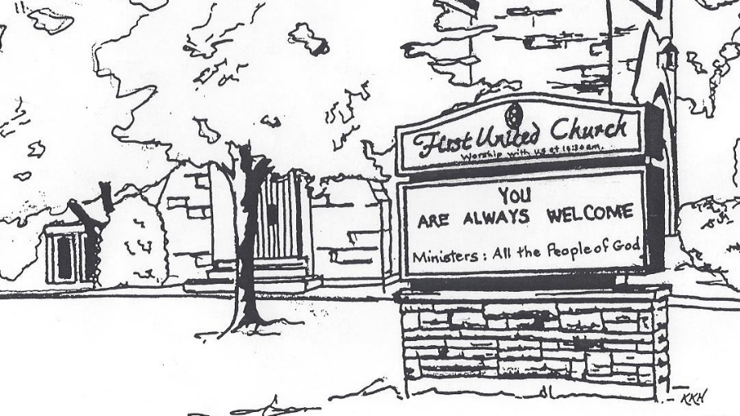

September 23, 2018 @ 10:30am

7 Curtis St., St.Thomas, ON N5P 1H3 Phone: (519) 631-7570
e-mail: office@1stunitedchurch.ca
web: www.1stunitedchurch.ca
MINISTERS: ALL THE PEOPLE OF GOD
Pastoral Minister: Rev. Emmanuel K. Ofori
Music Minister: Jody McDonald-Groulx
Secretary/Treasurer: Lori Hoffman
Custodian: Dave Luftenegger

18th Sunday After Pentecost
Sunday, September 23, 2018
10:30 a.m. Worship
Preacher: Rev. Emmanuel K. Ofori

Notes: Asterisk (*) – You may stand if comfortable doing so
VU = Voices United MV = More Voices

God Gathers Us Together
Musical/Choral Prelude
- We are the light of the world.
God’s love in human form.
If we follow the love, we’ll learn the mystery
Of what we were meant to do and be. (2x)

- Shine, Jesus shine fill this land with the Father’s glory;
Blaze Spirit blaze, set our hearts on fire…
Send forth your Word, Lord and let there be light. (2x)

* Opening Hymn: VU#222 “Come, Let Us Sing”

Life and Work of the Church [see insert]

Passing the Peace (Halle, Halle, Halle)

Welcoming of Visitors

God Draws Us Near To Worship
Call to Worship: Psalm 1 VU Page # 724

Prayer of Thanksgiving & Intercession

The Lord’s Prayer (VU #960)

Senior Choir Anthem

Circle Time (Children’s Story)

Hymn: VU#585 “Jesus Bids Us Shine”
Those wishing to go to Church School may do so during the hymn.

God Invites Us To Listen For His Word
Gospel Reading: Mark 9:30-37
Reader: This is the Gospel Message
All: We praise You, O Christ

Jeremiah 11:18-20
Reader: This is the Word of the Lord
All: Thanks be to God

* Hymn of Preparation: VU#595 “We Are Pilgrims”
The Message: “Greatness in Service”

God Invites Us To Respond To His Love
Offertory
Hymn of Dedication
God of love, hear our prayer, bless this offering we bring you.
May our lives do your will, guide and guard us forever.
Give us courage to stand for truth, help us give to others.
God of love, hear our prayer, bless this offering we bring you.
Offertory Prayer

God Sends Out Into the World to Serve
*Closing Hymn: VU#431 “Sing Amen”
* Benediction
*Sending Forth
Threefold Amen
Commissioning Hymn: MV#209 “Go, Make a Diff’rence”(2x)
Musical Postlude

TODAY’S MESSAGE
As humans, we all do aspire to greatness.
While our modern society is different from the ancient one, there are several similarities and core social dynamics that have proved to be always true.
- We seek social and political status.
- We want to excel in our various fields of endeavour.
- We compete to gain the approval of our peers, subordinates or superiors with the aim of achieving our ultimate goal being the best at what we do.

But what is true greatness?

- Greatness on our Terms
Our notion of greatness is based on
- status,
- wealth,
- achievement et cetera

- Greatness on Jesus’ Terms
- Greatness on Jesus’ terms means being humble, lowly, and vulnerable as a child
- Greatness on Jesus’ terms is risky; it can even get a person killed.
- But as Jesus teaches repeatedly, his way of greatness is also the path of life.

Think about this:
The radical grace of God that Jesus proclaims and lives completely obliterates the world’s notions of greatness.

True greatness, Jesus says, is not to be above others, but to be least of all and servant of all.
It is not to ascend the social ladder but rather descend it, taking the lowest place.
It is not to seek the company of the powerful, but to welcome and care for those without status, such as the child that Jesus embraces and places before h

