First United Church
Seeking to be a welcoming community of Christian faith, proclaiming and celebrating the love of God in Jesus Christ through the Inspiration of the Holy Spirit

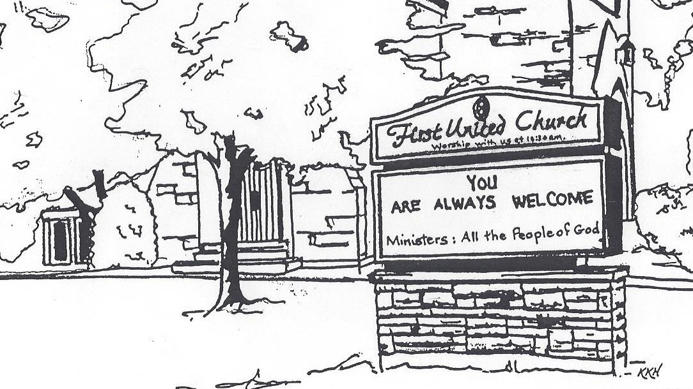

September 22, 2019 @ 10:30am

7 Curtis St., St.Thomas, ON N5P 1H3 Phone: (519) 631-7570
e-mail: office@1stunitedchurch.ca
web: www.1stunitedchurch.ca
MINISTERS: ALL THE PEOPLE OF GOD
Music Minister: Jody McDonald-Groulx
Secretary/Treasurer: Lori Hoffman
Custodian: Dave Luftenegger

Order of Service
* You are invited to stand if comfortable doing so

VU = Voices United MV = More Voices

We Gather to Worship
Prelude

Welcome and Announcements

Call to Worship: (in unison)
Listening God, we come in worship seeking Your presence in our lives. There is much around us that is contradictory to Your way of life for us. Many forces assail us, many things tempt us from knowing Your presence. Open our hearts to hear Your call; open our spirits to the power of Your voice crying for justice and peace, through the precious name of Jesus we pray.

Prayer of Confession: (in unison)
Loving God, You challenge us to be your faithful people.
You find us in our apathy and challenge us to enthusiasm.
You find us in our daily routine and challenge us to serve our neighbours.
You find us committed to the local church and challenge us to mission.
You find us rooted in familiar traditions and challenge us to fresh ways.
You find us in prayer and we are blessed. Amen.

Assurance of Pardon: (in unison)
We believe you will renew and enliven us, O God, and with our changed attitudes and determined action You will grant us pardon and peace. Amen.

We Hear the Word
First Scripture Reading: Acts 11: 25-30 (The disciples decided to provide help for the brothers and sisters living in Judea. This they did, sending their gift to the elders with Barnabas and Saul.)

Time with all God’s Children

Second Scripture Reading: Luke 10: 25-37 (The Good Samaritan: “Go and do likewise”.)

Reflection & CFGB Presentation: “Who is my Neighbour?”

We Respond
Ministry of Music : Senior Choir

Invitation to the Offering

*Sung Offertory Response:
God of love, hear our prayer, bless this offering we bring you.
May our lives do your will, guide and guard us forever.
Give us courage to stand for truth, help us give to others.
God of love, hear our prayer, bless this offering we bring you.

Prayers of the People and the Lord’s Prayer:
Our Father, who art in heaven, hallowed be thy name. Thy kingdom come, thy will be done, on earth as it is in heaven. Give us this day our daily bread. And forgive us our trespasses as we forgive those who trespass against us. And lead us not into temptation but deliver us from evil. For thine is the kingdom, the power, and the glory for ever and ever. Amen.

We Go Out into the World
*Hymn: VU#227 “For the Fruit of All Creation”

Commissioning and Benediction

Postlude & time for personal reflection:

Seek good, not evil, that you may live. Then the Lord God Almighty will be with you, just as you say he is. Hate evil, love good; maintain justice in the courts.

Let justice roll down like a river, righteousness like a never-failing stream!

(Amos 5: 14-15, 24)

Thank you to Helen Keenliside
for sharing her message with us this morning.

