First United Church
Seeking to be a welcoming community of Christian faith, proclaiming and celebrating the love of God in Jesus Christ through the Inspiration of the Holy Spirit

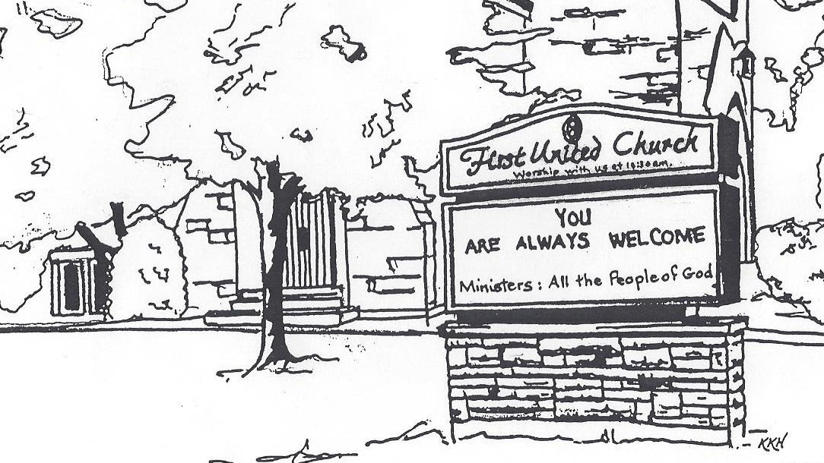

September 15, 2019 @ 10:30am

7 Curtis St., St.Thomas, ON N5P 1H3 Phone: (519) 631-7570
e-mail: office@1stunitedchurch.ca
web: www.1stunitedchurch.ca
MINISTERS: ALL THE PEOPLE OF GOD
Music Minister: Jody McDonald-Groulx
Secretary/Treasurer: Lori Hoffman
Custodian: Dave Luftenegger

Order of Service
* You are invited to stand if comfortable doing so

VU = Voices United MV = More Voices

Musical Prelude

Welcome

Choral Musical Prelude
- “That’s Why We Praise Him”
That’s why we praise Him, that’s why we sing
That’s why we offer Him our everything
That’s why we bow down and worship this King
‘Cause He gave His everything
‘Cause He gave His everything.

- MV#21 “Open Our Hearts”
Open our hearts, open our minds.
Open our lives to you, O loving God.
(Open our hearts)

Opening Prayer

Call to Worship:

Lighting of the Christ Candle
I am the light of world, you people come and follow me.
If we follow and love, we’ll learn the mystery
Of what we were meant to do and be.

Passing of the Peace (VU #958 “Halle, Halle, Halle”)
Musical Offering: Senior Choir
Welcome/Life and Work of the Church
Hymn of Praise: MV#122 “This is the Day”
Prayers of the People/The Lord’s Prayer
Hymn: VU#400 “Lord, Listen to Your Children Praying”
Conversation with the Young People
Children & Youth may leave for Church School

Offering Ourselves, Tithes & Gifts

Dedication Hymn: (tune “Eidelweiss”)
God of Love, hear our prayer. Bless this offering we bring you. May our lives do Your will; guide and guard us forever. Give us courage to stand for truth; help us give to others. God of Love, hear our prayer, Bless this offering we bring you.

Scripture Reading: Acts 3:1-10

Hymn of Preparation: VU#402 We Are One” (vv 1, & 2)

The Message: “Doing What You Can” Kevin Abell

Prayer

Hymn of Response: MV#221 “I Am Walking A Path of Peace”

*Commissioning/ Benediction
Closing - Sing: MV #209
Go make a diff’rence. We can make a diff’rence.
Go make a diff’rence in the world.
Go make a diff’rence. We can make a diff’rence.
Go make a diff’rence in the world.

* Musical Postlude

Thank you to Kevin Abell
for sharing his message with us today.

