First United Church
Seeking to be a welcoming community of Christian faith, proclaiming and celebrating the love of God in Jesus Christ through the Inspiration of the Holy Spirit

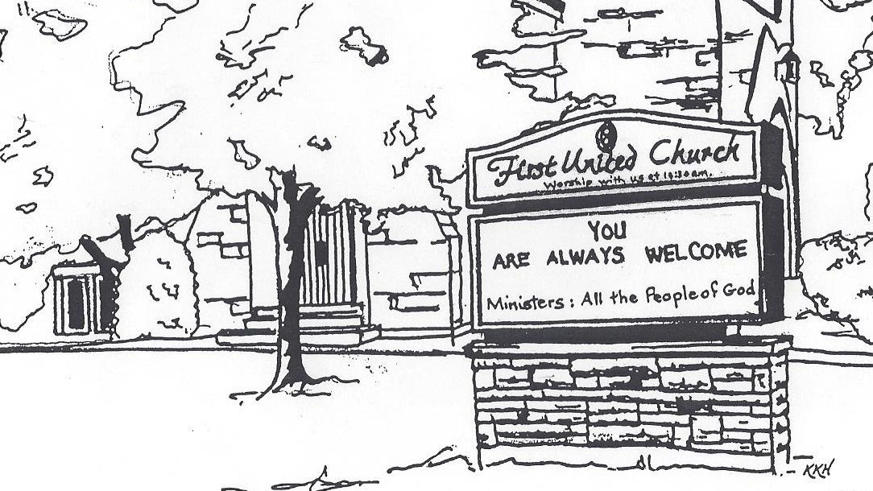

September 1, 2019 @ 10:30am
Communion

7 Curtis St., St.Thomas, ON N5P 1H3 Phone: (519) 631-7570
e-mail: office@1stunitedchurch.ca
web: www.1stunitedchurch.ca
MINISTERS: ALL THE PEOPLE OF GOD
Music Minister: Jody McDonald-Groulx
Secretary/Treasurer: Lori Hoffman
Custodian: Dave Luftenegger

Order of Service
* You are invited to stand if comfortable doing so

VU = Voices United MV = More Voices

Musical Prelude

Choral Prelude: MV#8 “And On This Path” (2x)
MV#18 “Lord, Prepare Me” (2x)

Opening Prayer

Call to Worship
One: Come! Come and worship,
you who woke early and you who slept late;
you who come often, and you who don’t.
ALL: Whether we are first or last or somewhere in between,
there is room for all of us in God’s kingdom,
and more than enough grace to go around.
One: Let’s worship God together!

Lighting of the Christ Candle
I am the light of world, you people come and follow me.
If we follow and love, we’ll learn the mystery
Of what we were meant to do and be.

Passing of the Peace (VU #958 “Halle, Halle, Halle”)
Welcome/Life and Work of the Church
Hymn of Praise: MV#175 “This Is The Day”
Prayers of the People/The Lord’s Prayer

Holy Sacrament of Communion
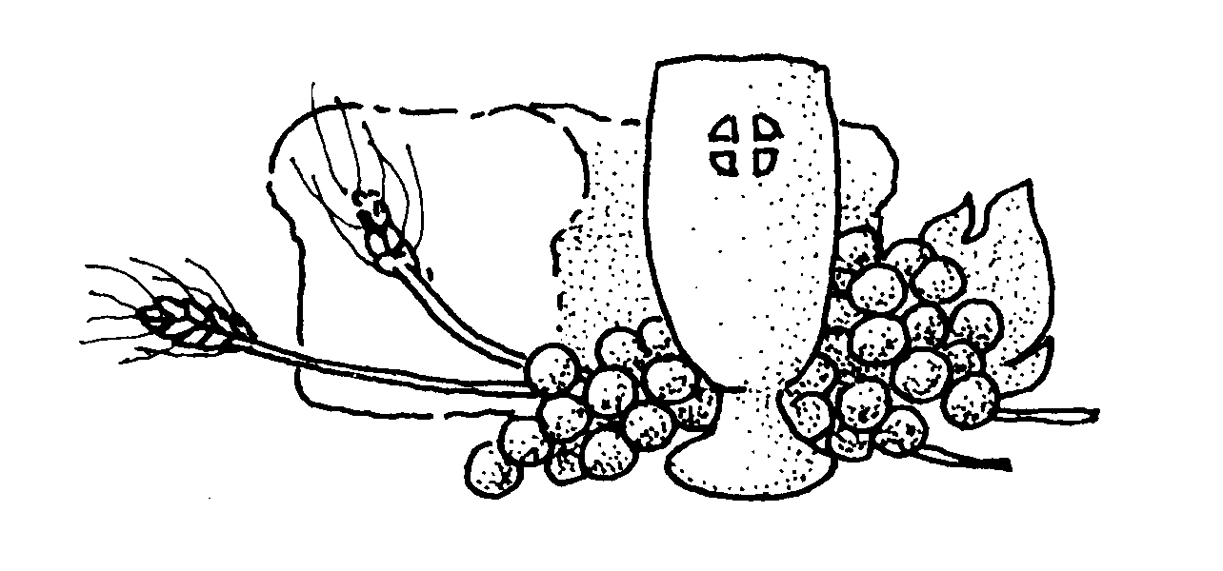
Minister: The peace of Christ be with you.
People: And also with you.

Words of Institution:
When we drink from the cup at this Holy Table, and when we give thanks to God, we are sharing the blood of Christ. And when we eat the bread we break, we are sharing the body of Christ. Because this is one loaf of bread, all of us – though many – are one body, because we all share the same loaf. (1 Corinthians 10: 16 – 17)

Invitation:
All those who have confessed their faith in Christ and are members of a Christian church are welcome at this Holy Table. Come, for all things are now ready.

Communion Hymn MV#195 “Long Ago and Far Away”

Prayer of the Veil: (Said by All)
Almighty and most merciful God, out of the fullness of your gifts, we offer this bread and this cup. Blessed be your Holy Name forever. Most righteous God, we remember in this Supper the perfect sacrifice offered once on the cross by Christ our Saviour for the sin of the whole world. In the joy of his resurrection and in the expectation of his coming again, we offer ourselves to you as living sacrifices. Send your Holy Spirit upon us we pray, that the bread we break and the cup we bless may be to us the communion of the body and blood of Christ. Grant that, being joined together in him, we may attain unity of the faith and grow in all ways toward Christ.

Silent Prayer

The Breaking of Bread:
On the same night he was handed over, Jesus took bread, and when he had given thanks, he broke it and said, “Take, eat. This is my body which is broken for you. Do this in remembrance of me.”
In the same manner, he took the cup after they had eaten, saying, “This is the new testament in my blood. As often as you do this, drink it in remembrance of me.”

The Distribution: (The elements will be distributed)
“The body of Christ broken for you. Take and eat in remembrance that Christ died for you and give thanks.”
“The blood of Christ shed for you. Drink and be thankful.”

Thanksgiving Prayer:
One: For the bread we have eaten. For the wine we have tasted.
We offer thanks.
All: Grant that what we have said and done and have been
given here, may put its mark upon us, so that it will always
remain with us. Grant that we may become mature
Christians, and that ours may be a faith which initiates
action, in the name of Christ, we pray. Amen.

Conversation with the Young People Children may leave for the Activity Room

Offering Ourselves, Tithes & Gifts
Dedication Hymn: (tune “Eidelweiss”)
God of Love, hear our prayer. Bless this offering we bring you. May our lives do Your will; guide and guard us forever. Give us courage to stand for truth; help us give to others. God of Love, hear our prayer, Bless this offering we bring you.

Scripture Readings: Matthew 20:1-16
Hymn of Preparation: VU#356 “Seek Ye First
The Message: “Life in the Upsidedown Kingdom:
Starting at the End” Rev. John Gould

Hymn of Response: VU#481 “Sent Forth By God’s Blessing”
*Commissioning/ Benediction
Closing - Sing: MV #209
Go make a diff’rence. We can make a diff’rence.
Go make a diff’rence in the world.
Go make a diff’rence. We can make a diff’rence.
Go make a diff’rence in the world.
* Musical Postlude

