First United Church
Seeking to be a welcoming community of Christian faith, proclaiming and celebrating the love of God in Jesus Christ through the Inspiration of the Holy Spirit
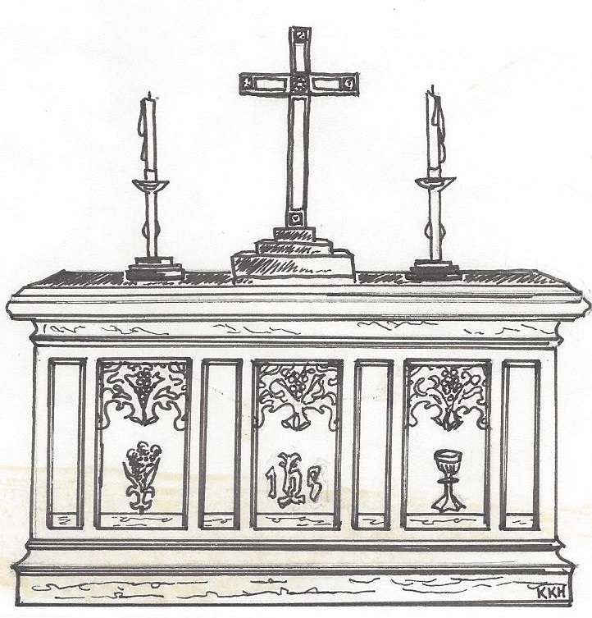

Communion Sunday
September 02, 2018 @ 10:30am

7 Curtis St., St.Thomas, ON N5P 1H3 Phone: (519) 631-7570
e-mail: office@1stunitedchurch.ca
web: www.1stunitedchurch.ca
MINISTERS: ALL THE PEOPLE OF GOD
Pastoral Minister: Rev. Emmanuel K. Ofori
Music Minister: Jody McDonald-Groulx
Secretary/Treasurer: Lori Hoffman
Custodian: Dave Luftenegger

15th Sunday of Pentecost
CELEBRATION OF HOLY COMMUNION
Sunday, September 02, 2018 - 10:30 a.m. Worship
Preacher: Rev. Emmanuel K. Ofori

Notes: Asterisk (*) – You may stand if comfortable doing so
VU = Voices United MV = More Voices

God Gathers Us Together

Musical/Choral Prelude
- VU#467 “One Bread, One Body”
One bread, one body, one Lord of all,
one cup of blessing which we bless;
and we, though many, throughout the earth,
we are one body in this one Lord.

- MV#18 “Lord Prepare me”
Lord prepare me, to be a sanctuary,
pure and holy, tried and true.
With thanksgiving, I’ll be a living
sanctuary for you.

Lighting of the Christ Candle

Life and Work of the Church [see pages 6 & 7]

Welcoming of Visitors

God Draws Us Near To Worship

Call to Worship: VU#78 (Psalm 45)

Prayer of Thanksgiving & Intercession
The Lord’s Prayer (VU #960)

God Invites Us To Listen For His Word

Gospel Reading: Mark 7:1-16
Reader: This is the Gospel of Christ
All: We praise You, O Christ

* Hymn of Preparation: VU # 672 “Take Time to Be Holy”
The Message: “Striving for Inner Beauty”

God Invites Us To Respond To His Love
Offertory
Hymn of Dedication (Doxology)
Praise God from whom all blessings flow;
Praise God, all creatures high and low;
Give thanks to God in love made known:
Creator, Word and Spirit One.

Offertory Prayer
God Invites Us To Break Bread Together

Communion Hymn: MV#195 “Long Ago and Far Away”

The Lord be with you.

And also with you

Lift up your hearts

We lift up our hearts unto the Lord

Let us give thanks to God

It is good and pleasant to give God thanks and praise

It is a good and pleasant thing, our joy and our moral duty, always and everywhere to give you thanks and praise, O Lord, God, ever-loving and ever-blessed, Almighty and all-loving.

Therefore, with angels and archangels, and with all the heavenly host, we join in the blessed hymn of everlasting praise saying …
Holy, holy, holy,
LORD God of hosts,
heaven and earth are full of your glory.
Hosanna in the highest.
Glory be to you, O Lord, most high. Amen.

*Affirmation of Faith: A New Creed
We are not alone,
we live in God's world.
We believe in God:
who has created and is creating,
who has come in Jesus,
the Word made flesh,
to reconcile and make new,
who works in us and others
by the Spirit.
We trust in God.
We are called to be the Church:
to celebrate God's presence,
to live with respect in Creation,
to love and serve others,
to seek justice and resist evil,
to proclaim Jesus, crucified and risen,
our judge and our hope.
In life, in death, in life beyond death,
God is with us.

We are not alone.

Thanks be to God.

The Institution
Blessed are you, Lord God, King of the universe, and blessed is your Son Jesus Christ our Lord; who on the night He was betrayed and arrested He turned to His disciples and said,
All: “I give you a new commandment, that you love one another. Just as I have loved you, you also should love one another. By this everyone will know that you are my disciples, if you have love for one another”.

Then Christ took bread and looking up to heaven gave thanks, broke it and gave it to His disciples, saying,
All: “Take this and eat it. This is my body given for you. Do this in remembrance of me.”

In the same way after Supper He took the cup, gave thanks and gave it to them saying,
All: “Drink from it, all of you. This is my blood of the new covenant poured out for you and for many for the forgiveness of sins. Do this whenever you drink it in remembrance of me.”

Therefore, let us proclaim the mystery of our faith …
All: Jesus Christ has died

Jesus Christ is risen

Jesus Christ will come again

For deep in my heart, I do believe

That Jesus Christ will come again

(Sung to tune: “We Shall Overcome” Traditional – arranged by compilers)

Prayer of Consecration
Invitation & Distribution of Elements
Prayer of Thanksgiving

God Sends Out Into the World to Serve

*Closing Hymn: MV#209 “Go Make A Diff’rence”
* Benediction
*Sending Forth
Threefold Amen
* Musical Postlude
TODAY’S MESSAGE
Charm is deceptive, and beauty is fleeting; but a woman [man] who fears the LORD is to be praised” (Proverbs 31:30)

“Beauty? Let me tell you something … Beauty is essentially meaningless, and it is always transitory” (Actress Halle Berry, one of People Magazine’s most beautiful people).

If “beauty is fleeting” or “always transitory”, then what is true beauty? In the era of cosmetics, true beauty comes from within the person and Scripture teaches us to strive for inner beauty because there is

- Power of Inner Beauty to Strengthen Us
- Inner beauty has the power to draw others to Christ through us
- Outward beauty and human traditions tend to drive people away from Christ.
Human traditions take credit which is due the Lord alone.
- Plan of Inner Beauty to Guide Us
Take time to be holy (see Voices United #672)
- Speak oft with the Lord – PRAYER
- Feed on His word – PERSONAL DEVOTION
- Make friend of God’s children – FELLOWSHIP with believers
- Pattern of Inner Beauty for Others to Emulate
We are called to be examples to others.

Think about this:
Most of the time we allow human traditions come between you and the Word of God.
As we stay the Word, the Spirit of Christ will refine our nature till the beauty of Christ be seen is us

Let us pray:
My Jesus, I love Thee, I know Thou art mine
For Thee all the follies of sin I resign;
My gracious Redeemer, My Saviour art Thou
If ever I loved Thee, My Jesus, ‘tis now.

LIFE & WORK OF THE CHURCH
September 2, 2018

Happy birthday this week to: Doug Whiteman, Madison Chute.

TODAY: *Faith Activity Room for children 4 & up in the Music Room.
*Join us in the Fellowship Room for refreshments following the worship service!

Upcoming Dates & Events
If you’d like to volunteer (starting in September) to MAKE & SERVE COFFEE following Sunday worship please call Ruth Zions @ 226-289-3055.

Next Sun., Sept. 9 – RALLY DAY @ FIRST CHURCH (see next peage)

Tues., Sept. 11 - OFFICIAL BOARD MEETING @7pm in the Music Room

Thurs., Sept. 13 - SENIOR CHOIR @ 7:30pm! Don’t be shy – singing’s great for the soul – come and give it a try!

Sun., Sept. 16 – WORSHIP @ 10:30am
CHURCH SCHOOL RESUMES! Then it’s Make Your Own Sundaes in the Assembly Hall following worship!

Next week!
Sunday, Sept. 9

RALLY DAY

A TIME TO RALLY TOGETHER AFTER THE SUMMER!

We’ll all be in worship together
younger and older alike
because that’s who we are!

Then, following worship

STAY FOR A

HOT DOG / HAMBURGER

LUNCH!!

Come & catch up with First Church Family & Friends!
Everyone Welcome!
Bring a Friend!!!

