First United Church
Seeking to be a welcoming community of Christian faith, proclaiming and celebrating the love of God in Jesus Christ through the Inspiration of the Holy Spirit

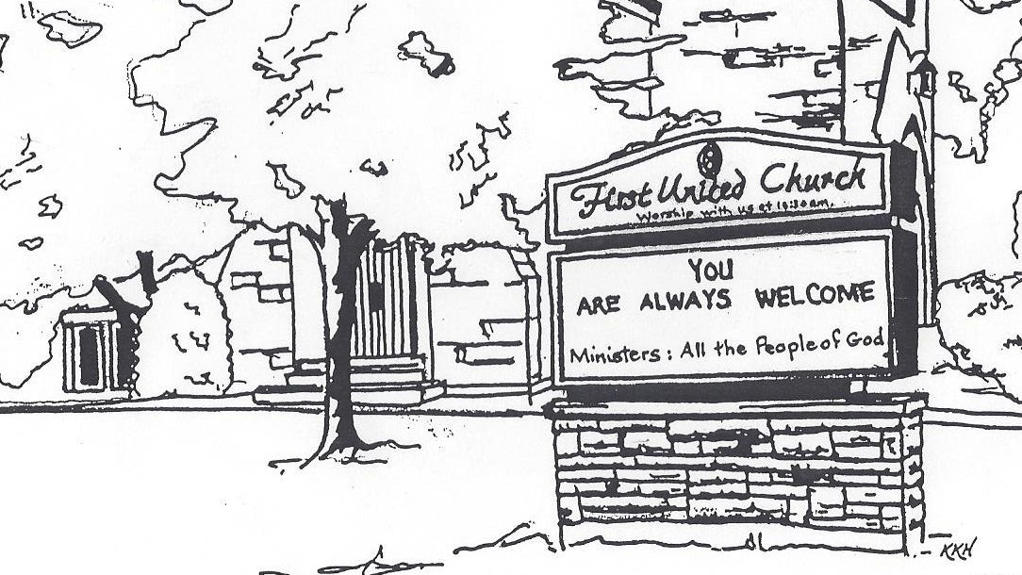

October 27, 2019 @ 10:30am

7 Curtis St., St.Thomas, ON N5P 1H3 Phone: (519) 631-7570
e-mail: office@1stunitedchurch.ca
web: www.1stunitedchurch.ca
MINISTERS: ALL THE PEOPLE OF GOD
Music Minister: Jody McDonald-Groulx
Secretary/Treasurer: Lori Hoffman
Custodian: Dave Luftenegger

Order of Service
* You are invited to stand if comfortable doing so

VU = Voices United MV = More Voices
Musical Prelude
Welcome
Choral Musical Prelude
- “Bless the Lord…” (2x)
Bless the Lord, O my Soul,
O my Soul
Worship His holy name,
Sing like never before
O my Soul
I’ll worship your holy name.

- “Trust In You” (2x)
When you don’t move the mountains, I’m needing you to move
When you don’t part the waters, I wish I could walk through
When you don’t give the answers, as I cry out to you
I will trust, I will trust, I will trust in you.

Opening Prayer

Call to Worship
One: Sisters and brothers,
enter into this space together to worship the Holy One.
Let us rejoice, for God offers us freedom through our Lord Jesus Christ, gives us the Spirit to be children of God
and to live free from fear and of insignificance.
All: We come to walk with Jesus;
the same way Jesus walked down the streets of Jerusalem
and throughout the countryside.
We come to remember the simple act of walking
as defiance against oppression,
and the simple act of writing
as calling attention to injustice;
each creates the peace and love that Jesus teaches us.
God we come!

Lighting of the Christ Candle
I am the light of world, you people come and follow me.
If we follow and love, we’ll learn the mystery
Of what we were meant to do and be.

Passing of the Peace
Sing: Halle, Halle, Halle, lu jah! Halle, Halle, Halle, lu jah!
Halle, Halle, Halle, lu jah! Halle lu jah! (clap) Halle lu jah!

Musical Offering: Senior Choir

Life and Work of the Church

Prayer/The Lord’s Prayer

Hymn: MV#122 “This Is the Day”

Conversation with the Young People: Children/Youth may go to Church School

Offering Ourselves, Tithes & Gifts
Dedication Hymn: (tune “Eidelweiss”)
God of Love, hear our prayer. Bless this offering we bring you. May our lives do Your will; guide and guard us forever. Give us courage to stand for truth; help us give to others. God of Love, hear our prayer, Bless this offering we bring you.

Scripture Reading: Exodus 14:10-16

The Message: “Just One More Step” Roxanne Bale

Hymn: VU#639 “One More Step Along the World I Go”

*Commissioning/ Benediction
Closing - Sing: VU #298
When you walk from here, when you walk from here,
Walk with justice, walk with mercy, and with God’s humble care.

* Musical Postlude
The Life & Work of the Church – October 27

Thank you to Roxanne Bale for sharing her message with us today.

Thank you to everyone who attended our Boston Pizza Fundraiser!
$470 was raised for the General Fund!

Looking for Board Members:
The church requires many hours of volunteer work to make it run smoothly. If you are able to serve or know of someone who would be good to serve on our Official Board please talk to an existing member of the Board, or Lori in the church office.

This week:

Tuesday - *EarlyON Playgroup 9:30-11:30am in the Gym

*First Youth Group - 7-8:15pm

Thursday - *Pathfinders / Rangers Group meets at 7pm

*Senior Choir practice @ 7:30pm

Upcoming Dates & Events
*Holly Fair & Vendor Market: Saturday, November 9 from 9am to noon (please note the change in date). At the 2019 Holly Fair we have decided to open up some of our space to host a Vendor Market!! We will still have our own amazing areas: Attic Treasures, Bake Table, Book Room, Cafe, Crafts & Holiday Entertaining (so we're still counting on your donations First Church Friends!!! (See our website for the wish list!) but we will be opening up space to some of your favourite Vendors just in time for Christmas Shopping!! MARK YOU CALENDARS for this ONE STOP SHOPPING Opportunity!
If you are a Vendor (Artisan or Direct Sales) we invite you to submit an application to be part of this event (available in the church office or on our website)! Our Holly Fair is a VERY well attended annual event - with people lined up at the door waiting to get in! So get your applications in asap so you don’t miss out on this opportunity.
*We will only be accepting one of each Direct Sales Vendors and will try to keep Vendors with similar items to a maximum of 2.
*Knox Presbyterian Church presents “The Sounds of Silents” on Saturday, November 9 @ 7pm - You are invited to a night at the movies featuring Martin Anderle on the Knox organ and grand piano. We will be watching a silent Laurel and Hardy movie as it was originally enjoyed, accompanied by live improvisational organ music. Then, a tribute to Canada with images from sea to sea by local photographers, accompanied by original piano music. FREE WILL offering with all proceeds going to the St. Thomas Inn out of the Cold. Dessert to follow.

Wednesday, November 13 – Chalk Couture Sign Night! Come out for a fun night and learn how to make Chalk Creations!
COST: $40/sign ($5/sign donated to church)
Includes 9x12” white frame & all supplies (transfer paper, chalk paint, etc)
Choose ONE design - First Come-First Served (only one person per design) Designs are available to be viewed on our facebook page under the 'Discussion Tab' in the event!
Contact Erin Chute to sign up! erinchute@hotmail.com or 519-615-9918
Check out their website: https://www.chalkcouture.ca/creativechalks

*Cocoa, Cookies & Caroling – immediately following the Santa Claus Parade (which First will have a float in again this year! Theme: Super Heroes!). We hope to have as many First Church Friends – and THEIR Friends in attendance as possible! Please plan to attend!! This was a fantastic, fun evening last year! Also, if you are interested in riding on the float/helping with the float, please contact Justin Chute @ 519-521-4723.

We need your help to know who is sick, in hospital
or just wishing a visit. Please let Lori know in the
Church Office at 519-631-7570 ext 21. Thank you!

2020 PAR CHALLENGE

We all know the members of First United love a good challenge - and always come through! The Finance Committee is issuing a 2020 PAR challenge to the congregation, and the good news is, you don’t need to be a golfer to participate!

What is PAR?
It stands for Pre-Authorized Remittance – or monthly automated contributions to the church. On the 20th of each month, money will automatically come out of your bank account and go towards the General Fund of our church. You also have the option of using your Visa or MasterCard. No cheques to write, no envelopes needed.

How do I sign up?
Signing up is easy! Simply obtain a PAR authorization form from the office or our website and fill it out. You will need either a void cheques or a credit card number. You can change or cancel the contribution at any time. You can also sign up through PayPal on our church’s website.

What’s the challenge?
Currently we have 28 members on PAR with total monthly contributions to the General Fund of $2874. Our challenge is by January 1st of 2020 to have 40 members and $4000 of monthly contributions to the General Fund. If you have not signed up, please consider doing so. If you have signed up, please consider increasing your contributions if you are able.

What about the Offering?
The offering is an important part of our Worship Service. We have cards available in the pews for those on PAR that can be placed in the offering plate. You can also consider donating a portion of your annual contributions by PAR, and still use your envelopes.
What are the benefits of PAR?
PAR allows for a regular, dependable flow of contributions to the church. It makes it easier for the church to budget and meet its monthly expenses. It also means continued support for our church, even if you are unable to be there every week. In addition, it makes supporting your church easier for you! Please consider signing up today!

⁶ Remember this: Whoever sows sparingly will also reap sparingly, and whoever sows generously will also reap generously. ⁷ Each of you should give what you have decided in your heart to give, not reluctantly or under compulsion, for God loves a cheerful* giver. 2 Corinthians 9:6-8

*Remember, here at First, we love grumpy givers too!!

From the Finance Committee
Update
In order to meet our Financial Obligations at First Church
we need, on average and excluding fundraising, $4,400 in General Fund Givings EVERY WEEK.

Last week our General Fund Givings were $1,647.00

This represents a shortfall for the week of $2,753.00

Year to Date Update (as at September 30/19)
YTD Amount Needed to Meet Obligations: $176,000

YTD Actual General Fund Givings: $84,090

This represents a YTD shortfall of $91,910

Our Current Financial Position is a Net Operating Loss of $83,052

Misc. Info
Revenue from Fundraising Projects to date: $7,278

Monthly General Fund PAR Givings $2,874

For more information, contact Don Renaud or Lori in the church office.

