First United Church
Seeking to be a welcoming community of Christian faith, proclaiming and celebrating the love of God in Jesus Christ through the Inspiration of the Holy Spirit

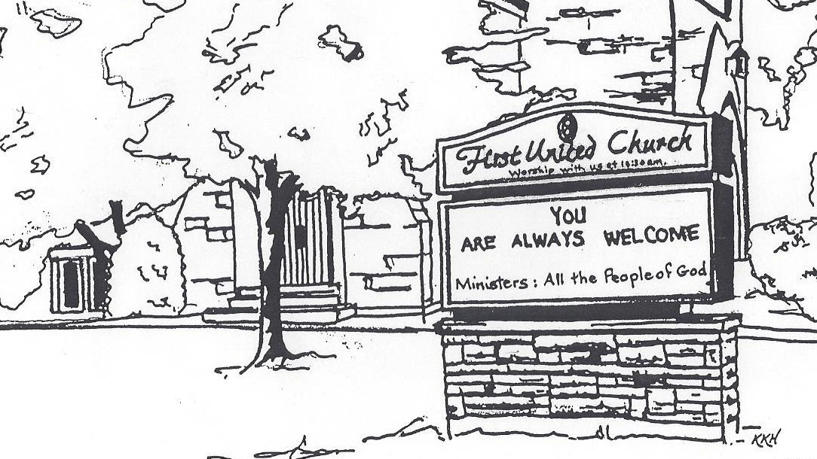

Thanksgiving
October 13, 2019 @ 10:30am

7 Curtis St., St.Thomas, ON N5P 1H3 Phone: (519) 631-7570
e-mail: office@1stunitedchurch.ca
web: www.1stunitedchurch.ca
MINISTERS: ALL THE PEOPLE OF GOD
Music Minister: Jody McDonald-Groulx
Secretary/Treasurer: Lori Hoffman
Custodian: Dave Luftenegger

Order of Service
* You are invited to stand if comfortable doing so

VU = Voices United MV = More Voices

Musical Prelude

Welcome

Choral Musical Prelude
- “Bless the Lord…” (2x)
Bless the Lord, O my Soul,
O my Soul
Worship His holy name,
Sing like never before
O my Soul
I’ll worship your holy name.

- “Awesome God” (2x)
Our God is an awesome God
he reigns from heaven above
With wisdom, power and love
our God is an awesome God.

Opening Prayer
Good and gracious God, today we pause and give you thanks for the many blessings we have received in our lives. So often we take for granted how truly blessed and gifted we are, give us hearts that are open to your healing word and your many blessings. Make us true believers in the power of your Word and give us the strength and courage to be generous followers of your Son, Jesus. This we ask in your name. Amen.

Call to Worship
One: The Creator has gathered us to this place.
All: We open our hearts to hear the word of God.
One: The Christ summons us to this place.
All: Where we can learn how to serve God without reservation or hesitation.
One: The Spirit will send us from this place.
All: Where we can put our faith into action, and be true believers
and leaders of the faith through our word and deed.

Lighting of the Christ Candle
I am the light of world, you people come and follow me.
If we follow and love, we’ll learn the mystery
Of what we were meant to do and be.

Passing of the Peace
The Peace of Christ be with you.
Response: And also with you!
Sing: Halle, Halle, Halle, lu jah! Halle, Halle, Halle, lu jah!
Halle, Halle, Halle, lu jah! Halle lu jah! (clap) Halle lu jah!

Musical Offering: Senior Choir
Life and Work of the Church
Hymn of Praise: VU#245 “Praise the Lord with the Sound of Trumpet”

Prayer/The Lord’s Prayer
Hymn: MV#51 ”Yaweh Be Praised”

Conversation with the Young People: Sarah Muma
Children & Youth may leave for Church School

Offering Ourselves, Tithes & Gifts: Duet: “Grateful” Lori & Rachel

Dedication Hymn: (tune “Eidelweiss”)
God of Love, hear our prayer. Bless this offering we bring you. May our lives do Your will; guide and guard us forever. Give us courage to stand for truth; help us give to others. God of Love, hear our prayer, Bless this offering we bring you.

Scripture Reading: Luke 17:11-19

The Message: Father Mark Sargent

Hymn: VU#240 “Praise my Soul, the God of Heaven”

*Commissioning/ Benediction
Closing - Sing: VU #298
When you walk from here, when you walk from here,
Walk with justice, walk with mercy, and with God’s humble care.

* Musical Postlude

Thank you to Father Mark Sargent
for sharing his message with us today and
thank you to Dr. Wayne Carroll for sharing on the organ.

The Life & Work of the Church – October 13
Happy Anniversary to: Sharlene & Bob Scott, Murray & Tracey Medhurst, Wayne & Brenda Smith.

Thank you to everyone who participated in our Epicure Fundraiser!

$236 was raised for the General Fund. If you missed out we will be hosting another Epicure Fundraiser at the Holly Fair in November! (You can contact Erin Chute (erinchute@hotmail.com) or Liza Visser (lizamikevisser@gmail.com) for more information (or to order!!)

This week:

Monday – Thanksgiving Monday – Church Office Closed

Tuesday - *EarlyON Playgroup 9:30-11:30am in the Gym

*First Youth Group - Bowling at Park N Bowl 7-8pm
*Finance Committee Meeting @ 6:30pm in the Fellowship Room
*Official Board Meeting @ 7pm in the Music Room (Please note change in date)

Wednesday – *Sorting for Rummage Sale @ 9am. If you can spare an hour or two come out and help

Thursday - *Pathfinders / Rangers Group meets at 7pm

*Senior Choir practice @ 7:30pm

Saturday - Sat., Oct. 19 – *Rummage Sale 8:30 – 11:30 am
Donations of gently used fall and winter clothing for all ages needed! Send along your extra special ladies clothing for our Ladies Boutique room. Looking for fall and Christmas home decor, knic knacs, pictures, china, glassware, bedding, towels, luggage, small appliances but please no microwaves, computers or TVs. Childrens and adult books, puzzles and games are needed as well. Remember toys toys toys for all ages!
Please bring your donations to the west accessibility door Mon-Thurs 9am-2:30pm. Call Lois W. 519-631-3337 to help sort, price or work sale day. ALSO – NEW THIS YEAR – We will be having a Bake Sale at the Rummage Sale!! Donations of Bake goods are needed!! Please contact Lois W for drop off times. Thankyou!

Upcoming Dates & Events
Mon., Oct. 21 – *Once again, First Church is hosting a Boston Pizza Night! A great ‘fun’raiser for the church. Cost is $20 per person –
but $10 of that comes back to the church. An opportunity to
visit and best of all – NO CLEAN UP! THE BUFFET includes: Pizza, Pasta and Caesar Salad (drinks not included) There will be DOOR PRIZES too! So be sure to write your name on the back of the ticket before you turn it in at the restaurant. Tickets will be drawn that night! Children can order from the ‘Children’s menu” instead of paying $20 for each child. Bring a friend or two! It’s a great & affordable evening out!
Tickets are available from the office!

*Holly Fair & Vendor Market: Saturday, November 9 from 9am to noon (please note the change in date). At the 2019 Holly Fair we have decided to open up some of our space to host a Vendor Market!! We will still have our own amazing areas: Attic Treasures, Bake Table, Book Room, Cafe, Crafts & Holiday Entertaining (so we're still counting on your donations First Church Friends!!! (See our website for the wish list!) but we will be opening up space to some of your favourite Vendors just in time for Christmas Shopping!! MARK YOU CALENDARS for this ONE STOP SHOPPING Opportunity!
If you are a Vendor (Artisan or Direct Sales) we invite you to submit an application to be part of this event (available in the church office or on our website)! Our Holly Fair is a VERY well attended annual event - with people lined up at the door waiting to get in! So get your applications in asap so you don’t miss out on this opportunity.
*We will only be accepting one of each Direct Sales Vendors and will try to keep Vendors with similar items to a maximum of 2.
Note: we are hosting our own Epicure Fundraiser at the event this year
to benefit the Church so we will not be accepting an Epicure Vendor for this event. Thank you for understanding.
We need your help to know who is sick, in hospital
or just wishing a visit. Please let Lori know in the
Church Office at 519-631-7570 ext 21. Thank you!

