First United Church
Seeking to be a welcoming community of Christian faith, proclaiming and celebrating the love of God in Jesus Christ through the Inspiration of the Holy Spirit

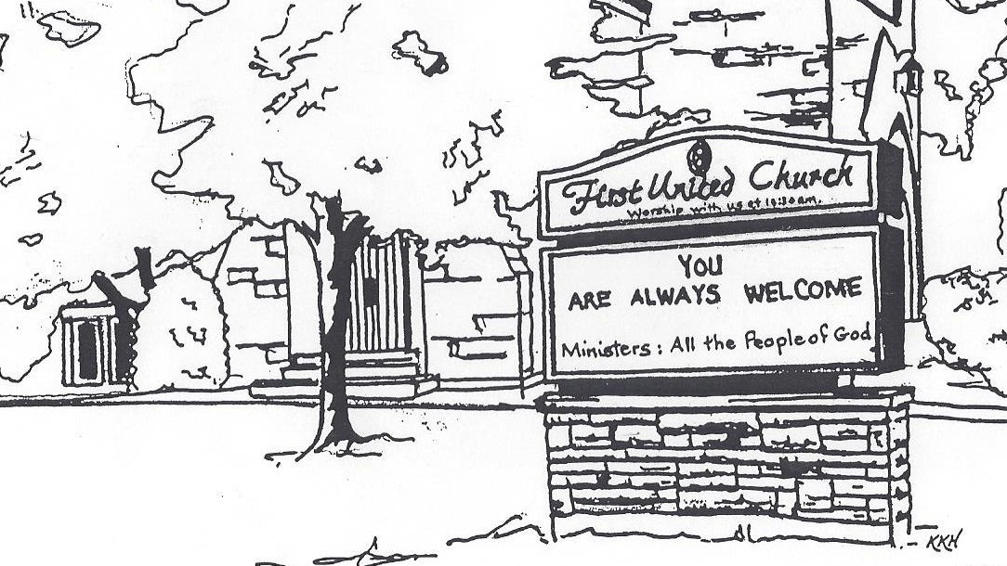

November 24, 2019 @ 10:30am

7 Curtis St., St.Thomas, ON N5P 1H3 Phone: (519) 631-7570
e-mail: office@1stunitedchurch.ca
web: www.1stunitedchurch.ca
MINISTERS: ALL THE PEOPLE OF GOD
Intentional Interim Minister: Rev. Daryl Webber
Music Minister: Jody McDonald-Groulx
Secretary/Treasurer: Lori Hoffman
Custodian: Dave Luftenegger

Order of Service
* You are invited to stand if comfortable doing so

VU = Voices United MV = More Voices

Musical Prelude

Welcome

Choral Musical Prelude
- “Bless the Lord…” (2x)
Bless the Lord, O my Soul,
O my Soul
Worship His holy name,
Sing like never before
O my Soul
I’ll worship your holy name.

- MV#18 “Lord, Prepare Me” (2x)
Lord, prepare me to be a sanctuary, pure and holy tried and true
With thanksgiving, I’ll be a living sanctuary for you.

Call to Worship
One: Raise our eyes,
All: and you are there.
One: We look to the heavens,
All: and you are there.
One: We look to each other,
All: and you are there.
One: We look inside,
All: and you are there.
no matter where we go God,
you are there. Always. Forever. Alleluia!
One: We gather here with you.
All: Let us Worship. Richard Bott – Moderator of UCC

Lighting of the Christ Candle
I am the light of world, you people come and follow me.
If we follow and love, we’ll learn the mystery
Of what we were meant to do and be.

Opening Prayer
One: Great strength of community,
for our community of faith
we bless you.
All: For the opportunity of our “now”
and for being participants in Your work here on earth
we are grateful.
For this present community,
whose strength is ancient and evolving in each of us here,
we are thankful.
We are strengthened by Your church here.
One: From here You steep our minds in Christ’s ways of justice.
From here we learn of Christ’s power
and pray to follow such a sacred and invitational way of life as his.
All: From here we must happen upon mercy,
And learn too, to inherit the earth, and its people.
One: From here our community encourages us with the wisdom,
that Spirit gives each generation.
All: From our church-family-imprint
We grow to listen and love our neighbours honestly and joyfully.
One: And we gain humility to pray for our enemies here
to reach our with open hands instead of clenched fists.
From the vantage paint of this Sabbath here,
we will be reflecting together and honing our lives,
as followers of the One who strengthens community.
All: May it be as such, O Source of our Strength. (Daryl Webber 2018)

Passing of the Peace
Sing: Halle, Halle, Halle, lu jah! Halle, Halle, Halle, lu jah!
Halle, Halle, Halle, lu jah! Halle lu jah! (clap) Halle lu jah!

Musical Offering: Senior Choir

Life and Work of the Church

Prayer/The Lord’s Prayer

Hymn: MV#30 “It’s a Song of Praise to the Maker” (Chorus Only)
And by the Spirit you and I
can join our voice in the holy cry
and sing, sing, sing to the Maker too. (2x)

Conversation with the Young People:
Children/Youth may go to Church School

Offering Ourselves, Tithes & Gifts

Dedication Hymn: (tune “Eidelweiss”)
God of Love, hear our prayer. Bless this offering we bring you. May our lives do Your will; guide and guard us forever. Give us courage to stand for truth; help us give to others. God of Love, hear our prayer, Bless this offering we bring you.

Scripture Readings: Micah 6:6-8
Matthew 13: 24-30

The Message: “Different Voices” Rev. Daryl Webber

Hymn: VU#701 “What Does the Lord Require of You”

*Commissioning/ Benediction
Closing - Sing: MV #209
Go make a diff’rence. We can make a diff’rence.
Go make a diff’rence in the world.
Go make a diff’rence. We can make a diff’rence.
Go make a diff’rence in the world.

* Musical Postlude

The Life & Work of the Church – November 24
We invite you to join us for a Spaghetti Lunch,
downstairs following worship! Also, we will be having a Mini Bazaar during the lunch! Cash, Debit & Credit accepted!

Coffee servers are needed! Please sign up on the chart in the Fellowship room if you are able to help! It's greatly appreciated.

Looking for Board Members:
The church requires many hours of volunteer work to make it run smoothly. If you are able to serve or know of someone who would be good to serve on our Official Board please talk to an existing member of the Board, or Lori in the church office

Happy birthday to: Clark Renaud.

*SECRET SANTA bags marked girl or boy and an age are available in the corner of the Sanctuary for you to take home. Bags need to be returned to the Sanctuary BY Gift Sunday, Dec 8. Helpful Hints: Please don’t gift wrap. Feel free to buy more than one of the same gift. Our gifts will be distributed by CHRISTMAS CARE along with their annual Christmas FOOD HAMPERS. We welcome gifts of non-perishable food items to help fill the hampers, also on Sunday. Dec. 8th This year we will also be collecting SOCKS for Grace Café. There is a huge need for Men’s, Women’s and children’s socks! Please keep these separate from your Secret Santa Bags. There will be a basket to collect your Sock donations. Our Ivor Fund supports Grace Café each year as well!

This week:

Monday - *Official Board Meeting @ 7pm in the Music Room

Tuesday - *EarlyON Playgroup 9:30-11:30am in the Gym
**The Youth Group will be Volunteering for the Salvation Army Kettle Drive again this year. They will be accepting donations at both entrances of the St. Thomas Walmart on Tuesday, November 26 from 6-8pm. If anyone would like to join them, they’d love to have you – contact Justin Chute

Thursday - *Senior Choir practice @ 7:30pm
NEXT SUNDAY
ADVENT 1 CELEBRATION
NEXT Sunday, December 1

IN THE MORNING….
AS YOU ENTER THE SANCTUARY
you will be offered an ornament to hang on the Christmas tree.

MUSIC FILLED WORSHIP
Soloists and the Senior Choir will present Christmas music as the congregation joins in the singing of traditional Christmas carols.

HOT CHOCOLATE will be served by the Youth Group following worship.
Proceeds will go toward Youth Outreach Programs

IN THE EVENING…
*Lessons & Carols Choral Celebration @ 7pm
Join us for a night of music featuring 8 local choirs! Belmont Community Choir, Central United Church, Centre St Baptist Church, First United Church, Knox Presbyterian Church, "Lunch Bunch", Port Stanley Community Choir, St. Hilda-St. Luke's Anglican Church. Freewill offering. Proceeds to The St. Thomas-Elgin Food Bank & First United. All welcome!

Upcoming Dates & Events
Wednesday, December 4 - *We're hosting our first ever Quarter Auction at the church and would be happy if you could join us for the night. Doors open at 6p.m. Auction starts at 7:00 p.m.
For more info, please contact Teresa at tl.turvey@gmail.com.

Saturday, December 7: *Annual Hat and Mitt Run – Everyone welcome! Join us for a nice leisurely run/walk (5 or 10 km) a visit and of course, treats afterwards! We are asking everyone to knit hats & mitts (or buy new) to donate to local groups in need.
When & Where: Saturday, December 7 at 8 am - First United Church
Entry Fee: Hat & Mitts for local groups in need
For more info call or email Carolyn Johnson 519-318-3386 or johnsongirltris@bell.net
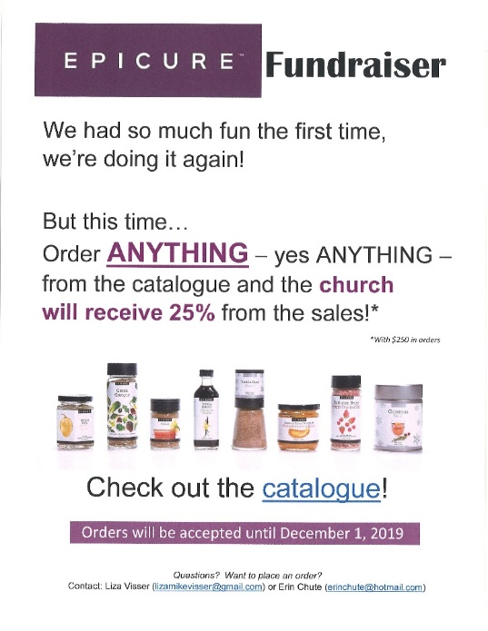

We need your help to know who is sick, in hospital
or just wishing a visit. Please let Lori know in the
Church Office at 519-631-7570 ext 21. Thank you!

From the Finance Committee
Update
In order to meet our Financial Obligations at First Church
we need, on average and excluding fundraising, $4,400 in General Fund Givings EVERY WEEK.

Last week our General Fund Givings were $1,792

This represents a shortfall for the week of $2,608

Year to Date Update (as at October 31/19)
YTD Amount Needed to Meet Obligations: $206,800

YTD Actual General Fund Givings: $106,905

This represents a YTD shortfall of $99,895

Our Current Financial Position is a Net Operating Loss of $78,648

Misc. Info
Revenue from Fundraising Projects to date: $9,948

Monthly General Fund PAR Givings $2,974

For more information, contact Don Renaud or Lori in the church office.

