First United Church
Seeking to be a welcoming community of Christian faith, proclaiming and celebrating the love of God in Jesus Christ through the Inspiration of the Holy Spirit

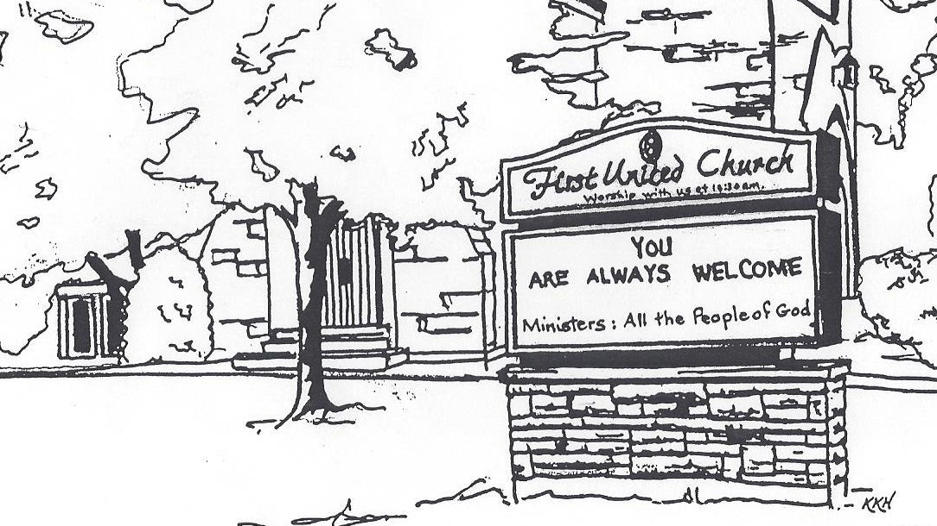

November 17, 2019 @ 10:30am

7 Curtis St., St.Thomas, ON N5P 1H3 Phone: (519) 631-7570
e-mail: office@1stunitedchurch.ca
web: www.1stunitedchurch.ca
MINISTERS: ALL THE PEOPLE OF GOD
Interim Minister: Rev. Daryl Webber
Music Minister: Jody McDonald-Groulx
Secretary/Treasurer: Lori Hoffman
Custodian: Dave Luftenegger

Order of Service
* You are invited to stand if comfortable doing so

VU = Voices United MV = More Voices

Musical Prelude

Welcome

Choral Musical Prelude
- MV#51 “Yahweh Be Praised” (2x)
Yahweh be praised in the heavens.
Yahweh be praised in the streets.
Yahweh be praised with our singing
when in worship we meet.
Yahweh be praised. Yahweh be praised.
Yahweh be praised. Yahweh be praised.
Yahweh be praised. Yahweh be praised.
Yahweh be praised. Yahweh be praised.

- MV#7 “Gather Us In” (2x)
Gather us in, ground us in you.
Gather us in, ground us in you.
Gather us in, gather us in
ground us, ground us in you.

Opening Prayer

Call to Worship
One: The Creator has gathered us to this place.
All: We open our hearts to hear the word of God.
One: The Christ summons us to this place.
All: Where we can learn how to serve God without reservation or hesitation.
One: The Spirit will send us from this place.
All: Where we can put our faith into action, and be true believers
and leaders of the faith through our word and deed.

Lighting of the Christ Candle
I am the light of world, you people come and follow me.
If we follow and love, we’ll learn the mystery
Of what we were meant to do and be.

Passing of the Peace
Sing: Halle, Halle, Halle, lu jah! Halle, Halle, Halle, lu jah!
Halle, Halle, Halle, lu jah! Halle lu jah! (clap) Halle lu jah!

Musical Offering: Senior Choir

Life and Work of the Church

Prayer/The Lord’s Prayer

Hymn: “Awesome God” (2x)
Our God is an awesome God,
and reigns from heaven above
with wisdom, pow’r and love,
Our God is an awesome God.

Conversation with the Young People: Rev. Daryl Webber
Children/Youth may go to Church School

Offering Ourselves, Tithes & Gifts: Sigmar Martin

Dedication Hymn: (tune “Eidelweiss”)
God of Love, hear our prayer. Bless this offering we bring you. May our lives do Your will; guide and guard us forever. Give us courage to stand for truth; help us give to others. God of Love, hear our prayer, Bless this offering we bring you.

Scripture Readings: 1 Chronicles 29:14-19
Matthew 5:13-16, 48

The Message: Rev. Daryl Webber

Hymn: MV#1 “Let Us Build A House…”
*Commissioning/ Benediction

Closing - Sing: VU #298
When you walk from here, when you walk from here,
Walk with justice, walk with mercy, and with God’s humble care.

* Musical Postlude

*Special Thanks to Dr. Wayne Carroll
& Sigmar Martin for sharing your musical gifts with us!

The Life & Work of the Church – November 17
We welcome our new Interim Minister,
Rev. Daryl Webber to First United Church.

Coffee servers are needed! Please sign up on the chart in the Fellowship room if you are able to help! It's greatly appreciated.

Looking for Board Members:
The church requires many hours of volunteer work to make it run smoothly. If you are able to serve or know of someone who would be good to serve on our Official Board please talk to an existing member of the Board, or Lori in the church office

Happy birthday to: Casey Elford.

Happy Anniversary to: Lois & Bill Beamish, Sharron & Avery Rupple.

Today: *SECRET SANTA bags marked girl or boy and an age are available in the corner of the Sanctuary for you to take home. Bags need to be returned to the Sanctuary BY Gift Sunday, Dec 8. Helpful Hints: Please don’t gift wrap. Feel free to buy more than one of the same gift. Our gifts will be distributed by CHRISTMAS CARE along with their annual Christmas FOOD HAMPERS. We welcome gifts of non-perishable food items to help fill the hampers, also on Sunday. Dec. 8th This year we will also be collecting SOCKS for Grace Café. There is a huge need for Men’s, Women’s and children’s socks! Please keep these separate from your Secret Santa Bags. There will be a basket to collect your Sock donations. Our Ivor Fund supports Grace Café each year as well!

This week:

Tuesday - *EarlyON Playgroup 9:30-11:30am in the Gym

*Youth Group: 7-8:15pm

Thursday:
STEWARDSHIP BUZZ!
Steps to take right now!
Clergy, church leaders, treasurers, trustees other interested people.
Come and be inspired and get that ball rolling!
Do you want your congregation to be more vital, sustainable
and abundant? (Me too!)
Does coaching around Whole Year Stewardship sound good to you?
(I hope so!)
Thursday, November 21, 2019 – 6:00-8:30 pm
First United Church, 7 Curtis St., St. Thomas
Free DINNER if you register by Tuesday, November 19 at noon!
Join Dave Jagger, Stewardship & Gifts Officer, for a Round-table discussion about Whole Year Stewardship that will take us into the future and find out what are those steps.
Register by Tuesday, November 19 at noon for your free meal
Please call Lori at 519-631-7570 ext. 21 or email office@1stunitedchurch.ca
You are welcome to come, last minute, even if you don’t register
but please bring your own food.

Thursday - *Senior Choir practice @ 7:30pm

Next Sunday, November 24 – Spaghetti Lunch after worship

Upcoming Dates & Events
Sunday, December 1 - *Hot Chocolate after worship. Proceeds will go towards Youth Outreach Programs.

*Lessons & Carols Choral Celebration – Sun., Dec 1 @ 7pm
Join us for a night of music featuring 8 local choirs! Belmont Community Choir, Central United Church, Centre St Baptist Church, First United Church, Knox Presbyterian Church, "Lunch Bunch", Port Stanley Community Choir, St. Hilda-St. Luke's Anglican Church. Freewill offering. Proceeds to The St. Thomas-Elgin Food Bank & First United. All welcome!

Wednesday, December 4 - *We're hosting our first ever Quarter Auction at the church and would be happy if you could join us for the night. Doors open at 6:30 p.m. Auction starts at 7:00 p.m.
Vendors are needed! Please contact Teresa at tl.turvey@gmail.com.

Saturday, December 7: *Annual Hat and Mitt Run – Everyone welcome! Join us for a nice leisurely run/walk (5 or 10 km) a visit and of course, treats afterwards! We are asking everyone to knit hats & mitts (or buy new) to donate to local groups in need.
Date: Saturday, December 7 at 8 am
Where: First United Church
Entry Fee: Hat & Mitts for local groups in need
For more info call or email Carolyn Johnson 519-318-3386 or johnsongirltris@bell.net

We need your help to know who is sick, in hospital
or just wishing a visit. Please let Lori know in the
Church Office at 519-631-7570 ext 21. Thank you!

