First United Church
Seeking to be a welcoming community of Christian faith, proclaiming and celebrating the love of God in Jesus Christ through the Inspiration of the Holy Spirit

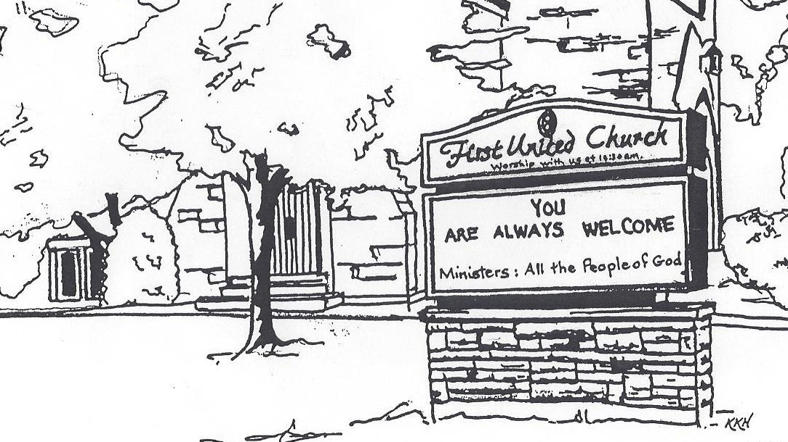

Remembrance Sunday
November 10, 2019 @ 10:30am
7 Curtis St., St.Thomas, ON N5P 1H3 Phone: (519) 631-7570
e-mail: office@1stunitedchurch.ca
web: www.1stunitedchurch.ca
MINISTERS: ALL THE PEOPLE OF GOD
Music Minister: Jody McDonald-Groulx
Secretary/Treasurer: Lori Hoffman
Custodian: Dave Luftenegger

Order of Service
* You are invited to stand if comfortable doing so

VU = Voices United MV = More Voices
Musical Prelude
Welcome
Choral Musical Prelude
- MV#33 “Jesus Came Bringing Us Peace” (2x)
Jesus came bringing us peace, Jesus came bringing us peace,
Jesus came bringing us peace, hallelujah forever more!

- MV#18 “Lord, Prepare Me” (2x)
Lord, prepare me to be a sanctuary, pure and holy tried and true
With thanksgiving, I’ll be a living sanctuary for you.

Opening Prayer

Call to Worship
One: Today is a day of memories….
All: May we remember the sacrifices of the past.
One: Today is a day of reflection….
All: May we reflect on the meaning of life, and the purpose for
which we are born.
One: Today is a day of past battles….
All: May we bring light to bear, on all those who are touched by
war.
One: Today is a day of new beginnings….
All: May we be open to the hope Christ promises, and the peace
that passes all understanding.

Lighting of the Christ Candle
I am the light of world, you people come and follow me.
If we follow and love, we’ll learn the mystery
Of what we were meant to do and be.

Passing of the Peace
Sing: Halle, Halle, Halle, lu jah! Halle, Halle, Halle, lu jah!
Halle, Halle, Halle, lu jah! Halle lu jah! (clap) Halle lu jah!

Life and Work of the Church

Prayer / Lord’s Prayer

Time of Remembrance

Sing: VU#524 “O Canada”

Remembrance Reading – In Flanders Fields
In Flanders fields the poppies blow
Between the crosses, row on row,
That mark our place; and in the sky
The larks, still bravely singing, fly
Scarce heard amid the guns below.
We are the Dead. Short days ago
We lived, felt dawn, saw sunset glow,
Loved, and were loved, and now we lie
In Flanders Fields.
Take up our quarrel with the foe:
To you from failing hands we throw
The torch; be yours to hold it high.
If ye break faith with us who die
We shall not sleep, though poppies grow
In Flanders Fields
– John McCrae (1872 – 1918)

Laying of Wreaths

Words of Remembrance
One: They shall grow not old, as we that are left grow old.
All: Age shall not weary them, nor the years condemn.
One: At the going down of the sun and in the morning.
All: We will remember them.

The Last Post

We Remember and Give Thanks For:
Those from this church who answered the call to serve, volunteering for active service with Canada’s fighting forces and for the following who lost their lives:
In 1914-1919, George Foster; Robert Freeman;
Edward Kitson; Albert Lipsey; George Metcalfe; Douglas McTavish;
Thorpe O’Mulvenny; Percy Shannon. and in 1939-1945, John Andrews; Alex Blakey; James Brown; Frank Gadsby; John Gray; Gordon Martin; Jack McKenzie; Kenneth Neville; George Patman; George Ponsford; Cameron Powles; Donald Riggs; Jack Spencer; Jack Taylor; Edward Thurston.

Silence
Reveille

Musical Offering: “Highway of Heroes” Jerome Thomas

Offering Ourselves, Tithes & Gifts

Dedication Hymn: (tune “Eidelweiss”)
God of Love, hear our prayer. Bless this offering we bring you. May our lives do Your will; guide and guard us forever. Give us courage to stand for truth; help us give to others. God of Love, hear our prayer, Bless this offering we bring you.

Scripture Readings: Micah 4:1-5; Romans 8:31-39

The Message: “Do You Remember?” Roxanne Bale

Hymn: VU#586 “We Shall Go Out With Hope of Resurrection”

*Commissioning/ Benediction
Closing - Sing: VU #298
When you walk from here, when you walk from here,
Walk with justice, walk with mercy, and with God’s humble care.

* Musical Postlude

Thank you to Hillary Tufford for sharing her gift of music today!

The Life & Work of the Church – November 10
Thank you to Roxane Bale for sharing her message with us today.

Coffee servers are needed! Please sign up on the chart in the Fellowship room if you are able to help! It's greatly appreciated.

Looking for Board Members:
The church requires many hours of volunteer work to make it run smoothly. If you are able to serve or know of someone who would be good to serve on our Official Board please talk to an existing member of the Board, or Lori in the church office.

Happy birthday to: Lois Whiteman, June Harris, Bill Turvey, Clare Beamish, Ken Lunn, Henry MacMenamin.

Today: *SECRET SANTA bags marked girl or boy and an age are available in the corner of the Sanctuary for you to take home. Bags need to be returned to the Sanctuary BY Gift Sunday, Dec 8. Helpful Hints: Please don’t gift wrap. Feel free to buy more than one of the same gift. Our gifts will be distributed by CHRISTMAS CARE along with their annual Christmas FOOD HAMPERS. We welcome gifts of non-perishable food items to help fill the hampers, also on Sunday. Dec. 8th This year we will also be collecting SOCKS for Grace Café. There is a huge need for Men’s, Women’s and children’s socks! Please keep these separate from your Secret Santa Bags. There will be a basket to collect your Sock donations. Our Ivor Fund supports Grace Café each year as well!

This week:

Tuesday - *Youth Group: 7-8:15pm

Wednesday– *Chalk Couture Sign Night! Come out for a fun night and learn how to make Chalk Creations!
COST: $40/sign ($5/sign donated to church). Includes 9x12” white frame & all supplies (transfer paper, chalk paint, etc)
For design choices that are available please contact Erin Chute erinchute@hotmail.com or 519-615-9918
Check out their website: https://www.chalkcouture.ca/creativechalks

Thursday - *Senior Choir practice @ 7:30pm

Saturday -*Cocoa, Cookies & Caroling First will have a float in The Santa Claus Parade again this year! Theme: Super Heroes! All children & youth (even adults) are welcome to participate!!
Immediately following the parade we will be hosting a Cocoa, Cookies & Caroling Nights! We hope to have as many First Church Friends – and THEIR Friends in attendance as possible! We are in need of cookie donations for this event! Please contact Erin Chute if you can help! This was a fantastic, fun evening last year! Also, if you are interested in riding on the float/helping with the float, please contact Justin Chute @ 519-521-4723.

Upcoming Dates & Events
STEWARDSHIP BUZZ!
Steps to take right now!
Clergy, church leaders, treasurers, trustees other interested people.
Come and be inspired and get that ball rolling!
Do you want your congregation to be more vital, sustainable
and abundant? (Me too!)
Does coaching around Whole Year Stewardship sound good to you?
(I hope so!)
Thursday, November 21, 2019 – 6:00-8:30 pm
First United Church, 7 Curtis St., St. Thomas
Free DINNER if you register by Tuesday, November 19 at noon!
Join Dave Jagger, Stewardship & Gifts Officer, for a Round-table discussion about Whole Year Stewardship that will take us into the future and find out what are those steps.
Register by Tuesday, November 19 at noon for your free meal
Please call Lori at 519-631-7570 ext. 21 or email office@1stunitedchurch.ca
You are welcome to come, last minute, even if you don’t register
but please bring your own food.

Sunday, November 24 – Spaghetti Lunch after worship

Sunday, December 1 - *Hot Chocolate after worship. Proceeds will go towards Youth Outreach Programs.

*Lessons & Carols Choral Celebration – Sun., Dec 1 @ 7pm
Join us for a night of music featuring 8 local choirs! Belmont Community Choir, Central United Church, Centre St Baptist Church, First United Church, Knox Presbyterian Church, "Lunch Bunch", Port Stanley Community Choir, St. Hilda-St. Luke's Anglican Church. Freewill offering. Proceeds to The St. Thomas-Elgin Food Bank & First United. All welcome!

Wednesday, December 4 - *We're hosting our first ever Quarter Auction at the church and would be happy if you could join us for the night. Doors open at 6:30 p.m. Auction starts at 7:00 p.m.
Vendors are needed! Please contact Teresa at tl.turvey@gmail.com.

Saturday, December 7: *Annual Hat and Mitt Run – Everyone welcome! Join us for a nice leisurely run/walk (5 or 10 km) a visit and of course, treats afterwards! We are asking everyone to knit hats & mitts (or buy new) to donate to local groups in need.
Date: Saturday, December 7 at 8 am
Where: First United Church
Entry Fee: Hat & Mitts for local groups in need
For more info call or email Carolyn Johnson 519-318-3386 or johnsongirltris@bell.net

We need your help to know who is sick, in hospital
or just wishing a visit. Please let Lori know in the
Church Office at 519-631-7570 ext 21. Thank you!

From the Library: Check out our Remembrance Day display of books. You are welcome to sign them out to read at home!

