First United Church
Seeking to be a welcoming community of Christian faith, proclaiming and celebrating the love of God in Jesus Christ through the Inspiration of the Holy Spirit

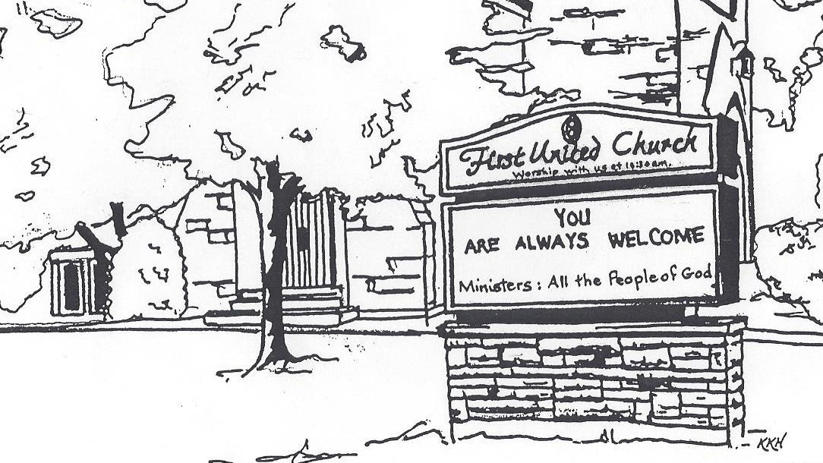

November 3, 2019 @ 10:30am

7 Curtis St., St.Thomas, ON N5P 1H3 Phone: (519) 631-7570
e-mail: office@1stunitedchurch.ca
web: www.1stunitedchurch.ca
MINISTERS: ALL THE PEOPLE OF GOD
Music Minister: Jody McDonald-Groulx
Secretary/Treasurer: Lori Hoffman
Custodian: Dave Luftenegger

Order of Service
* You are invited to stand if comfortable doing so

VU = Voices United MV = More Voices
Musical Prelude
Welcome
Choral Musical Prelude
- MV#156 “Dance with the Spirit” (2x)
Dance with the Spirit early in the mornin’
walk with the Spirit throughout the long day.
Work and hope for the new life a-bornin’
listen to the Spirit to how you the way.

- MV#18 “Lord, Prepare Me” (2x)
Lord, prepare me to be a sanctuary,
pure and holy tried and true
With thanksgiving, I’ll be a living
sanctuary for you.

Opening Prayer

Call to Worship
One: The Creator has gathered us to this place.
All: We open our hearts to hear the word of God.
One: The Christ summons us to this place.
All: Where we can learn how to serve God without reservation or hesitation.
One: The Spirit will send us from this place.
All: Where we can put our faith into action, and be true believers
and leaders of the faith through our word and deed.

Lighting of the Christ Candle
I am the light of world, you people come and follow me.
If we follow and love, we’ll learn the mystery
Of what we were meant to do and be.

Passing of the Peace
Sing: Halle, Halle, Halle, lu jah! Halle, Halle, Halle, lu jah!
Halle, Halle, Halle, lu jah! Halle lu jah! (clap) Halle lu jah!

Musical Offering: Senior Choir

Life and Work of the Church

Prayer/The Lord’s Prayer

Hymn: VU#574 “Come Let Us Sing” (vv 1, 4)

Conversation with the Young People: Greg Fluit
Children/Youth may go to Church School

Offering Ourselves, Tithes & Gifts: Alvin Epp
Dedication Hymn: (tune “Eidelweiss”)
God of Love, hear our prayer. Bless this offering we bring you. May our lives do Your will; guide and guard us forever. Give us courage to stand for truth; help us give to others. God of Love, hear our prayer, Bless this offering we bring you.

Scripture Reading: Mark 12:18-24

The Message: “Arguing About the Rules”

Hymn: VU#381 “Spirit of Life”

*Commissioning/ Benediction
Closing - Sing: VU #298
When you walk from here, when you walk from here,
Walk with justice, walk with mercy, and with God’s humble care.

* Musical Postlude

The Life & Work of the Church – November 3
Thank you to Greg Fluit for sharing his message with us today.

Coffee servers are needed! Please sign up on the chart in the Fellowship room if you are able to help! It's greatly appreciated.

Looking for Board Members:
The church requires many hours of volunteer work to make it run smoothly. If you are able to serve or know of someone who would be good to serve on our Official Board please talk to an existing member of the Board, or Lori in the church office.

This week:

Tuesday - *Holly Fair & Vendor Market Setup – 8:30am. If you can help – we’d appreciate it (only 1 hour!) We will also need “tear down/clean up” help on Saturday @ 12:15pm! Thank you!

Thursday - *Senior Choir practice @ 7:30pm

Saturday - *HOLLY FAIR & VENDOR MARKET

This is it First Church Friends! Time to make those donations to ensure this year’s Holly Fair is a HUGE SUCCESS!!

Here is the “Wish List” again, in case you missed it! Please donate if you can! It takes all of us to make this a successful fundraiser for the Church! Your donations are GREATLY APPRECIATED!
Bake Shop with Country Store: Pies, cakes, tarts, cookies, cupcakes, brownies, Gluten Free Items (Lori in the office would LOVE Gluten Free & Dairy Free haha), Loaves of any kind, Coffee Cake, Biscuits, Fun Kids Items, Fudge, Caramel Corn, Bark, Candy mice, Chocolate covered items, Nuts & Bolts, Flavoured Nuts, Peanut Brittle, Pickles, Relishes, Jams & Jellies, Salsa.
Single serving items are in HIGH demand: Cabbage Rolls, Casseroles, Lasagna, Mac & Cheese, Meat PIes, Baked Beans

Holiday Entertaining: Orange & Red Pepper Jelly, Mini Quiche, Cheese Balls, Meatballs, mini Christmas Puddings, Food Gift Baskets, Hostess Gifts, Toast Rounds, Homemade Dips / Sauces, Freezable hors d'oeurves in high demand!
Attic Treasures: Donations GREATLY Needed!!! Jewelry, China, Mirrors, Wall Pictures, Crystal, Gift Wrap, Gift bags, Christmas items needed! (No electronics, furniture or large items)
Book Shop: Popular Novels, Christmas CD's or DVD's, Like new children's books or comic books, like new books for teens / tween, Adult reading books, Hard or soft cover
Blind Auction: Donations appreciated from Church Members - Items are to be NEW, not used please. People write their "best bid" on a ballot in the designated bag for the specific item (No one can see the bids). At the end of the event, the person who has the "best bid" on the item wins the bid.
Crafter's Market: New Jewelry, Christmas items, stocking stuffers, wreaths, gifts tags, gift baskets, quilts, artwork, pillows, dishcloths, wall decor, knitted items (scarves, mitts, etc)Lap blankets, cloth shopping bags, homemade games, wooden toys, homemade ornaments, angels, Christmas door decor.
Cafe: We are in need of lots of Muffins, Cookies & Juice Box donations for the Café.

**All donations / items can be dropped off at the Church Monday – Thursday 9am to 3pm and Friday from 9am – at least noon! We’ll keep you posted! THANK YOU SO MUCH!

*Knox Presbyterian Church presents “The Sounds of Silents” on Saturday, November 9 @ 7pm - You are invited to a night at the movies featuring Martin Anderle on the Knox organ and grand piano. We will be watching a silent Laurel and Hardy movie as it was originally enjoyed, accompanied by live improvisational organ music. Then, a tribute to Canada with images from sea to sea by local photographers, accompanied by original piano music. FREE WILL offering with all proceeds going to the St. Thomas Inn out of the Cold. Dessert to follow.
Next Sunday, November 10: *SECRET SANTA bags marked girl or boy and an age will be available in the corner of the Sanctuary for you to take home next week. Bags need to be returned to the Sanctuary BY Gift Sunday, Dec 8. Helpful Hints: Please don’t gift wrap. Feel free to buy more than one of the same gift. Our gifts will be distributed by CHRISTMAS CARE along with their annual Christmas FOOD HAMPERS. We welcome gifts of non-perishable food items to help fill the hampers, also on Sunday. Dec. 8th This year we will also be collecting SOCKS for Grace Café. There is a huge need for Men’s, Women’s and children’s socks! Please keep these separate from your Secret Santa Bags. There will be a basket to collect your Sock donations. Our Ivor Fund supports Grace Café each year as well!

Upcoming Dates & Events
Wednesday, November 13 – Chalk Couture Sign Night! Come out for a fun night and learn how to make Chalk Creations!
COST: $40/sign ($5/sign donated to church). Includes 9x12” white frame & all supplies (transfer paper, chalk paint, etc)
For design choices that are available please contact Erin Chute erinchute@hotmail.com or 519-615-9918
Check out their website: https://www.chalkcouture.ca/creativechalks

Saturday, November 16 - *Cocoa, Cookies & Caroling First will have a float in The Santa Claus Parade again this year! Theme: Super Heroes! All children & youth (even adults) are welcome to participate!!
Immediately following the parade we will be hosting a Cocoa, Cookies & Caroling Nights! We hope to have as many First Church Friends – and THEIR Friends in attendance as possible! We are in need of cookie donations for this event! Please contact Erin Chute if you can help! This was a fantastic, fun evening last year! Also, if you are interested in riding on the float/helping with the float, please contact Justin Chute @ 519-521-4723.

Sunday, November 24 – Spaghetti Lunch after worship

Sunday, December 1 - *Hot Chocolate after worship. Proceeds will go towards Youth Outreach Programs.

*Lessons & Carols Choral Celebration – Sun., Dec 1 @ 7pm
Join us for a night of music featuring 8 local choirs! Belmont Community Choir, Central United Church, Centre St Baptist Church, First United Church, Knox Presbyterian Church, "Lunch Bunch", Port Stanley Community Choir, St. Hilda-St. Luke's Anglican Church. Freewill offering. Proceeds to The St. Thomas-Elgin Food Bank & First United. All welcome!

Wednesday, December 4 - *We're hosting our first ever Quarter Auction at the church and would be happy if you could join us for the night. Doors open at 6:30 p.m. Auction starts at 7:00 p.m.
Vendors are needed! Please contact Teresa at tl.turvey@gmail.com.

We need your help to know who is sick, in hospital
or just wishing a visit. Please let Lori know in the
Church Office at 519-631-7570 ext 21. Thank you!

