First United Church
Seeking to be a welcoming community of Christian faith, proclaiming and celebrating the love of God in Jesus Christ through the Inspiration of the Holy Spirit

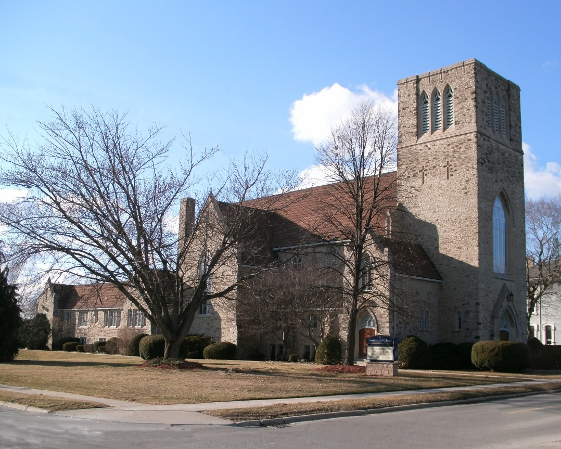

May 5, 2019 @ 10:30am

7 Curtis St., St.Thomas, ON N5P 1H3 Phone: (519) 631-7570
e-mail: office@1stunitedchurch.ca
web: www.1stunitedchurch.ca
MINISTERS: ALL THE PEOPLE OF GOD
Pastoral Minister: Rev. Emmanuel K. Ofori
Music Minister: Jody McDonald-Groulx
Secretary/Treasurer: Lori Hoffman
Custodian: Dave Luftenegger
Third Sunday after Easter

Guest Speaker: Richard Auckland
* You are invited to stand if comfortable doing so

VU = Voices United MV = More Voices

We Gather Together
Opening Prayer
Choral Prelude
- MV#92 “Like A Rock” (2x)
Like a rock, like a rock, God is under our feet.
Like the starry night sky, God is over our head.
Like the sun on the horizon, God is ever before.
Like the river runs to ocean, our home is in God evermore.

- “Awesome God” (2x)
Our God is an awesome God, and reigns from heaven above
with wisdom, pow’r and love, Our God is an awesome God.

Lighting of the Christ Candle (2x)
The Kennington Family – Deb, Gavin and Georgia
I am the Light of the world! You people come and follow me!
If you follow and love you’ll learn the mystery
of what you were meant to do and be.

Passing of the Peace (VU 958 “Halle, Halle, Halle”)
Welcome
Life and Work of the Church (see insert) Marisa Tippett

We Draw Near to Worship
Call to Worship
Circle Time
(children go to Sunday School)

Anthem: Senior Choir
Prayers
Thanksgiving/ Intercessory Prayer
Silent Reflection
Lord’s Prayer (said)

We Respond in Love
Offering
Hymn/Song of Dedication
God of Love hear our prayer, bless this offering we bring you.
May our lives do you will, guide and guard us forever.
Give us courage to stand for truth, help us give to others.
God of Love hear our prayer, bless this offering we bring you.

Offertory Prayer

We Listen for God’s Word
* Hymn of Preparation: VU#331 “The Church’s One Foundation”
Scripture Readings: 1 Corinthians 12: 12-31 Gerdy MacKay

The Message: Where We’ve Been, Where We are, Where Are We Going?
(Our past, present & future.)

We Go Out to Serve
*Closing Hymn: VU#509 “Here I Am Lord”
* Commissioning Hymn: “MV#209 “Go Make a Diff’rence”

* Benediction

* Triple Amen

* Musical Postlude

Today’s Message
Past: *The church has undergone many changes.
*Many people have contributed to the success of First United.
*Our ministers were our spiritual and institutional leaders.
*We were a minister-lead congregation/church.

Present:
*Emmanuel has brought many of the things we had asked for
in our profile/search

*Artisan Sale, El Sistema Concert, Rummage Sale, Youth Groups, Sunday School, changes to church governance
*Lots of Participation/Assistance
*We are becoming more of a congregation-lead church

Future: *Focus Groups
*Decisions and Greater Involvement from the members
*Stewardship
*Where/how can you contribute? What will you help make our church become?
???

Our 2020 Vision: To be a vibrant community of faith, engaging all with a focus on youth and young families in ministry and reaching out to the world with the love of God in Christ.

