LIFE & WORK OF THE CHURCH
May 27, 2018

Happy Birthday to: Bill McMillan, Jordan Groulx, Emma Pipes,
Mark Snowsell, Georgia Kennington, Vicki Snowsell, Bill Aarts, &
Rev. Emmanuel
Happy Anniversary to: Mark & Vicki Snowsell.

TODAY: *Join us for Coffee & Juice in the Fellowship Room following worship

THIS WEEK:
Thursday: *EarlyON Playgroup meets in the gym: 9:30-11:30am
*Senior Choir meets @ 7:30pm in the Music Room
This Friday Evening
First United proudly presents…

Friday, June 1st @ 7 p.m.

Tickets are $15.00 and are available
in the church office during the week,
after worship on Sunday mornings by the lift, by calling Esther @ 519-619-5107
or Jody @ 519-495-4819 or online @
https://www.picatic.com/
firstunitedsaintthomas

Upcoming Dates & Events
Saturday, June 2 - *Safe Food Handling Certification Course (offered by the London Training Centre in conjunction with the Elgin Middlesex Public Health Unit.) The course runs from 9am to 3:30pm at Knox Presbyterian Church. Cost is $50 per person. Bring a pencil and a brown bag lunch. Deadline for registration is May 25. More info is available from Lori in the Church Office.

*Sunday, June 10 – BAPTISM Sunday. If you are interested in having your child baptized, please contact Rev. Emmanuel through the church office or email him at minister@1stunitedchurch.ca
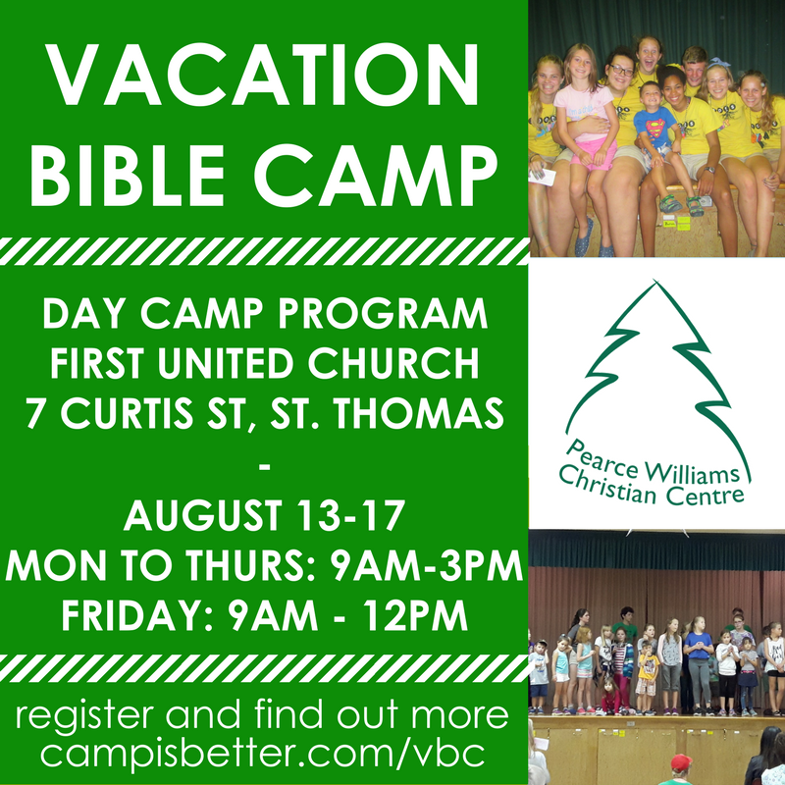

Remember our Website address
and Church Email addresses have changed
New website address: www.1stunitedchurch.ca
New church office email: office@1stunitedchurch.ca
New email for Rev. Emmanuel: minister@1stunitedchurch.ca
LIFE & WORK OF THE CHURCH
May 27, 2018

Happy Birthday to: Bill McMillan, Jordan Groulx, Emma Pipes,
Mark Snowsell, Georgia Kennington, Vicki Snowsell, Bill Aarts, &
Rev. Emmanuel
Happy Anniversary to: Mark & Vicki Snowsell.

TODAY: *Join us for Coffee & Juice in the Fellowship Room following worship

THIS WEEK:
Thursday: *EarlyON Playgroup meets in the gym: 9:30-11:30am
*Senior Choir meets @ 7:30pm in the Music Room
This Friday Evening
First United proudly presents…

Friday, June 1st @ 7 p.m.

Tickets are $15.00 and are available
in the church office during the week,
after worship on Sunday mornings by the lift, by calling Esther @ 519-619-5107
or Jody @ 519-495-4819 or online @
https://www.picatic.com/
firstunitedsaintthomas

Upcoming Dates & Events
Saturday, June 2 - *Safe Food Handling Certification Course (offered by the London Training Centre in conjunction with the Elgin Middlesex Public Health Unit.) The course runs from 9am to 3:30pm at Knox Presbyterian Church. Cost is $50 per person. Bring a pencil and a brown bag lunch. Deadline for registration is May 25. More info is available from Lori in the Church Office.

*Sunday, June 10 – BAPTISM Sunday. If you are interested in having your child baptized, please contact Rev. Emmanuel through the church office or email him at minister@1stunitedchurch.ca

Remember our Website address
and Church Email addresses have changed
New website address: www.1stunitedchurch.ca
New church office email: office@1stunitedchurch.ca
New email for Rev. Emmanuel: minister@1stunitedchurch.ca

