First United Church
Seeking to be a welcoming community of Christian faith, proclaiming and celebrating the love of God in Jesus Christ through the Inspiration of the Holy Spirit

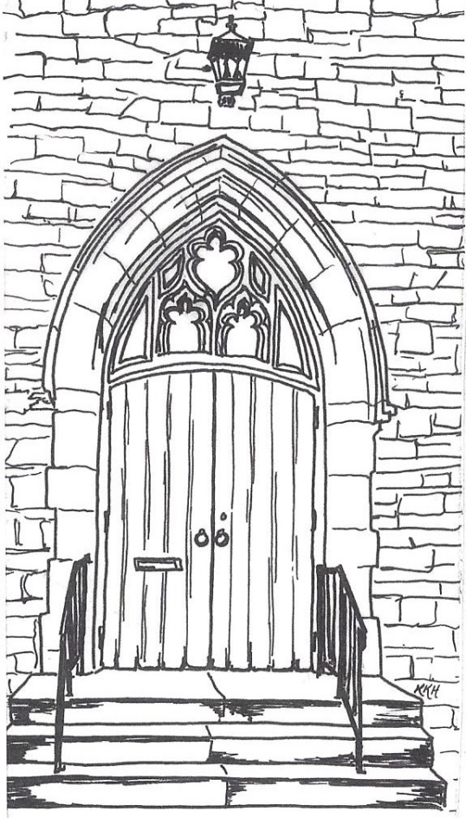

May 26, 2019 @ 10:30am

7 Curtis St., St.Thomas, ON N5P 1H3 Phone: (519) 631-7570
e-mail: office@1stunitedchurch.ca
web: www.1stunitedchurch.ca
MINISTERS: ALL THE PEOPLE OF GOD
Pastoral Minister: Rev. Emmanuel K. Ofori
Music Minister: Jody McDonald-Groulx
Secretary/Treasurer: Lori Hoffman
Custodian: Dave Luftenegger

ORDER OF SERVICE

Opening Prayer/Songs/Choruses
- MV#8 “And On This Path” (2x)
And on this path, the gates of holiness are open wide.
And on this path, the gates of holiness are open wide.
And on this path, the gates of holiness are open wide.
Open wide! Open wide! Open wide! The gates are open wide!

- Thy word is a lamp unto my feet and a light unto my path. (3x)

- “That’s Why We Praise Him” (Chorus only)
That’s why we praise him, that’s why we sing
That’s why we offer him our everything
That’s why we bow down, and worship this King
‘Cause He gave His everything
‘Cause He gave His everything.

Call to Worship: Responsive Psalm 119:105-112
One: Your word is a lamp for my feet,
All: a light on my path.
One: I have taken an oath and confirmed it,
All: that I will follow your righteous laws.
One: I have suffered much;
All: preserve my life, Lord, according to your word.
One: Accept, Lord, the willing praise of my mouth,
All: and teach me your laws.
One: Though I constantly take my life in my hands,
All: I will not forget your law.
One: The wicked have set a snare for me,
All: but I have not strayed from your precepts.
One: Your statutes are my heritage forever;
All: they are the joy of my heart.
One: My heart is set on keeping your decrees
All: to the very end.
Lighting of the Christ Candle

Circle Time

Welcome/Notices

Offering: Solo: Alvin Epp

Offertory Hymn/Prayer of Dedication

God of Love, hear our prayer. Bless this offering we bring you.

May our lives do your will. Guide and guard us forever.

Give us courage to stand for truth, help us give to others.

God of Love, hear our prayer. Bless this offering we bring you.

Hymn: VU#356 “Seek Ye First”

Scripture Readings: 2 Timothy 3:12-17; Acts 17:10-12

Hymn of Preparation: VU#357 “Tell Me the Stories of Jesus” (vv 1, 2, 5)
The Message: “Why Read the Bible?”
Prayer
*Closing Hymn: MV#49 “When We Seek Language”
* Benediction
* Commissioning Hymn: MV#209 “Go Make A Diff’rence”
Go make a diff’rence. We can make a diff’rence.
Go make a diff’rence in the world.
Go make a diff’rence. We can make a diff’rence.
Go make a diff’rence in the world.

* Musical Postlude

The Life & Work of the Church - May 26, 2019

Happy birthday to: Mike Muma, Bill McMillan, Mark Snowsell, Georgia Kennington.

Happy anniversary to: Mark & Vicki Snowsell.

This week:
Monday: *Youth Group with Chris Ross (grades 8-12 every week) & Justin Chute (grades 5-7 every other week) in the Gym from 6:30-8pm.

Tuesday: *EarlyON Playgroup in the gym - 9:30 – 11:30am

Thursday – *Sr. Choir @ 7:30pm in the Music Room

Next Sunday - *Interactive Story with Puppets will be presented in Sunday School by Rosemarie Johnson-Clarke

Future Dates / Events
Thursday Evenings in June (7pm) - Parenting on Purpose Video Series by Mark Hughes from The Church of the Rock. Presented by the CD/Membership Committee. All Welcome.

Sunday, June 16 – “Cause Dad… you’re cooler than ice cream!” Ice Cream Sundae following worship in the Assembly Hall.

Sunday, July 28 – Worship & Picnic in the Park (at Pinafore Park) beginning @ 10:30am Lakeside Pagoda - More details to follow

August 12-15 from 9am to 3pm - Vacation Bible Camp
led by the counsellors from Pearce Williams Christian Centre
and supervised by the CD / Membership Committee
Register at https://www.campisbetter.com/vbc

Minister’s Drop-In Office Hours
Tuesday, Wednesday & Thursday 10am to 12 Noon
*Other times available by appointment (519-631-7570 ext. 22)

