First United Church
Seeking to be a welcoming community of Christian faith,
proclaiming and celebrating the love of God in Jesus Christ
through the Inspiration of the Holy Spirit

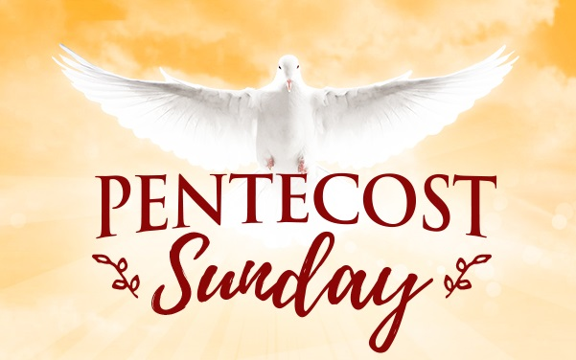

Pentecost Sunday
May 20, 2018 @ 10:30am

7 Curtis St., St.Thomas, ON N5P 1H3 Phone: (519) 631-7570
e-mail: office@1stunitedchurch.ca
web: www.1stunitedchurch.ca
MINISTERS: ALL THE PEOPLE OF GOD
Pastoral Minister: Rev. Emmanuel K. Ofori
Music Minister: Jody McDonald-Groulx
Secretary/Treasurer: Lori Hoffman
Custodian: Dave Luftenegger

Pentecost Sunday
LAUNCHING OF VISION 2020
Sunday, May 20, 2018 - 10:30 a.m. Worship
Preacher: Rev. Emmanuel K. Ofori

Notes: Asterisk (*) – You may stand if comfortable doing so
VU = Voices United MV = More Voices

God Gathers Us Together

Musical/Choral Prelude
- VU#381 “Spirit of Life”
Spirit of Life, come unto me. Sing in my heart all the stirrings of compassion. Blow in the wind, rise in the sea; move in the hand,
giving life the shape of justice. Roots hold me close; wings set me free; Spirit of Life, come to me, come to me.
- MV#18 “Lord Prepare Me”
Lord, prepare me to be a sanctuary, pure and holy tried and true; with thanksgiving, I’ll be a living sanctuary for you. (2x)

* Opening Hymn: VU#264 “Immortal, Invisible, God Only Wise”

Life and Work of the Church [see insert]

Welcoming of Visitors

God Draws Us Near To Worship

Call to Worship
One: Come, sing a new song of worship.
All: Come, sing a new song of praise.
One: Today is a day of a promise fulfilled.
All: With joy we celebrate Pentecost.
One: Blazing Flame of the Spirit, burn away our fears!
All: Come, Holy Spirit, inspire our hearts with your fiery presence!
One: Rushing Wind of the Spirit, breathe new life into us!
All: Comforting Presence of the Spirit, heal our wounds
One: Come, Holy Spirit, energize our lives to work for God.
All: Let your flame burn within us, stirring us to action.
One: Come, let us worship our triune God.
All: We come to worship the Holy Mystery, our awesome God
One: Spirit of God, come upon us this day and fill us with your love.
All: Make us people who will proclaim God’s good news of love in all that we do. AMEN.

Prayer of Thanksgiving & Intercession/ The Lord’s Prayer (VU #960)
Circle Time (Children’s Story)
Hymn: MV#92 “Like A Rock”

God Invites Us To Listen For His Word

New Testament Reading: Acts 2:1-13
Reader: This is the Word of God
All: Thanks be to God

* Hymn of Preparation: VU #376 “Spirit of the Living God”
The Message: “You Shall Receive Power When the
Holy Spirit Comes on You” Acts 1:8

God Invites Us To Respond To His Love
Offertory: Lauren Evely
Hymn of Dedication
God of love, hear our prayer, bless this offering we bring you.
May our lives do your will, guide and guard us forever.
Give us courage to stand for truth, help us give to others.
God of love, hear our prayer, bless this offering we bring you.
Offertory Prayer

God Sends Out Into the World to Serve
*Closing Hymn: VU #375 “Spirit, Spirit of Gentleness”
* Benediction
*Sending Forth
Threefold Amen
Commissioning Hymn: MV#209 “Go Make a Difference”
Musical Postlude
We welcome Paula Thomas as our Music Leader this morning.
TODAY’S MESSAGE
A healthy church is a worshipping community. It is also an evangelistic community which shares God’s love in Jesus with others. We cannot do this on our own. Jesus said, “apart from me you can do nothing” (John 15:5). We need to plug into the power of the Holy Spirit to enliven the church. On the day of Pentecost, the first followers of Christ “plugged in” and received the power of God to bear witness to Christ.

- God promised to send the Holy Spirit

- We pray for the coming of the Holy Spirt

- We partner with the Holy Spirit for Him to work with and through us

- We proclaim the good news of God’s love in Christ Jesus to “all nations”

The proclamation of the Good News of salvation in Christ is what we refer to as evangelism
“Evangelism is not salesmanship. It is not urging people, pressing them, coercing them, overwhelming them, or subduing them. Evangelism is telling a message. Evangelism is reporting good news.” – Richard C. Halverson

Evangelism is the announcement, proclamation, and/or preaching of the gospel, the good news of and about Jesus Christ (1 Cor. 15:1-4). It is simply sharing the love of God in Christ Jesus.

Think about this
- We need the help of the Holy Spirit to obey God from the heart and bring our thoughts, attitudes and actions in line with God’s.
- When we have received the power of the Holy Spirit, we become witnesses to Jesus Christ’s death and resurrection. We proclaim the love of God in Christ. When was the last time you shared the good news of God’s love with another person?

