First United Church
Seeking to be a welcoming community of Christian faith, proclaiming and celebrating the love of God in Jesus Christ through the Inspiration of the Holy Spirit

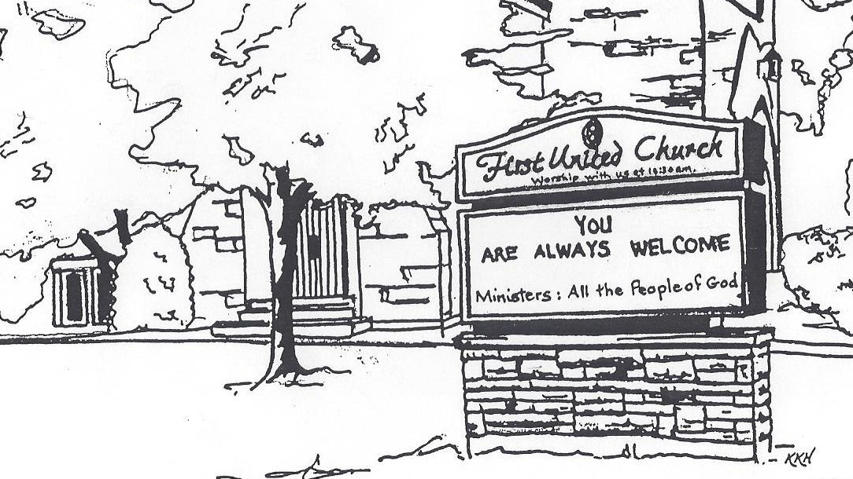

May 19, 2019 @ 10:30am

7 Curtis St., St.Thomas, ON N5P 1H3 Phone: (519) 631-7570
e-mail: office@1stunitedchurch.ca
web: www.1stunitedchurch.ca
MINISTERS: ALL THE PEOPLE OF GOD
Pastoral Minister: Rev. Emmanuel K. Ofori
Music Minister: Jody McDonald-Groulx
Secretary/Treasurer: Lori Hoffman
Custodian: Dave Luftenegger

PREACHER: Rev. Emmanuel K. Ofori

Notes: Asterisk (*) – You may stand if able

God Gathers Us Together

Opening Prayer

Musical/Choral Prelude:
- MV#30 “It’s a Song of Praise to the Maker”
- MV#21 “Open Our Hearts” (2x)
Open our hearts, open our minds.
Open our lives to you O loving God.
(Open our hearts)

Life and Work of the Church
Welcoming of Visitors
Passing of the Peace (VU 958 “Halle, Halle, Halle”)

God Draws Us Near To Worship
Call to Worship [Using the song, “I’m Gonna Live So God Can Use Me”]
Choir: singing verse 1
One: What magnificent diversity we have in the church!
All: God has called us to this place to share our gifts and talents.
Sisters: singing verse 2
One: There are so many ways that we can serve the Lord in the church!
All: We pray that God will enable us to use our talents to help others.
Brothers: singing verse 3
One: Our lives should be prayers of thanksgiving to God.
All: Let our hearts be open and our voices raise in song to God who continually blesses our lives.

ALL: singing verse 4

Intercessory Prayer / The Lord’s Prayer (VU #960)
Anthem: Senior Choir
Circle Time:

Hymn/Chorus: MV#156 “Dance with the Spirit” (2x)

Dance with the Spirit early in the mornin’,

walk with the Spirit throughout the long day.

Work and hope for the new life abornin,

listen to the Spirit to show you the way.

God Invites Us To Respond To His Love
Offertory
Offertory Dedication Hymn

God of Love, hear our prayer.

Bless this offering we bring you.

May our lives do your will.

Guide and guard us forever.

Give us courage to stand for truth,

help us give to others.

God of Love, hear our prayer.
Bless this offering we bring you.

Offertory Prayer
God Invites Us To Listen For His Word

Gospel Reading: Matthew 16:13-20
Reader: This is the Word of God
All: Thanks be to God

*Sermon Hymn: VU #331 “The Church’s One Foundation”

Message: “I Will Build My Church”

God Sends Out Into the World to Serve

*Closing Hymn: “We are the church” (vv 1, 2, 4)
* Benediction
* Triple Amen

* Commissioning Hymn: VU#298 “”When You Walk From Here”

When you walk from here, when you walk from here,

Walk with justice, walk with mercy, and with God’s humble care.

* Musical Postlude
TODAY’S MESSAGE
Jesus said, “I will build my church” (Matthew 16:18)
What does He mean?
Does He mean He will put buildings all over the world?

What is the church? (1 Peter 2:9)
It is not a building. Nor is it a corporation with a cross on top.
It is His people, gathered anywhere in His name through faith in Him.

What are the distinguishing marks of the church?
A statement of the Nicene Creed (VU # 920) reads
“We believe in one holy catholic and apostolic Church”

How would you describe the church?
Any metaphors that come into your mind?

In your own understanding, what is purpose of church?

Think about this:
When you think of the church as the fellowship of all true believers in Christ throughout all time, how does it affect the way you think of yourself as an individual Christian?

