Seventh Sunday of Easter

PREACHER: Rev. Emmanuel K. Ofori
* You are invited to stand if comfortable doing so

VU = Voices United MV = More Voices

We Gather Together
Choral Prelude
- MV#51 Yahweh Be Praised
Yahweh be praised in the heavens. Yahweh be praised in the streets. Yahweh be praised with our singing when in worship we meet. Yahweh be praised. Yahweh be praised. Yahweh be praised. Yahweh be praised. Yahweh be praised. Yahweh be praised. Yahweh be praised. Yahweh be praised. (2x)

- MV#122 “This Is The Day”
This is the day that God had made; we will rejoice and be glad! This is the day that God has made; we will rejoice and be glad! Singing hallelu, singing hallelu, singing hallelu! We will rejoice and be glad! Singing hallelu, singing hallelu, singing hallelu!
We will rejoice and be glad!

Opening Prayer
*Hymn: VU#120 “O Jesus, I Have Promised”
Lighting of the Christ Candle
Passing of the Peace (VU#958 “Halle, Halle, Halle” )
Welcome
Life and Work of the Church (see insert)

We Draw Near to Worship
Call to Worship Psalm 1 VU p. 724
Silence
Prayers of the Faithful
Intercessory Prayer
We have prayed all these through Christ Jesus our Lord; He is the One who taught us to pray saying … “Our Father …”
The Lord’s Prayer (sung) VU #960
Children’s Choir
Circle Time (with the Children)
* Children’s Hymn of Praise: MV#48 “I Can Feel You Near Me God” (2x)
And I’ll jump for joy, I’m singing Alleluia; Jump for joy for you.
I will jump for joy, I’m singing Alleluia; Jump for joy for you.

We Listen for God’s Word
Scripture Reading: Acts 1:15-17; 21-26
Reader: This is the Word of God
All: Thanks be to God.

* Hymn of Preparation: VU#575 “I’m Gonna Live So God Can Use Me”
The Message: “Imperfect in Every Way”

We Respond in Love
Offering
Hymn/Song of Dedication
God of love, hear our prayer, bless this offering we bring you.
May our lives do your will, guide and guard us forever.
Give us courage to stand for truth, help us give to others.
God of love, hear our prayer, bless this offering we bring you.

Offertory Prayer

We Go Out to Serve
*Closing Hymn: VU#556 “Would You Bless Our Homes & Families” v 1, 3 &4
* Benediction
* Triple Amen
* Commissioning Hymn: MV#209 “Go, Make A Diff’rence”
Go make a diff’rence. We can make a diff’rence. Go make a
diff’rence in the world. Go make a diff’rence. We can make a
diff’rence. Go make a diff’rence in the world.

* Musical Postlude

We thank Rev. Tom Hiscock for sharing his message
with us this morning.

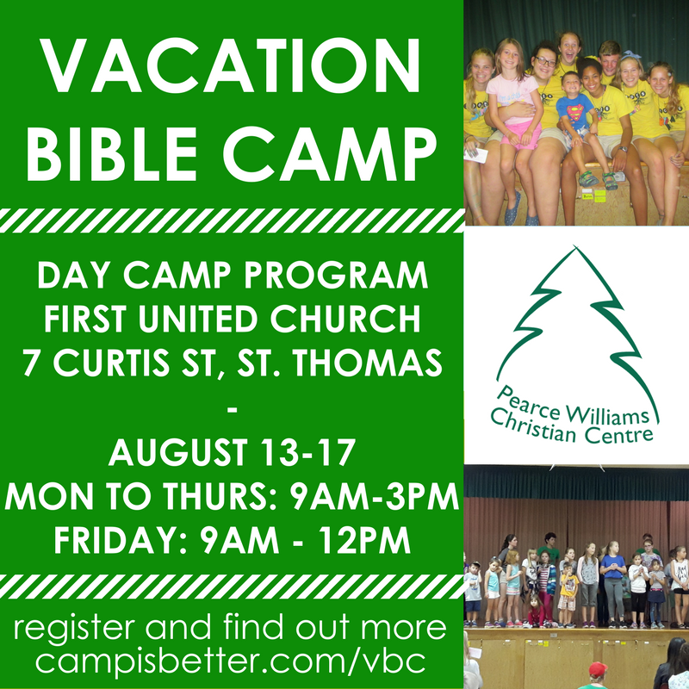

First United Church
Seeking to be a welcoming community of Christian faith, proclaiming and celebrating the love of God in Jesus Christ through the Inspiration of the Holy Spirit

Sunday, May 13, 2018
10:30am

7 Curtis St., St. Thomas, ON N5P 1H3
Phone: (519) 631-7570 Fax: (519) 631-2052
Church Office Email: office@1stunitedchurch.ca
Rev. Emmanuel’s Email: minister@1stunitedchurch.ca
web: www.1stunitedchurch.ca

MINISTERS: ALL THE PEOPLE OF GOD
Pastoral Minister: Rev. Emmanuel K. Ofori
Music Minister: Jody McDonald-Groulx
Secretary/Treasurer: Lori Hoffman
Custodian: Dave Luftenegger

