First United Church
Seeking to be a welcoming community of Christian faith, proclaiming and celebrating the love of God in Jesus Christ through the Inspiration of the Holy Spirit

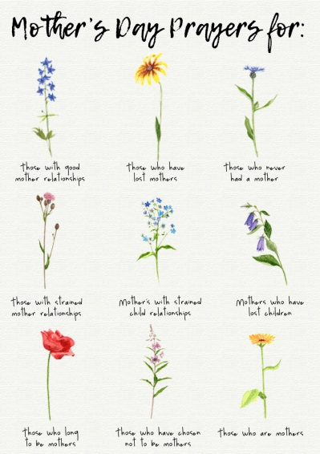

May 12, 2019 @ 10:30am

Fourth Sunday of Easter

ORDER OF SERVICE
Opening Prayer
Choruses/Songs
- MV#182 “Grateful” (2x)
Grateful for the life your give us, thankful for your Holy Son,
Joyful in your spirit flowing over all, O God of Love.
Grateful for the Bread of Heaven, thankful for your Holy Word,
Joyful in your mercy flowing, we will praise you.

- MV#122 “This is the Day” (2x)
This is the day that God has made; we will rejoice and be glad!
This is the day that God has made; we will rejoice and be glad!
Singing hallelu, singing hallellu, singing hallelu,
we will rejoice and be glad!
Singing hallelu, singing hallellu, singing hallelu,
we will rejoice and be glad!

- MV#18 “Lord, Prepare Me…” (2x)
Lord, prepare me to be a sanctuary, pure and holy tried & true; with thanksgiving, I’ll be a living sanctuary for you.

Welcome/Notices

Call to Worship

Anthem: Children’s Choir

Circle Time

Prayers/The Lord’s Prayer

Invitation to Invest in God’s Mission

Offertory Hymn/Prayer of Dedication

God of Love, hear our prayer. Bless this offering we bring you.

May our lives do your will. Guide and guard us forever.

Give us courage to stand for truth, help us give to others.

God of Love, hear our prayer. Bless this offering we bring you.

Hymn: MV#195 “Long Ago & Far Away”

Communion

Scripture Reading: Isaiah 42:13-15

Hymn of Preparation VU #580 – “Faith of Our Fathers”

The Message: “My Faith Journey as a Mother”
(Rev. Emmanuel K. Ofori & Sherry Johnstone)
Prayer

*Closing Hymn: VU#337 “Blessed Assurance”

* Benediction

* Commissioning Hymn: VU#298 “When You Walk From Here”
When you walk from here, when you walk from here,
walk with justice, walk with mercy, and with God’s humble care.

Musical Postlude

7 Curtis St., St.Thomas, ON N5P 1H3 Phone: (519) 631-7570
e-mail: office@1stunitedchurch.ca
web: www.1stunitedchurch.ca
MINISTERS: ALL THE PEOPLE OF GOD
Pastoral Minister: Rev. Emmanuel K. Ofori
Music Minister: Jody McDonald-Groulx
Secretary/Treasurer: Lori Hoffman
Custodian: Dave Luftenegger
TODAY’S MESSAGE

A Litany: We Thank God For Mothers

One: Mothers come in many different forms, and today we celebrate them all!
All: Thank God for mothers!

One: Everyone here is either a son or a daughter.
All: Thank God for my mother!

One: For those women who have joined God in Heaven and whom we miss dearly here on earth.
All: Thank God for the mothers of the past.

One: For every woman who is working day and night to raise her children right now.
All: Thank God for the mothers of today.

One: For all the women who are expecting, but aren't quite mothers yet!
All: Thank God for the soon-to-be-mothers.

One: For the women who took in others' children through adoption and foster care.
All: Thank God for the mothers with hearts so big.

One: For those women who have lost a child to death and must carry on.
All: Thank God for the mothers who are so strong.

One: For all the women who have desperately wanted to have children of their own, but chose instead to mother everyone else.
All: Thank God for the mothers in spirit.
We thank you, Lord, for the women who have influenced our lives in so many ways. We pray that we will honor them in everything we do. Amen.

Think about this
We thank God for lives of our mothers and mother-figures – what are some of the things your mother or mother-figure has done that you are thankful to God for.

Next Week:
“The lessons my mother or mother-figure taught me about God”
(2 Timothy 1:3-7)

