First United Church
Seeking to be a welcoming community of Christian faith, proclaiming and celebrating the love of God in Jesus Christ through the Inspiration of the Holy Spirit

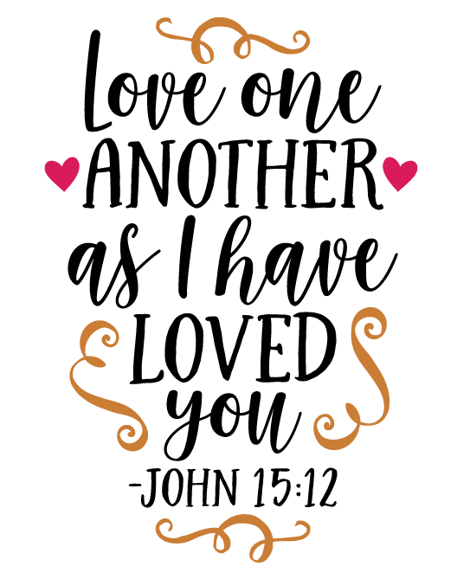

Communion Sunday
May 06, 2018 @ 10:30am

7 Curtis St., St.Thomas, ON N5P 1H3 Phone: (519) 631-7570
e-mail: office@1stunitedchurch.ca
web: www.1stunitedchurch.ca
MINISTERS: ALL THE PEOPLE OF GOD
Pastoral Minister: Rev. Emmanuel K. Ofori
Music Minister: Jody McDonald-Groulx
Secretary/Treasurer: Lori Hoffman
Custodian: Dave Luftenegger

Sixth Sunday of Easter
CELEBRATION OF HOLY COMMUNION
Sunday, May 06, 2018 - 10:30 a.m. Worship
Preacher: Rev. Emmanuel K. Ofori

Notes: Asterisk (*) – You may stand if comfortable doing so
VU = Voices United MV = More Voices

God Gathers Us Together

Musical/Choral Prelude
- Lord, listen to your children praying, Lord, send your Spirit in this place; Lord, listen to your children praying, send us love, send us power, send us grace.

- We are one as we feast, as we feast, peace becomes the sign; in the bread and the wine there’s a sense of love divine. We are one as we come, as we feed, we are fed; and we feel God’s refreshing grace as we meet at table in this place.

* Procession Hymn: VU#220 “Praise to the Lord, the Almighty”

Life and Work of the Church [see insert]

Welcoming of Visitors

God Draws Us Near To Worship

Call to Worship
One: Beloved, we are called to love one another, because love is from God.
All: God’s love is poured in us from our birth.

One: We are called to extend the love of God to all people.
All: God’s loved is taught to us through the witness of God’s faithful people.

One: We are called to proclaim God’s love in all that we say and do.
All: In all creation, in all our relationships, may God’s love be made known. AMEN.

Prayer of Praise and Adoration
Prayer of Confession (John 15)
One: Jesus, friend and brother,
you taught us to abide in your generous love,
for it completes our lives and gives us joy;
All: you ask us to love others as you have loved us,
for it brings your creation to fruition.
One: We sometimes struggle to love the people in our lives as you have loved us.
All: Forgive us, we pray, and teach us your love again. Amen.

Words of Assurance (John 15:15b-16a)
One: Long ago Jesus said to his disciples,
“I have called you friends, because I have made
known to you everything that I have heard from [God].
You did not choose me, but I chose you!” Jesus speaks these words to us today. Jesus forgives us and chooses us to be His friends, sharing his great work of love.
All: Hallelujah! Thanks be to God. Amen

Intercessory Prayer / The Lord’s Prayer (VU #960)
Senior Choir Anthem

God Invites Us To Listen For His Word

Old Testament Reading: Acts 10:44-48
Reader: This is the Word of God
All: Thanks be to God

Gospel Reading: John 15:9-17
Reader: This is the Gospel Message
All: We Praise You O Christ

* Hymn of Preparation: MV #145 “Draw the Circle Wide”
The Message: “Break Barriers, Build Bridges”

God Invites Us To Respond To His Love
Offertory
Hymn of Dedication
God of love, hear our prayer, bless this offering we bring you.
May our lives do your will, guide and guard us forever.
Give us courage to stand for truth, help us give to others.
God of love, hear our prayer, bless this offering we bring you.

Offertory Prayer

God Invites Us To Break Bread Together

Communion Hymn: VU#602 “Blest Be the Tie That Binds”

The Lord be with you.

And also with you

Lift up your hearts

We lift up our hearts unto the Lord

Let us give thanks to God

It is good and pleasant to give God thanks and praise

It is a good and pleasant thing, our joy and our moral duty, always and everywhere to give you thanks and praise, O Lord, God, ever-loving and ever-blessed, Almighty and all-loving.

Therefore, with angels and archangels, and with all the heavenly host, we join in the blessed hymn of everlasting praise saying …
Holy, holy, holy,
LORD God of hosts,
heaven and earth are full of your glory.
Hosanna in the highest.
Glory be to you, O Lord, most high. Amen.

*Affirmation of Faith (The Apostles’ Creed)

I believe in God,
the Father Almighty,
Creator of heaven and earth,
and in Jesus Christ, His only Son, our Lord,
who was conceived by the Holy Spirit,
born of the Virgin Mary,
suffered under Pontius Pilate,
was crucified, died and was buried;
He descended into hell;
on the third day He rose again from the dead;
He ascended into heaven,
and is seated at the right hand of God the Father Almighty;
from there He will come to judge the living and the dead.

I believe in the Holy Spirit,
the Holy Catholic Church,
the communion of Saints,
the forgiveness of sins,
the resurrection of the body,
and life everlasting.
Amen.

The Institution
Blessed are you, Lord God, King of the universe, and blessed is your Son Jesus Christ our Lord; who on the night He was betrayed and arrested He turned to His disciples and said,

All: “I give you a new commandment, that you love one another. Just as I have loved you, you also should love one another. By this everyone will know that you are my disciples, if you have love for one another”.

Then Christ took bread and looking up to heaven gave thanks, broke it and gave it to His disciples, saying,
All: “Take this and eat it. This is my body given for you. Do this in remembrance of me.”

In the same way after Supper He took the cup, gave thanks and gave it to them saying,
All: “Drink from it, all of you. This is my blood of the new covenant poured out for you and for many for the forgiveness of sins. Do this whenever you drink it in remembrance of me.”

Therefore, let us proclaim the mystery of our faith …
All: Jesus Christ has died

Jesus Christ is risen

Jesus Christ will come again

For deep in my heart, I do believe

That Jesus Christ will come again

(Sung to tune: “We Shall Overcome” Traditional – arranged by compilers)

Prayer of Consecration
Invitation & Distribution of Elements
Prayer of Thanksgiving

God Sends Out Into the World to Serve

*Closing Hymn: “They’ll Know We Are Christians by Our Love”
We are One in The Spirit,
We are One in The Lord.
We are One in The Spirit,
We are One in The Lord.
And we pray that all unity may one day be restored.

Refrain
And they'll know we are Christians by our love,
By our Love,
Yes they'll know we are Christians by our love.

We will walk with each other,
We will walk hand in hand.
We will walk with each other,
We will walk hand in hand.
And together we'll spread the News
that God is in our land. R

We will work with each other,
We will work side by side.
We will work with each other,
We will work side by side.
And we'll guard each man's dignity
And save each man's pride. R

All praise to the Father,
From whom all things come,
And all praise to Christ Jesus,
His only Son
And all praise to the Spirit,
That makes us one. R

* Benediction
*Sending Forth
Threefold Amen
Commissioning Hymn: VU#298 “When You Walk From Here”
When you walk from here, when you walk from here,
walk with justice, walk with mercy, and with God’s humble care.

* Musical Postlude

TODAY’S MESSAGE
A new phase in the work and expansion of the early church began when it found itself forced to decide about its attitude to those who were not Jews.

God breaks through human limitations
God taught Peter to accept Cornelius, the gentile army officer. Whether or not Peter understands or even agrees with the expanse of God’s action, his encounter with Cornelius brings him to accept the limitless reach of God.

God is saying to all who live outside, beyond the barrier of separation from God:
I have come to life in Jesus Christ and in the presence of the Holy Spirit to break down all that separates you from me. As with Cornelius, I have heard your prayers. I have come to visit your house no matter how humble it might be. I pour out my Spirit of life upon you. I break down the barriers of sin, Satan, and death that have kept you from me. Even to you this day I give the possibility of repentance unto life.

God is saying to you and me
Armed with the knowledge of the limitless reach of God,
- go out to all those who live outside,
- break down all barriers and walls of hostilities
- build bridges and invite ALL to come in

Draw the circle wide; and wider still.
How can you do this?

Think about this
- What barriers in your life need to be broken? How?

- What has been your attitude to those who are different than you? In terms of gender, race, ethnicity or class/status?
- How can we break down barriers, and begin to build bridges for others to come to know Christ and, perhaps, join this local congregation?

