First United Church
Seeking to be a welcoming community of Christian faith, proclaiming and celebrating the love of God in Jesus Christ through the Inspiration of the Holy Spirit

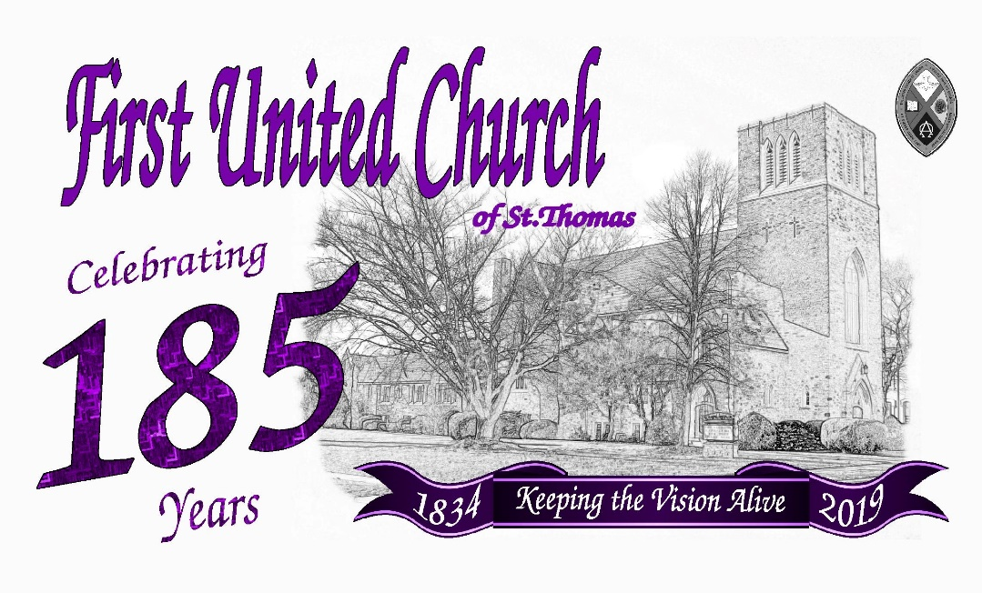

Sunday, March 31, 2019 @ 10:30am

7 Curtis St., St. Thomas, ON N5P 1H3 Phone: (519) 631-7570
e-mail: firstunited@bellnet.ca
web: www.firstunitedchurch.weebly.com

MINISTERS: ALL THE PEOPLE OF GOD
Pastoral Minister: Rev. Emmanuel K. Ofori
Music Minister: Jody McDonald-Groulx
Secretary/Treasurer: Lori Hoffman
Custodian: Dave Luftenegger

From the Minister’s Desk
Congratulations, sisters and brothers. We are one hundred and eighty-five years, Hurray! We have been resilient in times of fires burning down our church buildings and other challenges, relying on God’s word which says, “Not by might nor by power, but by (God’s) Spirit” (Zechariah 4:6). Therefore, today, we can sing joyfully with Albert Goodson that:
“We’ve come this far by faith,
Leaning on the Lord,
Trusting in his holy Word
He has never failed me yet.”
Hannah and the children – Samuel, Emmanuella, Grace and Stephen – join me to congratulate First United Church as we celebrate 185 years of faith-full ministry.
Let us keep the faith and spread it gently.
I am your fellow worker and friend,
Rev. Emmanuel Kwadwo Ofori

Fraternal Greetings from Rev. Don Parsons
Dear First friends.
Marg. and I are very honoured to be invited to share in this special anniversary year.

Our time with you (1973-81) was memorable for our family, and we continue to cherish the relationships we enjoyed during that lively time at First.

May your 185th anniversary year be flavoured with profound worship, delightful celebrations, and a renewed passion for the vital ministry and mission you are called to share in this community.

Rev. Don Parsons

Karen Vecchio, MP, Elgin-Middlesex-London
First United Church is filled with 185 years of history. It is filled with families, young and old. It is filled with music. It is filled with the Word of God. But most of all, it is filled with Love.

The church has witnessed times of peace, and times of war. It has been a home to many great Canadians, who have served our nation well. It is a place where the community can come for assistance through counselling, prayers and friendships. It is truly a place where everyone is welcome, and where people are encouraged to wholeheartedly love their neighbours.

As we come together to celebrate the 185th birthday of First United Church, I would like to extend my congratulations on this incredible milestone. I am proud to represent the congregation of this magnificent church for all that it does and all that it stands for.

Best Wishes,
Karen Vecchio,
MP, Elgin-Middlesex-London

Jeff Yurek, MPP, Elgin-Middlesex-London
I would like to extend my sincere congratulations to the congregation of First United for 185 years of faith, family, and fellowship. What a momentous occasion to celebrate this fixture of our city. Indeed, the history of First United is deeply intertwined with that of St. Thomas, and you are part of a proud legacy of parishioners who have made significant contributions to the community.

The symbol of the bell is uniquely meaningful to the story of First United. It was first a steadfast call to worship, then a sign of hope among the ashes, then a relic of memory. All of these reflect a remarkable church history and are an inspiration for its future.

On behalf of the Province of Ontario and the constituents of Elgin-Middlesex-London, please accept my best wishes for a wonderful celebration and many more anniversaries to come.

Sincerely,

Jeff Yurek, MPP
Elgin-Middlesex-London

The Mayor, City of St. Thomas
185 years of gathering people together in St. Thomas. Families growing, marriages, funerals, summer picnics and Christmas pageants. A mix of fun and worship make a community church vibrant.

Memories of 185 years and more memories made each week. Congratulations on this milestone.

Mayor Joe Preston

Councillor, Gary Clarke
I wish you much continued success and thank you for being such an important St Thomas community partner. Your presence as a Church has provided much guidance, support and leadership to so many. Good luck as you continue to live the vision!

From St. Andrew’s United Church
“The only thing that counts is faith working through love.” (Gal 5:6)
Dear Friends at First United Church: Your neighbours at St Andrew’s join you in spirit today, celebrating your 185th year of worship, witness, and service in our midst. With joy we bless you all, taking Paul’s words to the Galatians as our inspiration: May your faith in God grow ever stronger, may your work in Christ’s name prosper, and may your love through the Spirit’s guidance unite you in peace and joy. Amen.

From St. John’s Anglican Church
We wish you a very happy 185th anniversary and all the best in the many years of worship and service to come.
* You are invited to stand if comfortable doing so

VU = Voices United MV = More Voices

We Gather Together
Opening Prayer
Choral Prelude
- “That’s Why We Praise Him” (Chorus only) (2x)
That’s why we praise him, that’s why we sing
That’s why we offer him our everything
That’s why we bow down, and worship this King
‘Cause He gave His everything
‘Cause He gave His everything.

- MV#18 “Lord, Prepare Me” (2x)
Lord prepare me, to be a sanctuary,
pure and holy, tried and true.
With thanksgiving, I`ll be a living
sanctuary for you.

Lighting of the Christ Candle
Passing of the Peace (VU# 958 “Halle, Halle, Halle” 3x)
Life and Work of the Church
Welcome/Fraternal Greetings

We Draw Near to Worship
Call to Worship
One: I will lift up mine eyes to the hills
From whence comes my help?
All: My help comes from the Lord,
Who made heaven and earth.
One: We’ve come this far by faith
Leaning on the Lord
Trusting in His Holy Word
He’s never failed us yet.
All: On this day, we celebrate and give glory to our God.
One: Let everything that hath breath praise the Lord
All: We declare in one resounding voice, praising the Lord for one hundred and eighty-five years!

Youth Presentation/Bell Ringing
Sunday School may go downstairs

*Hymn: VU#820 “Make a Joyful Noise”
Refrain:
Make a joyful noise all the earth! Worship your God with gladness.
Make a joyful noise all the earth. Come to this place with a song!

- Know that your God has made you. Know it’s to God we belong.
And come to this place with joyfulness and praise.
Worship your God with a song! (Refrain)

- Enter these gates, thanksgiving. Enter these courts with praise.
Sing thanks to your God and bless the Holy Name.
Worship your God with a song! (Refrain)

- Ages through endless ages, seasons of endless years,
the love of our Maker ever shall endure.
Worship your God with a song! (Refrain)

Litany of Thanksgiving
Leader: We rejoice in the Lord our Maker who has looked upon us with favour!
All: We give thanks to God for our forebears.
Leader : We recall the labour of our ancestors who heard God’s call, covenanted together more than two centuries ago.
All: We give thanks to God for our ancestors and ancestresses.
Leader : We delight in the grace of our God who provides us with spiritual food and give thanks for the lives of our pastors whom you have called into their eternal rest.
All: We give thanks for your faithfulness, O God.
Leader : For the lives of our living and current pastors, staff and volunteers.
All: We give thanks for your faithfulness, O God.
Leader : We give thanks for those who have supported and continue to support us.
All: Lord, we give you thanks.
Leader : Glory be to our Triune God.
All: As it was in the beginning, it is now and ever shall be, world without end. AMEN

Prayer of the People
The Lord’s Prayer (sung VU# 960)
Anthem: Senior Choir
We Respond in Love
Offering: Soloist - Kelsey Bradley
Hymn/Song of Dedication
God of Love hear our prayer, bless this offering we bring you.
May our lives do you will, guide and guard us forever.
Give us courage to stand for truth, help us give to others.
God of Love hear our prayer, bless this offering we bring you.

Offertory Prayer

We Listen for God’s Word
* Hymn of Preparation: VU #642 “Be Thou My Vision”
1. Be thou my vision, O joy of my heart;
naught be all else to me, save that thou art,
thou my best thought, by day or by night,
waking or sleeping, thy presence my light.
2. Be thou my wisdom, my calm in all strife;
I ever with thee, and thou in my life;
thou loving parent, thy child may I be,
thou in me dwelling, and I one with thee.
3. Be thou my battle shield, sword for the fight;
be thou my dignity, thou my delight,
thou my soul's shelter, thou my high tower;
raise thou my heavenward, O power of my power.
4. Riches I heed not, nor vain empty praise,
thou mine inheritance, now and always;
thou and thou only, first in my heart,
great God of heaven, my treasure thou art.
5. Great God of heaven, after victory won,
may I reach heaven's joys, O bright heaven's sun!
Heart of my own heart, whatever befall,
still be my vision, O ruler of all.
Scripture Readings Matthew 20:1-16
Reader: This is the Word of God
All: Thanks be to God.

The Message: “Living into the Vision According to God’s
Weird Math”

Affirmation of Faith (Unison)
We are not alone,
we live in God’s world.
We believe in God:
who has created and is creating,
who has come in Jesus,
the Word made flesh,
to reconcile and make new,
who works in us and others
by the Spirit.
We trust in God.
We are called to be the Church:
to celebrate God’s presence,
to live with respect in Creation,
to love and serve others,
to seek justice and resist evil,
to proclaim Jesus, crucified and risen,
our judge and our hope.
In life, in death, in life beyond death,
God is with us.
We are not alone.
Thanks be to God.

We Go Out to Serve
*Closing Hymn: VU#288 “Great is Thy Faithfulness”
- Great is thy faithfulness, God our Creator,
there is no shadow of turning with thee;
thou changest not, thy compassions, they fail not;
as thou has been thou forever wilt be.

[Refrain:]
Great is thy faithfulness!
Great is thy faithfulness!
Morning by morning new mercies I see;
all I have needed thy hand hath provided --
great is thy faithfulness, ever to me!

- Summer and winter and springtime and harvest,
sun, moon, and stars in their courses above
join with all nature in manifold witness
to thy great faithfulness, mercy and love. [Refrain]

- Pardon for sin and a peace that endureth,
thine own dear presence to cheer and to guide,
strength for today and bright hope for tomorrow --
wondrous the portion thy blessings provide. [Refrain]

* Benediction
* Triple Amen
* Commissioning Hymn: VU#884 “We Shall Go Out With Joy”
You shall go out with joy and be led forth with peace;
the mountains and the hills will break forth before you;
there’ll be shouts of joy, and all the trees of the field
will clap, will clap their hands!

And all the trees of the field will clap their hands,
the trees of the field will clap their hands,
the trees of the field will clap their hands
while you go out with joy!

* Musical Postlude

Thank you for taking the time to celebrate with us.
You are invited to join us for light lunch and
the Cutting of the Anniversary Cake

185 Years of Faith: Proud Past, Bright Future
One of St. Thomas’s oldest and most respected churches has reached an impressive milestone. The First United Church is excited to be taking this year to celebrate 185 years of spreading faith in this community.

“Over 30 years before the confederation of Canada our little church formed and connected with this community. Even with a few set backs our faith and congragation has continued to grow” says First United Church board member Richard Routhier

As part of the church celebrations this year, the church is hosting its former ministers. On March 31st, Reverend Don Parsons who was the church’s leader during the 70s and early 80s, will return to preach at 10:30 a.m. And, of course birthday cake will be part of the celebration following the service. The broader community is invited to come and be a part of our celebrations throughout the year.

In January of 2018, the church welcomed Reverend Emmanuel Ofori, his wife Hannah and their children Stephen, Grace, Emmanuella and Samuel to the community of faith. He brings a variety of experiences to the church having grown up in Ghana, West Africa, serving in Selkirk, Ontario and in Montreal at Union United Church. “I’m excited to be part of this exciting event and I can’t wait to see what God has in store for us in the next 185 years.” Says Reverend Ofori.

About First United Church
The First United Church congregation had its beginning as a small Methodist church built in 1834 on Stanley Street. The congregation began to gather at the corner of Curtis and St. George Streets and a new church was built in 1873. After suffering two fires, 1895 and the most recent being in March of 1946, the church was rebuilt as you see it today. During that 1946 fire, the church was destroyed, and the bell fell from the belfry. As part of the fundraising for the new building, the large bell was melted down to make small hand-held bells. Members of the congregation banded together and amazingly enough, the mortgage was paid off in short order and money was put away in investments to provide for future needs including the addition of a Christian Education wing at the back of the church in the 1950s. An archival video details the construction techniques of the late 1940s.

The financial forethought of the predecessors as well as the generosity of current members has enabled the church to do much good work in our community and abroad. Dr. George T. Kennedy, a local medical practitioner, was a centenarian who bequeathed money to the church and the head office of the United Church. These monies are still used today for the good work of the church. Support for the residents of an African village, a congregation in Bella Coola, British Columbia, refugee families from Laos and Syria, Pearce Williams, and more local charities including supporting families in need, have been part of the outreach.

The “2020 Vision” (results from congregational soul searching in 2017) is summarized in the following statement: “First United Church seeks to be a vibrant community of faith engaging ALL with a focus on youth and young families in ministry and reaching out to the world with the love of God in Christ.” The church’s activities are focused on and reflect that vision.

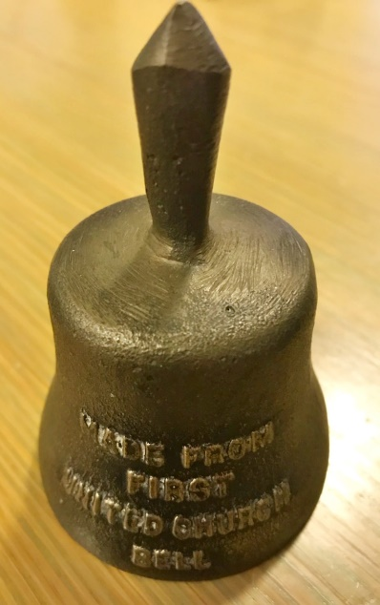
Most recently, the church entered a float in the 2018 St. Thomas Santa Claus parade and held a carol sing complete with hot chocolate following that event. About 60 new-to-the-church individuals attended. Youth groups for students in grades 7 & 8 and grades 9 to 12 are part of the conscious outreach to the youth of our community. In fact, the youth have taken on projects including fundraising for “Inn Out of the Cold,” the Grace Café and they took part in the Salvation Army’s Kettle Drive at Christmas.
Officiating Clergy
Rev. Emmanuel K. Ofori, Host Minister, First United Church
Rev. Don Parsons, Guest Preacher

Official Board Members
Richard Routhier – Vice Chair
Lois Whiteman – Secretary

Christian Development/Membership Committee
Richard Routhier (C), Lisa Bosveld, Erin Chute, Justin Chute, Chris Ross, Sharlene Scott

Finance Committee
Don Renaud (C), Ray Bosveld

Ministry & Personnel Committee
Marisa Tippett (C), Ray Bosveld, Mark Snowsell

Property Committee
John Surmacz (C), Richard Auckland, Lyle Cameron

Worship & Music Committee
Mary Virginia Towers (C), Karen Auckland, Mike Muma

Team 185
Karen & Richard Auckland, Lisa Bosveld, Erin & Justin Chute, Sherry Johnstone, Mike Muma, Chris Ross, Richard Routhier, Mary Virginia Towers, Sara Turner.
Thank you to Kelsey Bradley
for sharing her gift of song with us this morning.

Thank you to Treana & Bob Fellows (Fellows Fernlea Flowers)
for donating the beautiful flowers this morning.

