First United Church
Seeking to be a welcoming community of Christian faith, proclaiming and celebrating the love of God in Jesus Christ through the Inspiration of the Holy Spirit

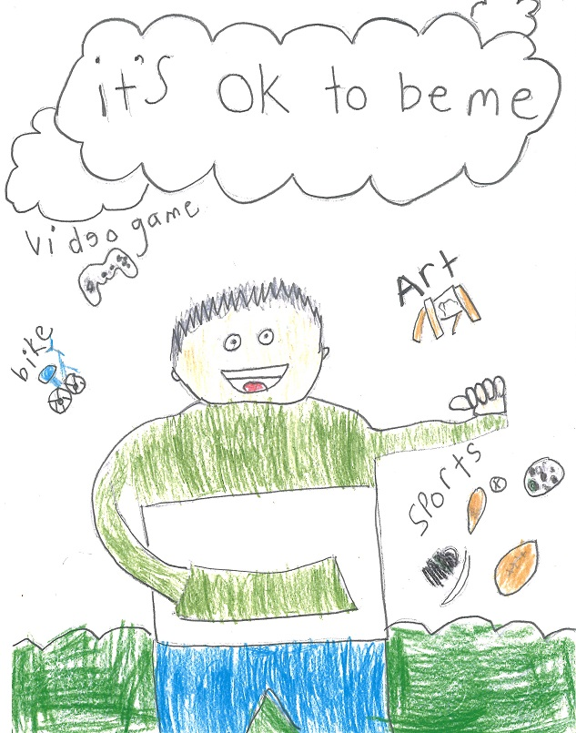
Jesus Says…

By Kyle T.
March 15, 2020 @ 10:30am

Order of Service
* You are invited to stand if comfortable doing so

VU = Voices United MV = More Voices

9:30am Conversational Church: “Listening for the Song of Faith”

10:25am Gathering in Song
“Give Me that Old Time Religion”
“I Saw the Light”

Opening Scripture: Psalm 63
One: You are my God, I long for you from early morning.
My whole being desires you like a dry, worn, waterless land.
My soul thirsts for you.
All: In the sanctuary let me see how mighty are your works,
Your constant love is better than life itself,
And so I will praise you.
One: I will give thanks as long as I live;
I raise my hands in prayer.
All: My soul will feast and be filled,
And I will sing and praise you.
One: As I lie in bed, I remember you, O God;
I think of you all night long, for you are my constant help.
All: In the shadow of you wings I sing for joy.
I cling to you, your hand keeps me safe.

SONG: “As the Deer Panteth for the Water“ VU pg. 780 (v 1,2)

Opening Prayer (Music continues in the background)
Pray for yourself.
Pray in thanksgiving for God’s grace to redeem you and call you to Himself in love. In light of that truth, pray for a whole-life devotion to Jesus. Confess to God the area(s) of your life where you have neglected following and obeying Jesus.

Pray for the next generation.
Pray for the discipleship of your family, and ask God to give you an integral role in shaping the next generation for His sake. Beyond your family, pray also in the spirit of 2 Timothy 2:2, that God would use you to multiply your faith in others. Pray with hopeful expectation that your influence will reach to generations of people long after you are gone!

Pray for a discipleship movement.
Pray that churches and Christians would see the Great Commission of Matthew 28 as our purpose for life. Everyone is being “discipled” into some way of life, so pray that we would see an increasing commitment to the way of Jesus take root in our communities. (Prayer from the Harvest Church)

Song: “As the Deer Panteth for the Water” VU pg#780 (v 1,3)

Welcome (Life & Work of the Church)

Lighting the Christ Candle
Sing: I am the light of world, you people come and follow me.
If we follow and love, we’ll learn the mystery
Of what we were meant to do and be.

Passing of the Peace:
Let us greet one another with these words
(instead of handshakes during this cold & flu season)
Greeting: The Peace of Christ be with you.
Response: And also with you!

Sing: Halle, Halle, Halle, lu jah! Halle, Halle, Halle, lu jah!
Halle, Halle, Halle, lu jah! Halle lu jah! (clap) Halle lu jah!

Conversation with the Young People

Hymn: VU#365 “Jesus Loves Me”
During the Hymn the children & youth are invited to leave for Church School.
Prayer/The Lord’s Prayer

Offering Ourselves, Tithes & Gifts: Paula & Carlene
Dedication Hymn: (tune “Eidelweiss”)
God of Love, hear our prayer. Bless this offering we bring you. May our lives do Your will; guide and guard us forever. Give us courage to stand for truth; help us give to others. God of Love, hear our prayer, Bless this offering we bring you.

Scripture Reading: John 15:1-7, 18-25

The Reflection: “Loving God. Living Word.
Series on Different Theologies Part 3 –
Fundamentalist Theology”
Prayer

*Hymn: VU#266 “Amazing Grace”

*Commissioning/Benediction
Closing - Sing: VU#209 “Go Make A Difference”
Go make a diff’rence, We can make a diff’rence.
Go make a diff’rence in the world.
Go make a diff’rence, We can make a diff’rence.
Go make a diff’rence in the world.

Musical Postlude

LIFE & WORK OF THE CHURCH
March 15, 2020

Thank you to Paula Thomas for sharing her musical gifts with us this morning. Jody is back next week!

Happy birthday to: Bob Nicol, Jonathan Renaud, Hannah Bosveld,
Rick West, Abby Visser.

*TODAY: *Join us for Coffee, Cold drinks & Conversation in the Fellowship Room following worship.

At First we love having a time of Fellowship after Worship on Sundays! It’s a time to greet friends, new and old, over a drink & maybe a goody!! If this is something you would enjoy hosting, you are invited to sign up on the sheet in the Fellowship Room (Drinks supplied – coffee would just need to be put on in the morning! We’d love to have you!

*Would you be willing to participate or lead the worship service? If so please speak to Rev. Daryl, Richard Auckland or one of the worship team leaders.

This week:
Monday: *Coffee & Conversation with Rev. Daryl from 10-11am. All welcome!
Tuesday: *EarlyON Playgroup in the Gym - 9:30 – 11:30am
*First Youth with Chris Ross & Justin Chute in Room 3/Gym from 7-8:15pm.

Thursday

*Sr. Choir @ 7:30pm! Don’t be shy – singing’s great for the soul – come and give it a try!
Next Sunday
9:30am Conversational Church: “Listening for the Song of Faith”
10: 25am Gathering in Song
*After worship on Sunday, March 22 the Quarter Auction Team would appreciate some help setting up tables in the Assembly Hall! If you can help, meet them downstairs after worship next Sunday! Thank you!

Upcoming Dates & Events
Monday, March 23 - We will be holding our 2nd Quarter Auction!
Doors open at 6 p.m. Auction starts at 7:00 p.m.
We will have vendors for shopping and food will be available for purchase. Join us for this super fun event! Admission is $5 (includes 1 paddle) Extra paddles are $2 each.

Anniversary Sunday – March 29, 2020
As our “185” celebrations come to a close, we celebrate the 70th anniversary since the sanctuary was opened on March 5, 1950!
We invite you to attend a special service on Sunday, March 29, 2020. During that service we will have a look back at some of our history through your eyes and then look to the future and the next 185+ years. Following the service there will be a chili luncheon. A variety of chili, buns, caeser salad and drinks will be provided (including a gluten free option). Local historian, St. Thomas alderman, Steve Peters will be talking about the church’s history at the luncheon following the service.
Invitation to contribute stories: We are inviting members of our congregation and community to contribute to the story that is First United Church. Perhaps you or your family have a special connection with the church, have an interesting story of your involvement or have a longer history as a member. We’d ask that you submit your story by sending it to Richard Auckland at rauck27@gmail.com or dropping it off in the church office. You may also handwrite your story and submit it (we may retype these to provide an opportunity for people to read them as they will be posted on the wall).
The intent is that your story will become part of a large timeline that will be posted in the hall on the way into the sanctuary by the Fellowship Room. Below are a couple of sample submissions, but you may have your own thoughts. If you have pictures feel free to include those as well.

Sample Church History Submissions
Please include the date (approximate is fine), your name and brief story or history of your family’s involvement at First United Church. If you happen to have a picture to include that would be great.
1946 – Some members of the Auckland Family have attended First United since the 1940s. My parents were wed at Talbotville United Church in 1948, moved to Pearl Street and attended the church. Lloyd (my dad) served on the Board, the Trustees and was witness to the horrific fire in 1946 which burned the church beyond repair. As leader of the Argonauts and Argonettes (the youth group), and as a local teacher, he taught many of St. Thomas’ future leaders. My mother, Phyllis, was an original member of the United Church Women (UCW) at the church. All five of us children were baptised and raised in the church. My sister, Sandra (& Mike), 1971 and our son Jon (& Laura), 2018 were wed in the church. A fond memory is coming to church and sitting in the south transept. It was always warm there with the heater on and the sun would often shine through. The Sandersons, the Parsons and other families sat in the same transept for many years as I grew up.
Submitted by Richard Auckland

1970s – A fond memory for me was growing up with Lloyd, my father leading the Argonettes and Argonauts. As a youngster, I was permitted to go tobogganing at Union Golf Course with the older crowd. After a really long run, I continued on into the creek and got a real soaker!
Submitted by Richard Auckland

On Anniversary Sunday, March 29 we will be kicking off an “Anniversary Fundraiser”. There will be 186 marked envelopes posted. You are invited to choose an envelope (or multiple envelopes) and fill them with the amount of dollars marked on the outside of the envelope (of course you are always more than welcome to donate more if you wish ). When we fill all of the envelopes we will have raised $18,000! We appreciate your participation! This will go a long way in helping us meet expenses!

PWCC
Registration is open for Pearce Williams Summer Camp Programs!
June 26 - 29: Family & Alumni Camp Weekend (ages 0-99)
July 5 - 10: Counsellor-In-Training Adventure (age 15 by July 12th)
July 12 - 17: July All Ages Camp (ages 7-14)
Wilderness I (ages 10-14)
July 19 - 24: Sports & Arts Camp (ages 7-12)
World Camp Week (ages 11-15)
July 26 - 31: Girls All Ages Camp (ages 7 -14)
Aug 3 - 7: Leadership Camp (ages 11-15)
Wilderness II Jr. (ages 9-12)
Aug 4 - 7: Primary Camp (ages 5-9)
Aug 9-14: August All Ages Camp (ages 7-14)
Wilderness III Girls Only (ages 10-14)
Aug 16-21: Youth Camp (ages 11-15)
For more info visit campisbetter.com

Both Lori & Jody are on vacation this week (March 15-21)
Jody will return next Sunday, March 22 for worship.
Lori will return Monday, March 23 @ 8:30am

*Official Board Minutes are posted on our church website (www.1stunitedchurch.ca) under the “Official Board Hub” tab.
Email Lori (office@1stunitedchurch.ca) for the password if required.

Church Office Hours
Monday to Thursday 8:30am to 3:30pm
(Closed from 12-1pm for lunch)

7 Curtis St., St.Thomas, ON N5P 1H3 Phone: (519) 631-7570
e-mail: office@1stunitedchurch.ca web: www.1stunitedchurch.ca
MINISTERS: ALL THE PEOPLE OF GOD
Intentional Interim Minister: Rev. Daryl Webber
Music Minister: Jody McDonald-Groulx
Secretary/Treasurer: Lori Hoffman Custodian: Dave Luftenegger

