Fourth Sunday of Lent

PREACHER: Rev. Emmanuel K. Ofori
* You are invited to stand if comfortable doing so

VU = Voices United MV = More Voices

We welcome Paula Thomas as our Music Leader this morning.
Jody will be back next Sunday!

We Gather Together
Choral Prelude
Halle, Halle, Halle, Halle-lujah, Ha-lle-lujah
Halle, Halle, Halle, Halle-lujah, Ha-lle-lujah
Hallelujah, Hallelujah, Hallelujah Praise the Lord
Hallelujah, Hallelujah, Hallelujah Praise the Lord

Opening Prayer
*Hymn: VU #266 “Amazing grace”
Lighting of the Christ Candle
Passing of the Peace (VU 958 “Halle, Halle, Halle”)
Welcome
Life and Work of the Church (see insert)

We Draw Near to Worship
Call to Worship
One: God loves us with a steadfast love.
All: Let the redeemed of the Lord say so!
One: God loves us so much he gave us his Son.
All: Let us believe and have eternal life!
One: God loves us with a great love, rich in mercy.
All: Let us have faith to receive this grace!
One: Give thanks to the Lord, for God is good ...
All: All the time
One: And all the time …
All: God is good.

Silence

Prayers of the Faithful
Intercessory Prayer
We have prayed all these through Christ Jesus our Lord; He is the One who taught us to pray saying … “Our Father …”

The Lord’s Prayer
Circle Time (with the Children)
* Children’s Hymn of Praise: VU#365 “Jesus Loves Me”

We Listen for God’s Word
Scripture Readings
Old Testament: Numbers 21:4–9
Reader: This is the Work of God
All: Thanks be to God.

Gospel Reading: John 3:14-21
Reader: This is the Gospel of Christ
All: We praise you, O Christ.

* Hymn of Preparation: VU #669 “Jesus, Lover of My Soul”
The Message: “Shining for All to See”

We Respond in Love
Offering
Doxology
Offertory Prayer
We Go Out to Serve
*Closing Hymn: VU# 585 “Jesus bids us shine”
* Benediction
* Triple Amen
* Commissioning Hymn: MV#209 “Go make a difference”
* Musical Postlude
TODAY’S MESSAGE
There are times we find ourselves in a desert without enough to live on, no food or water, or we may find ourselves living in a state we detest … However,
“as Moses lifted up the bronze snake on a pole in the wilderness, so the Son of Man must be lifted up, so that everyone who believes in him will have eternal life …But those who do what is right come to the light, so others can see that they are doing what God wants”
(John 3:14-15, 21)

- As the SNAKE was lifted up in the Wilderness …

- … so the SAVIOUR will be lifted up on the Cross …

- … For the SINNER to be lifted out of life’s Wilderness …

- … and to SHINE in this world of darkness

Think about this:
- Salvation in Christ Jesus is personal, but not private.
- You have been saved to do “good works” (Ephesians 2:10). You are called to shine in this dark world of sin. How has your light been shining at home, office or at the public square?

First United Church
Seeking to be a welcoming community of Christian faith, proclaiming and celebrating the love of God in Jesus Christ through the Inspiration of the Holy Spirit

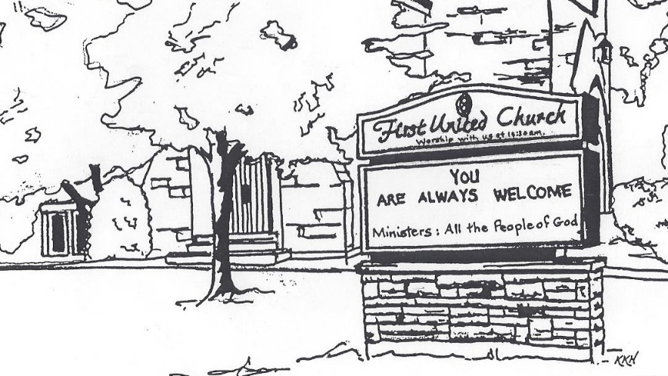

Sunday, March 11, 2018
10:30am

7 Curtis St., St.Thomas, ON N5P 1H3 Phone: (519) 631-7570
e-mail: firstunited@bellnet.ca
web: www.firstunitedchurch.weebly.com
MINISTERS: ALL THE PEOPLE OF GOD
Pastoral Minister: Rev. Emmanuel K. Ofori
Music Minister: Jody McDonald-Groulx
Secretary/Treasurer: Lori Hoffman
Custodian: Dave Luftenegger

