First United Church
Seeking to be a welcoming community of Christian faith, proclaiming and celebrating the love of God in Jesus Christ through the Inspiration of the Holy Spirit

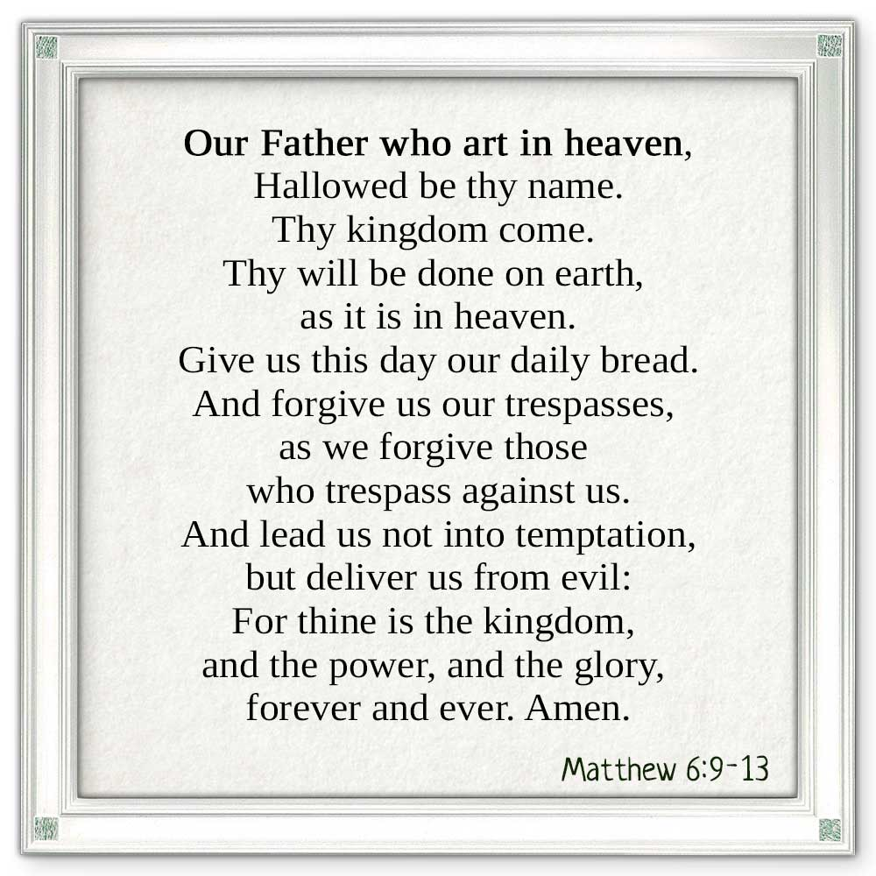

The Life & Work of the Church for March 10, 2019 @ 10:30am

7 Curtis St., St.Thomas, ON N5P 1H3 Phone: (519) 631-7570
e-mail: office@1stunitedchurch.ca
web: www.1stunitedchurch.ca
MINISTERS: ALL THE PEOPLE OF GOD
Pastoral Minister: Rev. Emmanuel K. Ofori
Music Minister: Jody McDonald-Groulx
Secretary/Treasurer: Lori Hoffman
Custodian: Dave Luftenegger

LIFE & WORK OF THE CHURCH
March 10, 2019

THANK YOUS!
Thank you to Mike Muma for organizing the kitchen cleanup last Sunday with his helpers: Bill Beamish, Don & Jacqueline Renaud &
Mark & Vicki Snowsell. Great Job!

Thanks also go out to all those who helped at & attended the Pancake Supper on Shrove Tuesday! $421.35 went to the General Fund!

Happy birthday to: Jim Harris, Carol Richardson, Lyle Cameron, Bob Nicol, Bill Richardson.

*TODAY: You are invited to gather in the Fellowship Room for refreshments following worship.

This week:
*Lori is on vacation this week. She will return Monday, March 18th at 9am.

Next Sunday: Newsletter Submission Deadline. All Newsletter Submissions must be received in the church office by end of day Sunday, March 17 in order to have it printed and ready for distribution on Sunday, March 24th! (Emailed and ready to insert into the document is GREAT and much appreciated!)

Future Dates / Events
*Property Committee - Tuesday, March 19 @6:30pm in Room 3
*Finance Committee – Tuesday, March 19 @ 6:30pm I the Fellowship Rm
*Official Board Executive – Tuesday, March 19 @ 7pm in the Fellowship Room

Spring Rummage Sale Sorting & Pricing begins on Wednesday, March 20 @ 9am. If you have an hour or two you can spare we’d appreciate the help! Join us in the gym! Also, since we’re ready to sort and price that means it’s the perfect time to bring in all the treasures you no longer need at home…Or purge your closet so you have room to buy some new spring outfits!! We’ll take all your Spring Cleaning items!!

*Rededication Service - Commitment Sunday, March 24. We encourage everyone to attend this special service.

*Anniversary Sunday – First Is Celebrating 185 years as a community of faith this year! Our first “Happy 185th” Special Event will be an Anniversary Sunday Service on March 31st. Reverend Don Parsons will be the Guest Minister. Come to church early (9:30 AM) before the service starts to share a coffee or juice with friends and family. Also, plan on staying after the service, to share fellowship, lunch & Birthday Cake downstairs in the Assembly Hall. Your CD & Membership Committee

*First Church & Friends Artisan & Vendor Market – Saturday, April 13th from 10am to 2pm. We hope to have as many Artisans & Vendors as possible so we can have a SUPER SUCCESSFUL event and raise some money for the General Fund!! So if you are an Artisan/Crafter/Baker, etc. or if you are involved in direct sales – WE’D LOVE TO HAVE YOU PARTICIPATE! {We will only be accepting ONE direct sales Vendor per company (ex. 1 Scentsy, 1 Tupperware, 1 Epicure, etc.,
as we want everyone to have a profitable day! So make sure you contact Lori in the office (office@1stunitedchurch.ca) ASAP to reserve your space! Don’t be disappointed!} Applications can be found on our website!

*Spring Rummage Sale – Saturday, April 27 from 8:30-11:30am
Donations being accepted now

*El Sistema Concert at First! Sunday, April 28 at 2:30pm. Tickets are $10 and are available in the Church office!

*Mom to Mom Sale – Saturday, May 25 from 9am to 1pm. We are renting out spaces for those who have an overabundance of children’s clothes/supplies so they can come and sell some of it
– and probably buy some more from other parents who are here!
If you’d like a space call or email Lori in the Church office! (office@1stunitedchurch.ca)
*First United is hiring a Family & Youth Ministry Co-ordinator! For more information or to see the job description please visit our website: www.1stunitedchurch.ca/family--youth-ministry-co-ordinator-position.html. All cover letters and applications can be sent to the attention of the Ministry & Personnel Committee at personnel@1stunitedchurch.ca
.
Minister’s Drop-In Office Hours
Tuesday, Wednesday & Thursday 10am to 12 Noon
*Other times available by appointment, call 519-631-7570 ext. 22
TODAY’S MESSAGE
Ash Wednesday begins Lent, the period of 40 days before Easter. Lent is a season of preparation before the celebrations of Easter – sober reflection, self-examination and spiritual renewal. The ultimate goal of Lent is spiritual renewal and growth.

In order to grow spiritually, we need to a) talk to God in prayer, b) allow God to talk us, c) talk with other believers and d) talk to those who also need the love of God in Christ.

For today, we look at “Talking to God in Prayer”, using the model prayer Jesus taught us (Matthew 6:9-13; Luke 11:1-4).

Our Father, which art in heaven, ……………. PRAISE
Hallowed be thy Name.
Thy Kingdom come ……………. PETITION
Thy will be done in earth,
As it is in heaven.
Give us this day our daily bread. ……………. PROVISION
And forgive us our trespasses, ……………. PARDON
As we forgive them that trespass against us.
And lead us not into temptation, ……………. PROTECTION
But deliver us from evil.
For thine is the kingdom, ……………. PRAISE
The power, and the glory,
For ever and ever.
Amen.

Think about this:
- You need prayer the way you need air to live.
- Your spiritual survival depends on prayer
- Have you talked to God today?

NEXT WEEK: “Let God Talk to You” (1 Peter 1:22-2:3)

