First United Church
Seeking to be a welcoming community of Christian faith, proclaiming and celebrating the love of God in Jesus Christ through the Inspiration of the Holy Spirit

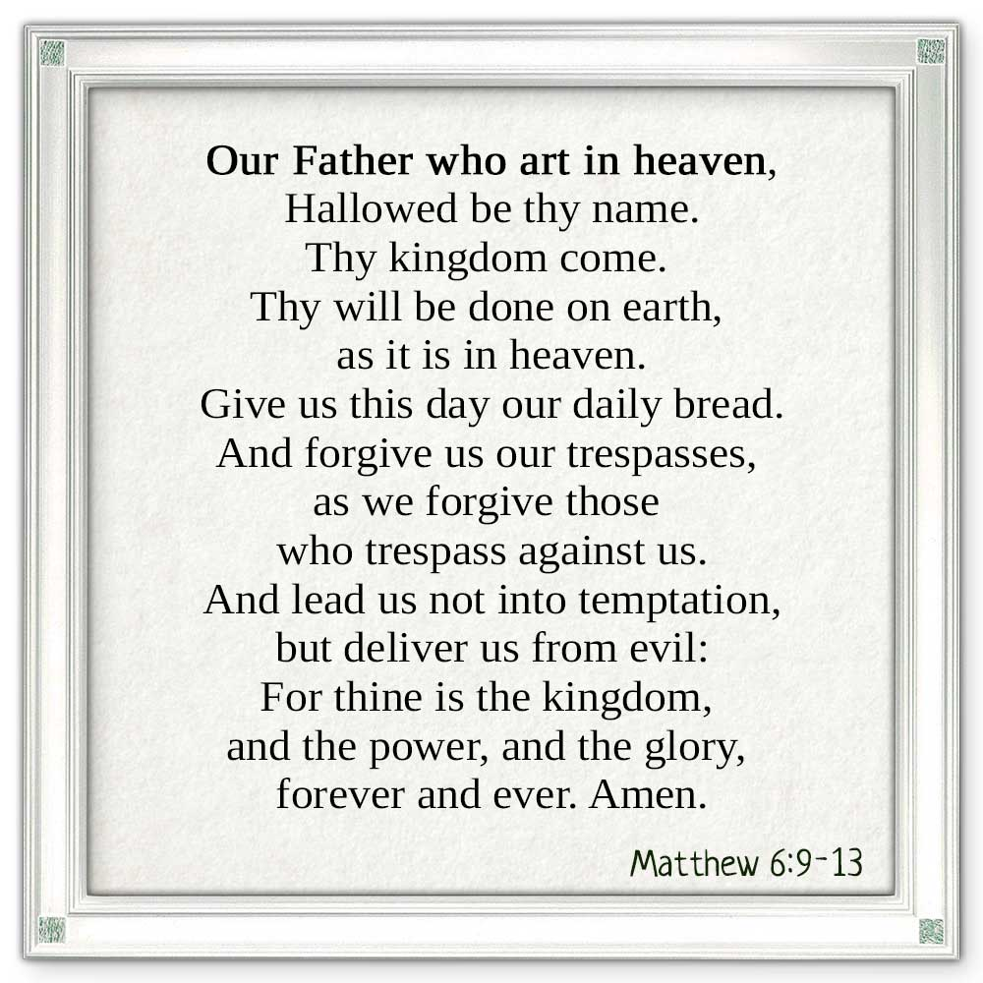

March 10, 2019 @ 10:30am

7 Curtis St., St.Thomas, ON N5P 1H3 Phone: (519) 631-7570
e-mail: office@1stunitedchurch.ca
web: www.1stunitedchurch.ca
MINISTERS: ALL THE PEOPLE OF GOD
Pastoral Minister: Rev. Emmanuel K. Ofori
Music Minister: Jody McDonald-Groulx
Secretary/Treasurer: Lori Hoffman
Custodian: Dave Luftenegger

Lent 1

ORDER OF SERVICE

Opening Prayer/Songs/Choruses
- MV# 183 “I’m Gonna Shout, Shout, Shout” (2x)
I’m gonna shout, shout, shout out my love for Jesus, for Jesus!
I’m gonna shout, shout, shout out my love
for God’s most holy child!
For whatever I might do today,
at home, at school, at work, at play,
I’ve got Jesus’ love deep down inside of me!

- “Awesome God” (2x)
Our God is an awesome God
He reigns from Heaven above
with wisdom, pow’r and love.
Our God is an awesome God!

- “I’ve Got Peace Like a River” (2x)
I’ve got peace like a river, I’ve got peace like a river,
I’ve got peace live a river in my soul.
I’ve got peace like a river, I’ve got peace like a river,
I’ve got peace like a river in my soul.

- “Testify to Love” (2x)
For as long as I shall live, I will testify to love
I’ll be a witness in the silences when words are not enough
With every breath I take I will give thanks to God above
For as long as I shall live, I will testify to love.

Circle Time

Welcome/Notices

Invitation to Invest in God’s Mission

Offertory Hymn/Prayer of Dedication

God of Love, hear our prayer. Bless this offering we bring you.

May our lives do your will. Guide and guard us forever.

Give us courage to stand for truth, help us give to others.

God of Love, hear our prayer. Bless this offering we bring you.

Songs/Choruses
- MV#156 “Dance With the Spirit” (2x)

Dance with the Spirit early in the mornin’

walk with the Spirit throughout the long day.

Work and hope for the new life abornin’

listen to the Spirit to show you the way.

- MV#21 “Open Our Hearts” (2x)

Open our hearts, open our minds,

Open our lives to you , O loving God.

(Open our hearts)

Scripture Reading: Matthew 6:9-13
Hymn of Preparation – VU #664 “What a Friend We Have in Jesus”
The Message: “Talk to God”
Prayer
*Closing Hymn: MV#214 “May God’s Sheltering Wings”
* Benediction
* Commissioning Hymn: MV#209 “Go, Make a Diff’rence”
Go make a diff’rence. We can make a diff’rence.
Go make a diff’rence in the world.
Go make a diff’rence. We can make a diff’rence.
Go make a diff’rence in the world.

* Musical Postlude

We welcome Paula Thomas as our Music Leader this morning.
Thank you for sharing your gifts with us today Paula!

TODAY’S MESSAGE
Ash Wednesday begins Lent, the period of 40 days before Easter. Lent is a season of preparation before the celebrations of Easter – sober reflection, self-examination and spiritual renewal. The ultimate goal of Lent is spiritual renewal and growth.

In order to grow spiritually, we need to a) talk to God in prayer, b) allow God to talk us, c) talk with other believers and d) talk to those who also need the love of God in Christ.

For today, we look at “Talking to God in Prayer”, using the model prayer Jesus taught us (Matthew 6:9-13; Luke 11:1-4).

Our Father, which art in heaven, ……………. PRAISE
Hallowed be thy Name.
Thy Kingdom come ……………. PETITION
Thy will be done in earth,
As it is in heaven.
Give us this day our daily bread. ……………. PROVISION
And forgive us our trespasses, ……………. PARDON
As we forgive them that trespass against us.
And lead us not into temptation, ……………. PROTECTION
But deliver us from evil.
For thine is the kingdom, ……………. PRAISE
The power, and the glory,
For ever and ever.
Amen.

Think about this:
- You need prayer the way you need air to live.
- Your spiritual survival depends on prayer
- Have you talked to God today?

NEXT WEEK: “Let God Talk to You” (1 Peter 1:22-2:3)

