First United Church
Seeking to be a welcoming community of Christian faith, proclaiming and celebrating the love of God in Jesus Christ through the Inspiration of the Holy Spirit

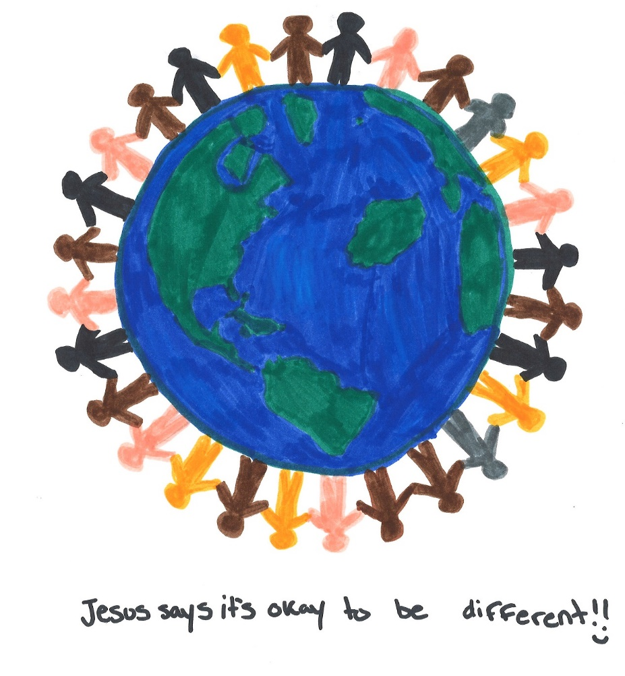

By Madison C.

March 1, 2020 @ 10:30am

Order of Service
* You are invited to stand if comfortable doing so

VU = Voices United MV = More Voices

9:30am Conversational Church: “Listening for the Song of Faith”

10:20am Gathering in Song

Musical Prelude

Welcome / Life & Work of the Church

Call to Worship
One: The Promises we make are a big deal.
Two: Promises are what life is built on.
Three: The promise of love as a child opens the door to trust,
One: A promise of a good listener encourages many values to be
sorted over the years.
Two: When someone gives us the foundation of promises
Three: we can fail,
One: we can feel unqualified oftentimes,
Two: we can be freed to grow in character in wild and tame ways,
Three: and a promise can ground us while we discern the gifts that are
authentically ours forever.
One: Promises can be renewed when broken, albeit, it can be a long
journey to believe in them again.
Two: Promises are like foundations for us
Three: and they are support walls too.
One: From the gift of promises that others have given to us
All: We, in turn, learn to give ourselves as leaders, parents, teachers,
friends, partners, neighbours, congregants, ministers.
Promises hold people and communities together
around a shared love in life.
Let us gather, faithful to the promise of gathering regularly,
that in our unity the Promise of the Most Vulnerable One,
the Christ, would be unafraid to be known among us.

Choral Musical Prelude
- MV#1 “Let Us Build a House” (All Are Welcome)
Let us build a house where hands will reach
beyond the wood and stone
to heal and strengthen, serve and teach,
and live the Word they’ve known.
Here the outcast and the stranger bear the image of God’s face; let us bring an end to fear and danger:
All are welcome, all are welcome, all are welcome in this place.

- MV#18 “Lord, Prepare Me” (2x)
Lord, prepare me to be a sanctuary, pure and holy tried and true
With thanksgiving, I’ll be a living sanctuary for you.

Lighting the Unity Candles
Margaret:
“Stars that shine together form a galaxy. Buildings that stand together begin a city. People who work together make a difference.

The Scouting & Guiding movement is one that sees people of all ages … from all walks of life … from every language and culture and religion around the world come together in brotherhood & sisterhood to live out a value system based on a promise and law with a common goal…. to help build a better world, where people are self-fulfilled as individuals, and can give back to society in a positive way … each one using their own gifts.

The movement welcomes diversity ….. our differences ….. different languages, religions and traditions. We are richer, and stronger, because of those differences.”

Light the first candle
“We light this candle in friendship for all of the people who are older or younger, taller or smaller, richer or poorer than we are. All those who worship in different languages and customs and different nations.”

Light the second candle
“We light this candle in friendship for all people who are involved in opening the doors of this church so we can meet here as Sparks, Pathfinders and Rangers. It seems like a small gesture, a small gift perhaps, but when people share space it becomes a place where promises are kept and people are nurtured in life. The church has opened its doors to us because it values us, and values what evolves from being in a place as a community. The church has its gift to share.”

Light the third candle
“We light this candle in friendship for all the leaders in the movement and especially ours this morning. They let their lives shine into our community.”

Light the fourth candle
“We light this candle in friendship for all people who don’t run, walk, see, hear, or learn the same way we do. We meet them in our groups oftentimes and we are glad to have become friends”

Light the fifth candle
“We light this candle for the joint birthday of Lord and Lady Baden Powell. They both saw possibilities for children if given a chance. We light this candle for them and for all those whose response to their faith has been, and is being lived out.”

Light the sixth candle
“We light the last candle for everyone here today. Each one of us is held in the same compassion. We know God wants us to grow in wisdom and knowledge concerning our world and the way it was designed. God wants us to help care for and heal our world and planet. Each of us may be different, but we have gifts to share in common.”

Margaret:
“As you watch the flames, notice that the light from each candle is the same as the others even though each candle will burn at different rates and intensity. We all belong to the same human race. And we share a common responsibility – to take care of the light in this world ….to leave it a little better than we found it…..and to take care of each other.

Sing: I am the light of world, you people come and follow me.
If we follow and love, we’ll learn the mystery
Of what we were meant to do and be.

Passing of the Peace: MV#145
Refrain: Draw the circle wide. Draw it wider still.
Let this be our song, no one stands alone,
standing side by side

Let out hearts touch far horizons, so encompass great and small;
let our loving know no borders, faithful to God’s call. Refrain.

Musical Offering: Senior Choir

Sacrament of Baptism: Mary Virginia Towers, Chair, Worship & Music Committee
Today we celebrate the sacrament of baptism with a family
new to First United.

Today, Adam & Ashley will have their son Quinton baptized.
Quinton is a little brother to Hazel.

We celebrate with them this new beginning and this journey we are on
with them.

Baptismal Hymn: VU#644 “I Was There to Hear Your Borning Cry”
*Baptismal family comes forward during the hymn

Profession of Faith: Promises
Do you trust in God, Source of love;
in Jesus the Christ, the embodiment of God’s love,
and in the Holy Spirit, love’s power?
I do, by the grace of God.

Will you follow in the way of Jesus Christ,
resisting oppression and evil, seeking justice,
and witnessing to God’s love for all creation?
I will, God being my helper

Through your words and actions,
will you proclaim Jesus, crucified and risen?
I will, God being my helper.
Will you join with your brothers and sisters in this community of faith
to celebrate God’s presence, and live with respect in creation,
and love and serve others?
I will, God being my helper.

Will you share your journey of faith with Quinton,
growing with him is faith, hope and love?
I will, God being my helper.

Congregational Commitment
The congregation may stand, in body or spirit, to pledge their support.

Let us pledge to these persons our support and care.
As a baptized and baptizing people,
We commit ourselves to support and uphold you
Within the community of faith.
May God grand us all the grace to live out our Baptism. Amen.

A New Creed
We are not alone,
we live in God’s world.
We believe in God:
who has created and is creating,
who has come in Jesus, the Word made flesh,
to reconcile and make new,
who works in us and others
by the Spirit.
We trust in God.
We are called to be the Church:
to celebrate God’s presence,
to live with respect in Creation,
to love and serve others,
to seek justice and resist evil,
to proclaim Jesus, crucified and risen,
our judge and our hope.
In life, in death, in life beyond death,
God is with us.
We are not alone.
Thanks be to God.

Prayer of Thanksgiving
Baptism

Hymn: MV#157 “I Am a Child of God”
During the Hymn the children & youth are invited to leave for Church School.

Offering Ourselves, Tithes & Gifts
Dedication Hymn: (tune “Eidelweiss”)
God of Love, hear our prayer. Bless this offering we bring you. May our lives do Your will; guide and guard us forever. Give us courage to stand for truth; help us give to others. God of Love, hear our prayer, Bless this offering we bring you.

Introduction to Scripture
One day God said, “There is still much to do. Your task is to build a better world”.

“How can I do that? The world is so big, and so complicated. And I am so small. I don’t think there’s anything I can do.”

“Just build a better you.”

I’ve already started. I joined Sparks and Guides.

Recitation of Vows A few words from Margaret McKnight
In his parting words, Lord Robert Baden Powell, the founder of the Scouting movement, said this:
I believe that God put us in this jolly world to be happy and enjoy life. Happiness doesn’t come from being rich, nor merely from being successful in your career, nor by self-indulgence. …..Nature study will show you how full of beautiful and wonderful things God has made the world for you to enjoy. Be contented with what you have got and make the best of it. Look on the bright side of things instead of the gloomy one.

But the real way to get happiness is by giving out happiness to other people. Try and leave this world a little better than you found it and when your turn comes to die, you can die happy in feeling that at any rate you have not wasted your time but have done your best. In all of this keep in mind that celebrating our firsts is an excellent place to start!
Scripture Reading: Luke 19:1-10 Zacchaeus the Tax Collector

The Reflection: Living Word. Loving God: The Promise of Orthodoxy
Rev. Daryl Webber
Closing Prayers
Margaret:
Creator Spirit, We Thank You today for the lives of Lord and Lady Baden Powell; for all the friends, the fun and adventures we have in Scouting and Guiding; for the beauty of the world and all the marvelous things you have made in nature; for our homes, our parents, our leaders, this church, and everyone who look after us.

Help us to always remember that we are members of a world-wide organization; that every Spark, Brownie, Guide, Pathfinder, Ranger, Beaver, Cub and Scout, Venturer and Rover has promised to love and serve you together.

Spark:
Great Teacher; teach us to be worthy of our uniform, to be strong and stand up for what is right. Help us to do our best in your service, and to be true to our Scouting promise always.

Guide:
We pray today for the people who are sick, the people who are lonely, and the people who don’t have enough. Help us to see ways to make our community, our country, and our world a place where all people enjoy good food and shelter, good friendships and peace–where all people have a fair share of the things they need to be healthy and happy and truly alive. Help us to act on what we see needs to be done.

Margaret:
Bless each of us now as we go out into the world, thankful that we have the freedom to experience so many things for the first time, thankful that we have the opportunity to learn every time we do something for the first time, thankful that we have so much to share with others. Bless Quinton on the day of his baptism and his parents Ashley and Adam. May they find delight in each other good support among his faith community here at First. And may he know the gift of good and faithful promises and wherever he may roam in the years ahead. Amen.
*Hymn: VU#556 “Would You Bless Our Homes and Families (v1,3)

*Commissioning/Benediction
Closing - Sing: VU#209 “Go Make A Difference”
Go make a diff’rence, We can make a diff’rence.
Go make a diff’rence in the world.
Go make a diff’rence, We can make a diff’rence.
Go make a diff’rence in the world.

Musical Postlude

LIFE & WORK OF THE CHURCH
March 1, 2020

Thank you to everyone who helped - in any way - at the Pancake Supper - even if you just came to eat! We made $626.08 for the General Fund!
Also – A BIG thank you to the Youth Group for putting all the
tables & chairs away after the event!

Happy birthday to: Jennifer Ewans.

Happy Anniversary to: Dave & Diane Irwin.

Looking for a volunteer to help with our new Canadian family to help with schoolwork 1 day a week after school. Interested? Let Lori in the office know and she’ll connect you!

*TODAY: *Join us for Coffee, Cold drinks & Conversation in the Fellowship Room following worship. There will be cake for Quinton & his family. Come celebrate this special day of his life.
(At First we love having a time of Fellowship after Worship on Sundays! It’s a time to greet friends, new and old, over a drink & maybe a goody!! If this is something you would enjoy hosting, you are invited to sign up on the sheet in the Fellowship Room (Drinks supplied – coffee would just need to be put on in the morning! We’d love to have you!)

*Would you be willing to participate or lead the worship service? If so please speak to Rev. Daryl, Richard Auckland or one of the worship team leaders.

This week:
Monday: *Coffee & Conversation with Rev. Daryl from 10-11am. All welcome!
*Healing Arts Lunch in the Fellowship Room from 12-1:30pm

Tuesday: *EarlyON Playgroup in the Gym - 9:30 – 11:30am
*First Youth with Chris Ross & Justin Chute in Room 3/Gym from 7-8:15pm.

Thursday

*Sr. Choir @ 7:30pm! Don’t be shy – singing’s great for the soul – come and give it a try!

Friday *World Day of Prayer @ Central United Church @ 1:30pm

Next Sunday
9:30am Conversational Church: “Listening for the Song of Faith”
10: 20am Gathering in Song

Upcoming Dates & Events
Monday, March 9 - *Official Board Meeting @ 7pm.

Monday, March 23 - We will be holding our 2nd Quarter Auction!
Doors open at 6 p.m. Auction starts at 7:00 p.m.
We will have vendors for shopping and food will be available for purchase. Join us for this super fun event! Admission is $5 (includes 1 paddle) Extra paddles are $2 each.

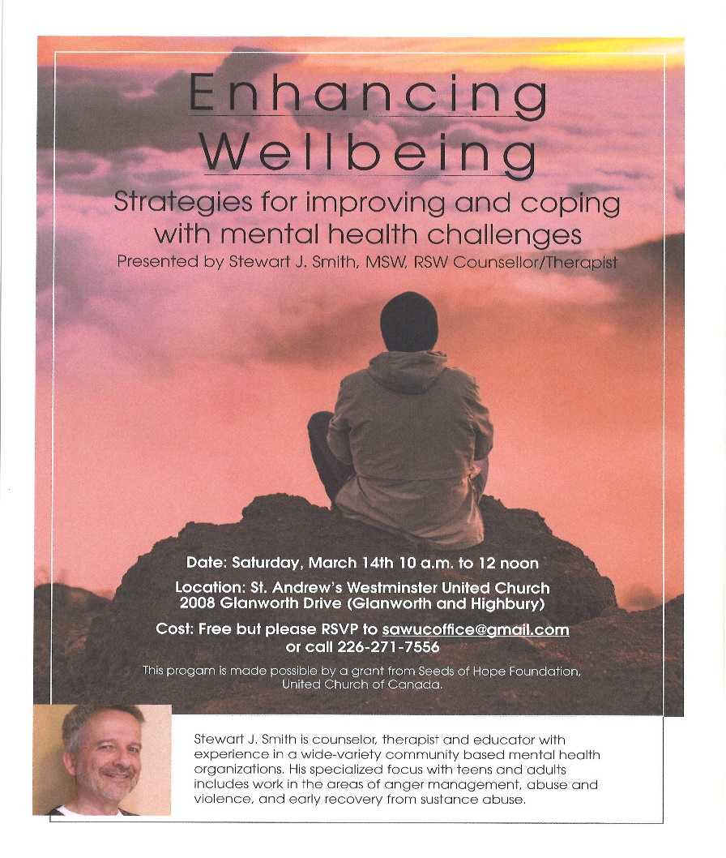

Church Office Hours
Monday to Thursday 8:30am to 3:30pm
(Closed from 12-1pm for lunch)

7 Curtis St., St.Thomas, ON N5P 1H3 Phone: (519) 631-7570
e-mail: office@1stunitedchurch.ca
web: www.1stunitedchurch.ca
MINISTERS: ALL THE PEOPLE OF GOD
Intentional Interim Minister: Rev. Daryl Webber
Music Minister: Jody McDonald-Groulx
Secretary/Treasurer: Lori Hoffman
Custodian: Dave Luftenegger

