First United Church
Seeking to be a welcoming community of Christian faith, proclaiming and celebrating the love of God in Jesus Christ through the Inspiration of the Holy Spirit

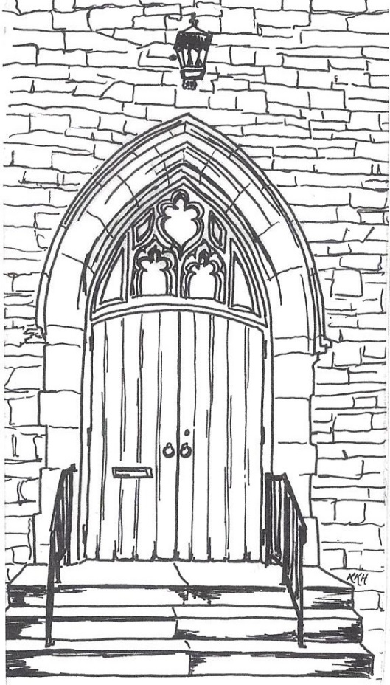

June 9, 2019 @ 10:30am

7 Curtis St., St.Thomas, ON N5P 1H3 Phone: (519) 631-7570
e-mail: office@1stunitedchurch.ca
web: www.1stunitedchurch.ca
MINISTERS: ALL THE PEOPLE OF GOD
Pastoral Minister: Rev. Emmanuel K. Ofori
Music Minister: Jody McDonald-Groulx
Secretary/Treasurer: Lori Hoffman
Custodian: Dave Luftenegger

ORDER OF SERVICE
Opening Prayer
Choruses/Songs
- MV#182 “Grateful” (chorus only)
Grateful for the life you give us, thankful for your Holy Son,
joyful in your Spirit flowing over all, O God of love.
Grateful for the Bread of Heaven, thankful for your Holy Word,
joyful in your mercy flowing, we will praise you.

- MV#109 “My Soul Is Thirsting for You” (2x)
My soul is thirsting for you, O lord, thirsting for you, my God. My soul is thirsting for you, O lord, thirsting for you my God, thirsting for you, my God.

- “Awesome God” (2x)
Our God is an awesome God, and reigns from heaven above
with wisdom, pow’r and love, Our God is an awesome God.

Lighting of Christ Candle

I am the light of the world.

You people come and follow me.

If you follow and love, you’ll learn the mystery

of what you were mean to do and be.

Welcome/Notices

Call to Worship
One: Jesus, You invite us to come to You.
All: MV #189 “Jesus, We are Here”
One: Master, we have gathered in this place to worship.
All: MV #189 “Master, We are Here”
One: Saviour, we are here for you.
All: MV #189 “Jesu Tawa pano”

Prayers/The Lord’s Prayer

Anthem: Senior Choir

Circle Time:

Invitation to Invest in God’s Mission

Offertory Hymn/Prayer of Dedication

God of Love, hear our prayer.

Bless this offering we bring you.

May our lives do your will.

Guide and guard us forever.

Give us courage to stand for truth,

help us give to others.

God of Love, hear our prayer.

Bless this offering we bring you.

Prayer of Dedication

Song/Chorus: MV#156 “Dance with the Spirit” (2x)
Dance with the Spirit early in the mornin’
Walk with the Spirit throughout the long day.
Work and hope for the new life abornin’
Listen to the Spirit to show you the way.

Scripture Reading: Philippians 3:12-14; Luke 5:1-5

Hymn of Preparation: VU #563 “Jesus, You Have Come to the Lakeshore”

The Message: Let Nothing Hold You Back or Down (Part 2)

Prayer

*Closing Hymn: VU pg #835 “Praise to the Lord”

* Benediction

* Commissioning Hymn: VU#298 “When You Walk From Here”

When you walk from here, when you walk from here,

Walk with justice, walk with mercy, and with God’s humble care.

Musical Postlude

TODAY’S MESSAGE
Last week we found that we all suffer setbacks at various levels of our lives from time to time. But we don’t have to let FEAR to hold us back or allow NOSTALGIA to hold us down. We ought to remember divine promise of
- God’s love,
- God’s plan and
- God’s abiding presence with us

This means God always takes the initiative and invites us to respond.

Our response to the Divine initiative is to:

- Forget the Past
But one thing I do: Forgetting what is behind and straining toward what is ahead (Philippians 3:13).
- Forget past successes

- Forget past failures

- Press on – be resilient
I press on toward the goal to win the prize for which God has called me heavenward in Christ Jesus (Philippians 3:14)

- Trust and Obey
“Master,” Simon replied, “we worked hard all last night and didn’t catch a thing. But if you say so, I’ll let the nets down again” (Luke 5:5)

Sometimes the simplest step from setback to comeback is just two words: Obey God.

Think about this:
- Your response to setbacks is to forget what lies behind you, press on towards the goal or vision and obey the word of God.
- Once you obey, God will take care of the rest.
- Let nothing hold you back or down any more.

