LIFE & WORK OF THE CHURCH
June 24, 2018

Happy Birthday to: Jonathon Auckland, Kaley Dawdy, Hannah Hoffman, Jack Moore, Jody McDonald-Groulx.

Happy Anniversary to: Wayne & Lynn Lalonde, Dave & Nancy Luftenegger, Sue & Bob Nicol.

TODAY! *Faith Activity Room begins for children 4 & up
*Join us in the Fellowship Room for refreshments following the worship service!

This Afternoon in the Community! – *Knox Presbyterian Church is hosting a Neighbourhood Party. A FREE event for the St. Thomas Community! 12noon to 3pm – Hot dogs, pizza, pop, musical entertainment, bouncy castle, face painting, The Snake Lady, dunk talk , hockey station, helium balloons, coton candy and more! This event is FREE! (with the exception of a small fee for food ($1.00 hot dog or pizza & 50₵ fro drinks) Everyone in the St. Thomas Community is welcome!

THIS WEEK:
Wednesday: *Bible Study/Prayer Group – Wednesday Evenings @ 7pm in the Fellowship Room
Thursday: *OEY Playgroup in the Gym 9:30-11:30am

Upcoming Dates & Events
If you’d like to volunteer to serve Summer Lemonade in the Fellowship Room following Sunday worship please call Ruth Zions @ 226-289-3055.

Don’t forget to register
for Vacation Bible Camp!!

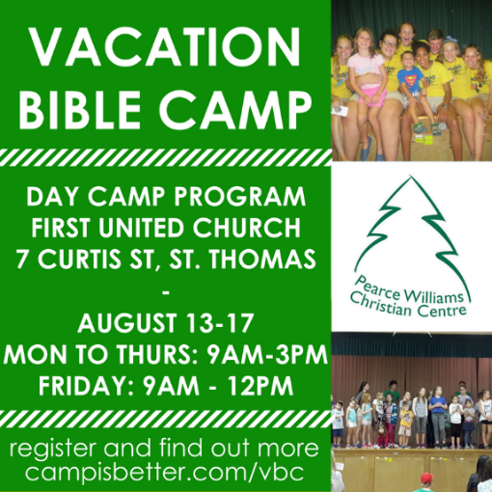

LIFE & WORK OF THE CHURCH
June 24, 2018

Happy Birthday to: Jonathon Auckland, Kaley Dawdy, Hannah Hoffman, Jack Moore, Jody McDonald-Groulx.

Happy Anniversary to: Wayne & Lynn Lalonde, Dave & Nancy Luftenegger, Sue & Bob Nicol.

TODAY! *Faith Activity Room begins for children 4 & up
*Join us in the Fellowship Room for refreshments following the worship service!

This Afternoon in the Community! – *Knox Presbyterian Church is hosting a Neighbourhood Party. A FREE event for the St. Thomas Community! 12noon to 3pm – Hot dogs, pizza, pop, musical entertainment, bouncy castle, face painting, The Snake Lady, dunk talk , hockey station, helium balloons, coton candy and more! This event is FREE! (with the exception of a small fee for food ($1.00 hot dog or pizza & 50₵ fro drinks) Everyone in the St. Thomas Community is welcome!

THIS WEEK:
Wednesday: *Bible Study/Prayer Group – Wednesday Evenings @ 7pm in the Fellowship Room
Thursday: *OEY Playgroup in the Gym 9:30-11:30am

Upcoming Dates & Events
If you’d like to volunteer to serve Summer Lemonade in the Fellowship Room following Sunday worship please call Ruth Zions @ 226-289-3055.

Don’t forget to register
for Vacation Bible Camp!!

