LIFE & WORK OF THE CHURCH
June 17, 2018

Happy Birthday to: Wayne Lalonde, Leah Fellows, Dave Luftenegger, Brian Groulx, Murray Medhurst, Rosemary Underhill.

Happy Anniversary to: Barb & Duncan Watterworth, Graham & Marg Sanderson.

TODAY! *Rosemarie Johnson-Clarke will be doing Interactive Stories with Puppets during the Church School time. All children are welcome to join in the Assembly Hall for a fun, interactive show!

*Join us in the Fellowship Room for refreshments following the worship service!

THIS WEEK:
Tuesday *OEY Playgroup in the Gym 9:30-11:30am
Wednesday: *Bible Study/Prayer Group – Wednesday Evenings @ 7pm in the Fellowship Room
*Christian Development Committee meeting at the Chute’s @ 7pm
Thursday: *OEY Playgroup in the Gym 9:30-11:30am

Upcoming Dates & Events
*Sunday, June 17 we will be starting our Summer Lemonade in the Fellowship Room following worship. Anyone interesting in serving, please call Ruth Zions @ 226-289-3055.

Sunday, June 24 – *Faith Activity Room will begin for children 4 & up

Sunday, June 24 – *Knox Presbyterian Church is hosting a Neighbourhood Party. A FREE event for the St. Thomas Community! 12noon to 3pm – Hot dogs, pizza, pop, musical entertainment, bouncy castle, face painting, The Snake Lady, dunk talk , hockey station, helium balloons, coton candy and more! This event is FREE! (with the exception of a small fee for food ($1.00 hot dog or pizza & 50₵ fro drinks) Everyone in the St. Thomas Community is welcome!

Don’t forget to register
for Vacation Bible Camp!!

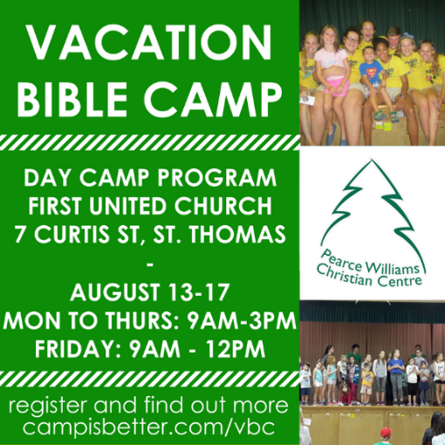

LIFE & WORK OF THE CHURCH
June 17, 2018

Happy Birthday to: Wayne Lalonde, Leah Fellows, Dave Luftenegger, Brian Groulx, Murray Medhurst, Rosemary Underhill.

Happy Anniversary to: Barb & Duncan Watterworth, Graham & Marg Sanderson.

TODAY! *Rosemarie Johnson-Clarke will be doing Interactive Stories with Puppets during the Church School time. All children are welcome to join in the Assembly Hall for a fun, interactive show!

*Join us in the Fellowship Room for refreshments following the worship service!

THIS WEEK:
Tuesday *OEY Playgroup in the Gym 9:30-11:30am
Wednesday: *Bible Study/Prayer Group – Wednesday Evenings @ 7pm in the Fellowship Room
*Christian Development Committee meeting at the Chute’s @ 7pm
Thursday: *OEY Playgroup in the Gym 9:30-11:30am

Upcoming Dates & Events
*Sunday, June 17 we will be starting our Summer Lemonade in the Fellowship Room following worship. Anyone interesting in serving, please call Ruth Zions @ 226-289-3055.

Sunday, June 24 – *Faith Activity Room will begin for children 4 & up

Sunday, June 24 – *Knox Presbyterian Church is hosting a Neighbourhood Party. A FREE event for the St. Thomas Community! 12noon to 3pm – Hot dogs, pizza, pop, musical entertainment, bouncy castle, face painting, The Snake Lady, dunk talk , hockey station, helium balloons, coton candy and more! This event is FREE! (with the exception of a small fee for food ($1.00 hot dog or pizza & 50₵ fro drinks) Everyone in the St. Thomas Community is welcome!

Don’t forget to register
for Vacation Bible Camp!!

