“We are the Church”

Chorus:
I am the Church! You are the Church! We are the Church together! All who follow Jesus, all around the world!
Yes, we’re the Church together.

- The Church is not a building, the church is not a steeple, the church is not a resting place, the church is a people.

Chorus

- We’re many kinds of people, with many kinds of faces,
all colours and all ages, too from all times and places.

Chorus

- And when the people gather, there’s singing and there’s praying, there’s laughing and there’s crying sometimes, all of it is saying:

Chorus

- I count if I am ninety, or nine or just a baby, There’s one thing I am sure about, and I don’t mean maybe:

Chorus

LIFE & WORK OF THE CHURCH
June 10, 2018

Happy Birthday to: Olivia Pay, Maggie Moore, Brenda Smith, Janet Mitchell, Ben Groulx.
Happy Anniversary to: Rob & Carlene MacMenamin, Allan & Kim Hughson

TODAY: *Join us for a BBQ on the South Lawn following the worship service!

THIS WEEK:
Tuesday: *Property Meeting @ 6:30pm in Room 3
*Finance Committee Meeting @ 6:30pm in the Fellowship Room
*Official Board Meeting @ 7pm in the Music Room
Wednesday: *Bible Study/Prayer Group – Wednesday Evenings @ 7pm in the Fellowship Room
Thursday: *OEY Playgroup in the Gym 9:30-11:30am

Upcoming Dates & Events
*Sunday, June 17 we will be starting our Summer Lemonade in the Fellowship Room following worship. Anyone interesting in serving, please call Ruth Zions @ 226-289-3055.

Sunday, June 24 – Knox Presbyterian Church is hosting a Neighbourhood Party. A FREE event for the St. Thomas Community! 12noon to 3pm – Hot dogs, pizza, pop, musical entertainment, bouncy castle, face painting, The Snake Lady, dunk talk , hockey station, helium balloons, coton candy and more! This event is FREE! (with the exception of a small fee for food ($1.00 hot dog or pizza & 50₵ fro drinks) Everyone in the St. Thomas Community is welcome!
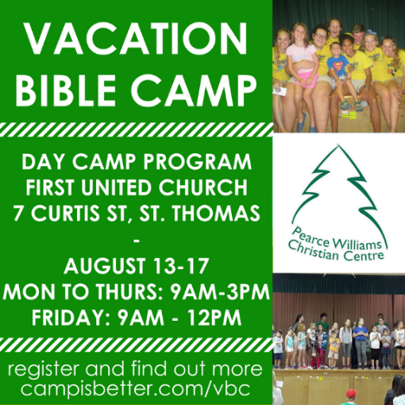

Don’t forget to register
for Vacation Bible Camp!!

“We are the Church”

Chorus:
I am the Church! You are the Church! We are the Church together! All who follow Jesus, all around the world!
Yes, we’re the Church together.

- The Church is not a building, the church is not a steeple, the church is not a resting place, the church is a people.

Chorus

- We’re many kinds of people, with many kinds of faces,
all colours and all ages, too from all times and places.

Chorus

- And when the people gather, there’s singing and there’s praying, there’s laughing and there’s crying sometimes, all of it is saying:

Chorus

- I count if I am ninety, or nine or just a baby, There’s one thing I am sure about, and I don’t mean maybe:

Chorus

LIFE & WORK OF THE CHURCH
June 10, 2018

Happy Birthday to: Olivia Pay, Maggie Moore, Brenda Smith, Janet Mitchell, Ben Groulx.
Happy Anniversary to: Rob & Carlene MacMenamin, Allan & Kim Hughson

TODAY: *Join us for a BBQ on the South Lawn following the worship service!

THIS WEEK:
Tuesday: *Property Meeting @ 6:30pm in Room 3
*Finance Committee Meeting @ 6:30pm in the Fellowship Room
*Official Board Meeting @ 7pm in the Music Room
Wednesday: *Bible Study/Prayer Group – Wednesday Evenings @ 7pm in the Fellowship Room
Thursday: *OEY Playgroup in the Gym 9:30-11:30am

Upcoming Dates & Events
*Sunday, June 17 we will be starting our Summer Lemonade in the Fellowship Room following worship. Anyone interesting in serving, please call Ruth Zions @ 226-289-3055.

Sunday, June 24 – Knox Presbyterian Church is hosting a Neighbourhood Party. A FREE event for the St. Thomas Community! 12noon to 3pm – Hot dogs, pizza, pop, musical entertainment, bouncy castle, face painting, The Snake Lady, dunk talk , hockey station, helium balloons, coton candy and more! This event is FREE! (with the exception of a small fee for food ($1.00 hot dog or pizza & 50₵ fro drinks) Everyone in the St. Thomas Community is welcome!

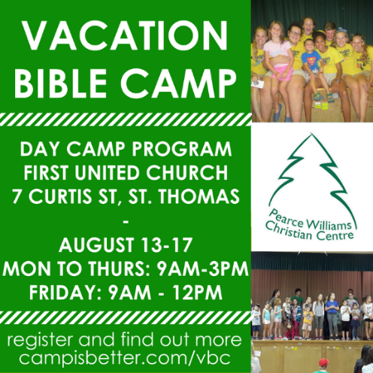

Don’t forget to register
for Vacation Bible Camp!!

