First United Church
Seeking to be a welcoming community of Christian faith, proclaiming and celebrating the love of God in Jesus Christ through the Inspiration of the Holy Spirit

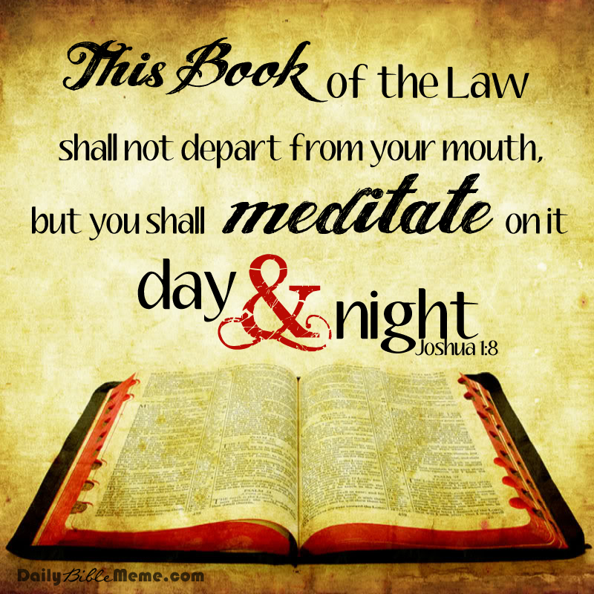

Communion Sunday
June 3, 2018 @ 10:30am

7 Curtis St., St.Thomas, ON N5P 1H3 Phone: (519) 631-7570
e-mail: office@1stunitedchurch.ca
web: www.1stunitedchurch.ca
MINISTERS: ALL THE PEOPLE OF GOD
Pastoral Minister: Rev. Emmanuel K. Ofori
Music Minister: Jody McDonald-Groulx
Secretary/Treasurer: Lori Hoffman
Custodian: Dave Luftenegger

2nd Sunday of Pentecost
CELEBRATION OF HOLY COMMUNION
Sunday, June 3, 2018 - 10:30 a.m. Worship
Preacher: Rev. Emmanuel K. Ofori

Notes: Asterisk (*) – You may stand if comfortable doing so
VU = Voices United MV = More Voices

God Gathers Us Together

Musical/Choral Prelude
- VU#467 “One Bread, One Body” (2x)
One bread, one body, one Lord of all, one cup of blessing which we bless; and we, though many, throughout the earth, we are one body in this one Lord.

- MV#18 “Lord, Prepare Me to Be a Sanctuary” (2x)
Lord, prepare me to be a sanctuary, pure and holy tried and true; with thanksgiving, I’ll be a living sanctuary for you.

Lighting of the Christ Candle

Life and Work of the Church [see insert]

Welcoming of Visitors

God Draws Us Near To Worship

Call to Worship: VU#840&841 (Refrain 5 & Part 5- Psalm 119:105-112)

Prayer of Thanksgiving & Intercession
The Lord’s Prayer (VU #960)
Senior Choir Anthem

God Invites Us To Listen For His Word

Old Testament Reading: Joshua 1:1-9
Reader: This is the Word of God
All: Thanks be to God

* Hymn of Preparation: VU #501 “Break Now the Bread of Life”

The Message

God Invites Us To Respond To His Love
Offertory: Rachel Rayner
Hymn of Dedication (Doxology)
Praise God from whom all blessings flow;
Praise God, all creatures high and low;
Give thanks to God in love made known:
Creator, Word and Spirit One.

Offertory Prayer

God Invites Us To Break Bread Together

Communion Hymn: VU#480 “Let Us Break Bread Together”

The Lord be with you.

And also with you

Lift up your hearts

We lift up our hearts unto the Lord

Let us give thanks to God

It is good and pleasant to give God thanks and praise

It is a good and pleasant thing, our joy and our moral duty, always and everywhere to give you thanks and praise, O Lord, God, ever-loving and ever-blessed, Almighty and all-loving.

Therefore, with angels and archangels, and with all the heavenly host, we join in the blessed hymn of everlasting praise saying …
Holy, holy, holy,
LORD God of hosts,
heaven and earth are full of your glory.
Hosanna in the highest.
Glory be to you, O Lord, most high. Amen.

*Affirmation of Faith: A New Creed
We are not alone,
we live in God's world.
We believe in God:
who has created and is creating,
who has come in Jesus,
the Word made flesh,
to reconcile and make new,
who works in us and others
by the Spirit.
We trust in God.
We are called to be the Church:
to celebrate God's presence,
to live with respect in Creation,
to love and serve others,
to seek justice and resist evil,
to proclaim Jesus, crucified and risen,
our judge and our hope.
In life, in death, in life beyond death,
God is with us.

We are not alone.

Thanks be to God.

The Institution
Blessed are you, Lord God, King of the universe, and blessed is your Son Jesus Christ our Lord; who on the night He was betrayed and arrested He turned to His disciples and said,
All: “I give you a new commandment, that you love one another. Just as I have loved you, you also should love one another. By this everyone will know that you are my disciples, if you have love for one another”.

Then Christ took bread and looking up to heaven gave thanks, broke it and gave it to His disciples, saying,
All: “Take this and eat it. This is my body given for you. Do this in remembrance of me.”

In the same way after Supper He took the cup, gave thanks and gave it to them saying,
All: “Drink from it, all of you. This is my blood of the new covenant poured out for you and for many for the forgiveness of sins. Do this whenever you drink it in remembrance of me.”

Therefore, let us proclaim the mystery of our faith …
All: Jesus Christ has died

Jesus Christ is risen

Jesus Christ will come again

For deep in my heart, I do believe

That Jesus Christ will come again

(Sung to tune: “We Shall Overcome” Traditional – arranged by compilers)

Prayer of Consecration
Invitation & Distribution of Elements
Prayer of Thanksgiving

God Sends Out Into the World to Serve

*Closing Hymn: MV#209 “Go Make A Diff’rence”
* Benediction
*Sending Forth
Threefold Amen
* Musical Postlude
We welcome Wayne Carroll on organ today.

TODAY’S MESSAGE

- Joshua 1:1-9
1 After the death of Moses the servant of the Lord, the Lord spoke to Joshua son of Nun, Moses' assistant, saying,
2 "My servant Moses is dead. Now proceed to cross the Jordan, you and all this people, into the land that I am giving to them, to the Israelites.
3 Every place that the sole of your foot will tread upon I have given to you, as I promised to Moses.
4 From the wilderness and the Lebanon as far as the great river, the river Euphrates, all the land of the Hittites, to the Great Sea in the west shall be your territory.
5 No one shall be able to stand against you all the days of your life. As I was with Moses, so I will be with you; I will not fail you or forsake you.
6 Be strong and courageous; for you shall put this people in possession of the land that I swore to their ancestors to give them.
7 Only be strong and very courageous, being careful to act in accordance with all the law that my servant Moses commanded you; do not turn from it to the right hand or to the left, so that you may be successful wherever you go.
8 This book of the law shall not depart out of your mouth; you shall meditate on it day and night, so that you may be careful to act in accordance with all that is written in it. For then you shall make your way prosperous, and then you shall be successful.
9 I hereby command you: Be strong and courageous; do not be frightened or dismayed, for the Lord your God is with you wherever you go."

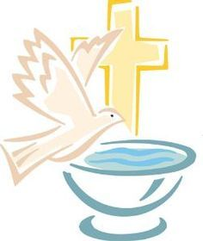
CD SUNDAY CELEBRATION
Next Sunday, June 10!!!!!

DURING WORSHIP
Baptism will be celebrated in the service.

FOLLOWING WORSHIP……
Our Well Loved…Annual BBQ ON THE LAWN
Hamburgers, hot dogs, chips, drinks & cake supplied.

WE INVITE YOU TO PLEASE CONTRIBUTE A SALAD IF YOU CAN. Please bring it downstairs to the big kitchen before worship. Thankyou!!

We are so thankful for our teachers & leaders
and thank them for a wonderful year of church school!

We are so blessed to have our young people in the congregation,
and to have adults dedicated to their Christian Development ………
let us celebrate!!

LIFE & WORK OF THE CHURCH
June 3, 2018

Happy Birthday to: Sue Nicol, Sharlene Scott, Don Wright, Mary Chute, Karen Rick.

Happy Anniversary to: Bob & Treana Fellows.

TODAY: *Join us for Coffee & Juice in the Fellowship Room following worship

THIS WEEK:
Thursday: *Election in the Gym all day
*Senior Choir meets @ 7:30pm in the Music Room

Upcoming Dates & Events
Next Sunday, June 10 – BAPTISM Sunday. If you are interested in having your child baptized, please contact Rev. Emmanuel through the church office or email him at minister@1stunitedchurch.ca

