First United Church
Seeking to be a welcoming community of Christian faith, proclaiming and celebrating the love of God in Jesus Christ through the Inspiration of the Holy Spirit

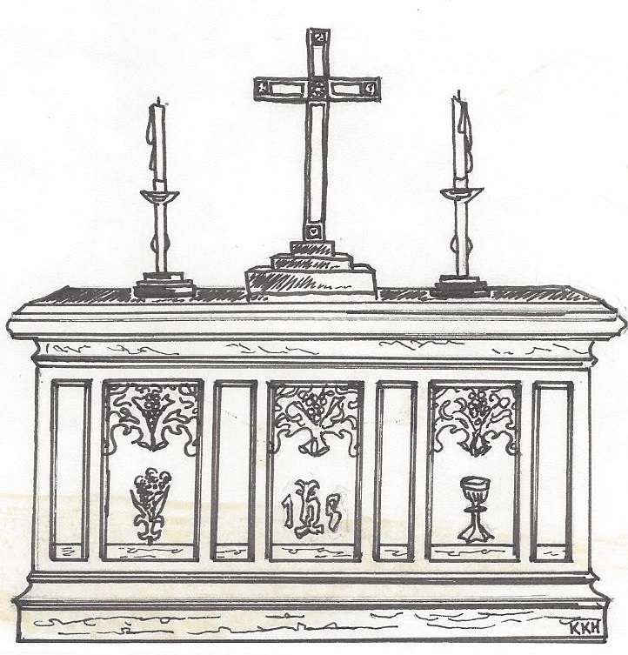

June 02, 2019 @ 10:30am

7 Curtis St., St.Thomas, ON N5P 1H3 Phone: (519) 631-7570
e-mail: office@1stunitedchurch.ca
web: www.1stunitedchurch.ca
MINISTERS: ALL THE PEOPLE OF GOD
Pastoral Minister: Rev. Emmanuel K. Ofori
Music Minister: Jody McDonald-Groulx
Secretary/Treasurer: Lori Hoffman
Custodian: Dave Luftenegger

PREACHER: Rev. Emmanuel K. Ofori
* You are invited to stand if comfortable doing so

VU = Voices United MV = More Voices

We Gather Together
Opening Prayer

Choral Musical Prelude:
- MV#96 “And When you Call For Me” (2x)
And when you call for me, I have already answered.
And when you call for me, I am already there.

- MV#18 “Lord, Prepare Me…” (2x)
Lord, prepare me to be a sanctuary,
pure and holy tried and true;
with thanksgiving, I’ll be a living
sanctuary for you.

Lighting of the Christ Candle: VU#87 “I Am the Light of the World”
Passing of the Peace (VU #958 “Halle, Halle, Halle”)
Welcome/Life and Work of the Church

We Draw Near to Worship
Call to Worship:
One: Jesus said, “I will build my church”. He welcomes us all in this place to come in and sit down for rest and restoration.
All: MV #1 “Let Us Build a House” (vs 1, 3, 5)

Anthem: Senior Choir

Sunday School children may go downstairs

We Respond in Love
Offering
Hymn of Dedication (Doxology)
Praise God from whom all blessings flow; praise God, all creatures high and low; give thanks to God in love made known: Creator, Word and Spirit, One.

Offertory Prayer
We Break Bread Together
* Communion Hymn: MV #202 “Bread for the Journey”
God be with you.

And also with you

Lift up your hearts

We lift up our hearts unto the Lord

Let us give thanks to God

It is good and pleasant to give God thanks and praise

It is good and pleasant thing, our joy and our moral duty, … to give you thanks and praise,… Therefore, with angels and archangels, and with all the heavenly host, we join in the hymn of everlasting praise saying …

Holy, holy, holy, LORD God of hosts,
heaven and earth are full of your glory.
Hosanna in the highest.
Glory be to you, O Lord, most high. Amen.

Prayer of Consecration
Invitation

Distribution of Elements

We Listen for God’s Word
* Hymn of Preparation: MV #161 “I Have Called You by Your Name”
Scripture Readings: Isaiah 43:1-2, 14-19
Reader: This is the Word of God
All: Thanks be to God.

The Message: “Let Nothing Hold You Back or Down”

We Go Out to Serve
*Closing Hymn: VU#481 “Sent Forth By God’s Blessing”
* Benediction
* Triple Amen
* Commissioning Hymn: VU#298 “When You Walk From Here”

When you walk from here, when you walk from here,

Walk with justice, walk with mercy, and with God’s humble care.

Thank you to Dr Wayne Carroll for sharing on the organ.
TODAY’S MESSAGE
Setbacks will come your way. You can’t avoid them. You may lose a job, a relationship, or your health. And when you do, you start to fear.
- Fear keeps you locked in a prison and unable to develop your full potential.
- It keeps you from becoming all God wants you to be.
- It also keeps you from building a legacy that will last into eternity.

But you don’t have to stay afraid. God has provided a way for you to take to break free from fear. Be reminded that …
- God loves you so much.
God will never stop loving you.
God’s love is unconditional and eternal.
“God is love. Whoever lives in love lives in God, and God in them . . . There is no fear in love. But perfect love drives out fear”
(1 John 4:16, 18 NIV).
- God’s has good plan for you.
For I know the plans I have for you,” declares the Lord, “plans to prosper you and not to harm you, plans to give you hope and a future (Jeremiah 29:11)

“We know that all that happens to us is working for our good if we love God and are fitting into his plans” (Romans 8:28, TLB).
- The phrase “all that happens” fits into God’s good plan – not just the good stuff. God specializes in bringing good out of bad.

- God is always with you
“Do not fear, for I have redeemed you; I have summoned you by name; you are mine … I will be with you; When you walk through the fire, you will not be burned ...” (Isaiah 43:1-2)

Think about this:
- You can choose faith over fear. When you’re experiencing a setback, trusting God’s love, plan and presence is the only path forward.

