LIFE & WORK OF THE CHURCH
July 29, 2018

TODAY! *Faith Activity Room for children 4 & up in the Music Room.

*Join us in the Fellowship Room for refreshments following the worship service!

Upcoming Dates & Events
If you’d like to volunteer to serve Summer Lemonade in the Fellowship Room following Sunday worship please call Ruth Zions @ 226-289-3055.

Don’t forget to register for Vacation Bible Camp!!
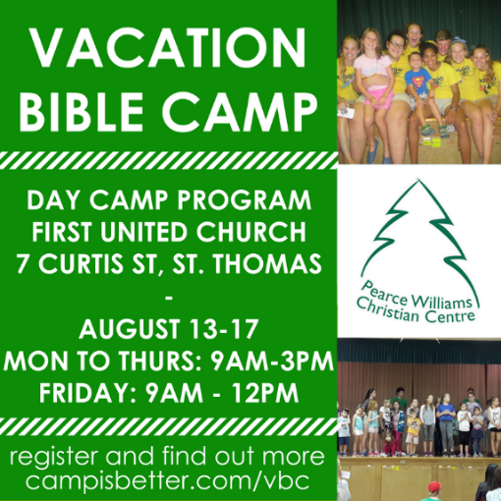

LIFE & WORK OF THE CHURCH
July 29, 2018

TODAY! *Faith Activity Room for children 4 & up in the Music Room.

*Join us in the Fellowship Room for refreshments following the worship service!

Upcoming Dates & Events
If you’d like to volunteer to serve Summer Lemonade in the Fellowship Room following Sunday worship please call Ruth Zions @ 226-289-3055.

Don’t forget to register for Vacation Bible Camp!!

