First United Church
Seeking to be a welcoming community of Christian faith, proclaiming and celebrating the love of God in Jesus Christ through the Inspiration of the Holy Spirit

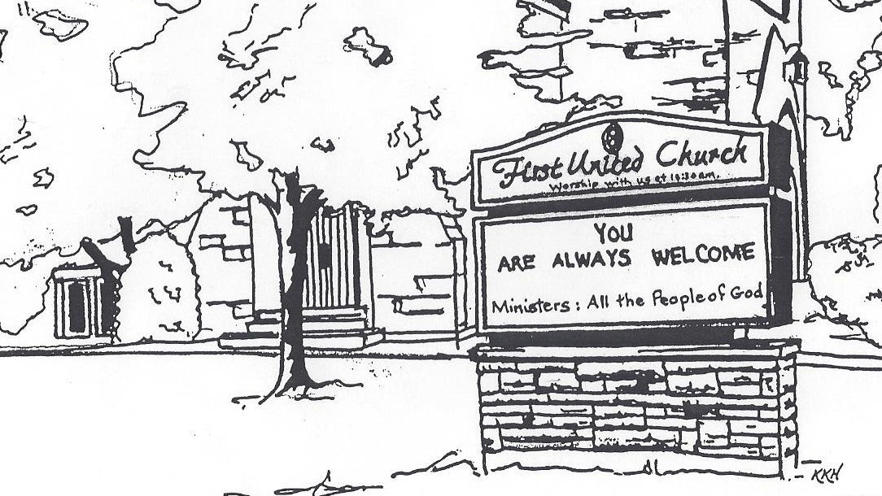

July 28, 2019 @ 10:30am
Worship & Picnic
at Pinafore Park

7 Curtis St., St.Thomas, ON N5P 1H3 Phone: (519) 631-7570
e-mail: office@1stunitedchurch.ca
web: www.1stunitedchurch.ca
MINISTERS: ALL THE PEOPLE OF GOD
Music Minister: Jody McDonald-Groulx
Secretary/Treasurer: Lori Hoffman
Custodian: Dave Luftenegger

Order of Service
* You are invited to stand if comfortable doing so

VU = Voices United MV = More Voices

Musical Prelude
Choral Musical Prelude
Opening Prayer

Call to Worship:
One: The Creator has gathered us to this place.
All: We open our hearts to hear the word of God.
One: The Christ summons us to this place.
All: Where we can learn how to serve God without reservation or hesitation.
One: The Spirit will send us from this place.
All: Where we can put our faith into action, and be true believers and leaders of the faith through our word and deed.

Lighting of the Christ Candle
I am the light of world, you people come and follow me.
If we follow and love, we’ll learn the mystery
Of what we were meant to do and be.

Passing of the Peace (VU #958 “Halle, Halle, Halle”)
Welcome/Life and Work of the Church
Sing Along with Jody and Jerome
Prayers of the People/The Lord’s Prayer

Offering Ourselves, Tithes & Gifts
Dedication Hymn: (tune “Eidelweiss”)
God of Love, hear our prayer. Bless this offering we bring you. May our lives do Your will; guide and guard us forever. Give us courage to stand for truth; help us give to others. God of Love, hear our prayer, Bless this offering we bring you.

Song: Give It Away
Pearce Williams Background
Song: I Can Do All Things
Story/Message: Geoff Auckland
Camp Songs: Pharaoh, Pharaoh
Fill My Cup
I Don’t Want to be a Sheep
The Fruit of the Spirit

Grace: Johnny Appleseed
*Commissioning/ Benediction
Closing - Sing: MV #209
Go make a diff’rence. We can make a diff’rence.
Go make a diff’rence in the world.
Go make a diff’rence. We can make a diff’rence.
Go make a diff’rence in the world.

* Musical Postlude
Picnic – Let’s Eat
Summer Services at First
We are pleased to welcome the following individuals to our services this summer who will share their experiences with us:
August 4 Rev. John Brown - communion
August 11 Chris Ross
August 18 Jamie MacArthur – Promise Keepers
August 25 We are worshipping at the St. Thomas Christian Church at 451 Wellington. There will be a catered lunch after the service. Please sign up in the Fellowship Room if you are intending to stay for the lunch that day (just trying to get a handle on numbers). There will be a free will offering to cover the cost.
September 1 We are back at First United for the fall. Join us as we
continue to celebrate our 185th year!
The Life & Work of the Church – July 28, 2019

Future Dates / Events
*August 12-15 from 9am to 3pm - Vacation Bible Camp
led by the counsellors from Pearce Williams Christian Centre
and supervised by the CD / Membership Committee
Register at https://www.campisbetter.com/vbc

Elgin Theatre Guild Fundraiser for First
On Thursday, September 26 at 7:30 PM, the Elgin Theatre Guild presents Sandy Toes and Salty Kisses at the historic Princess Ave. Playhouse. Tickets can be purchased for this date through First United Church for $20, with $8 from every ticket sold going back to the church! This is a great opportunity to invite friends, family and neighbours for a fun evening out, and raise money for First! Tickets are available through the church office. Check our website for more details

July Thank yous!
Thank you to Rev. Tom Hiscock for sharing his message with us on July 7. It’s always nice to have Rev. Tom with us at First!

Thank you to Darin Dees for delivering the message on July 14. He inspired those present with his "Compassion to Action" presentation on Red Cross Disaster Relief. If you wish to donate directly to the Red Cross you may do so by visiting their website www.redcross.ca.

Thank you to Susan Grieve for sharing her story about WE Charity on July 21. Her desire to raise funds for a school build in Inkaat, Kenya, and being able to see the results was inspiring. If you wish to support Susan in her quest for a second build in a nearby Kenyan village you may do so by visiting www.susansretirementproject.com or mail a cheque payable to WE Charity to Susan Grieve, 1874 Wilton Grove Road, London, ON N6N 1M8.

This week's service is being lead in part by Pearce Williams staff. If you have a soft spot for Pearce, or know of an individual who would benefit from a camp experience, you can donate online at www.campisbetter.com or send a cheque payable to: Pearce Williams, 8009 Iona Road Fingal, ON N0L 1K0

In all cases you will receive a tax receipt for your contribution. Additional information about these organizations can be found on their website or on some of their print material which can be found in the Fellowship Room after the service.

