First United Church
Seeking to be a welcoming community of Christian faith, proclaiming and celebrating the love of God in Jesus Christ through the Inspiration of the Holy Spirit

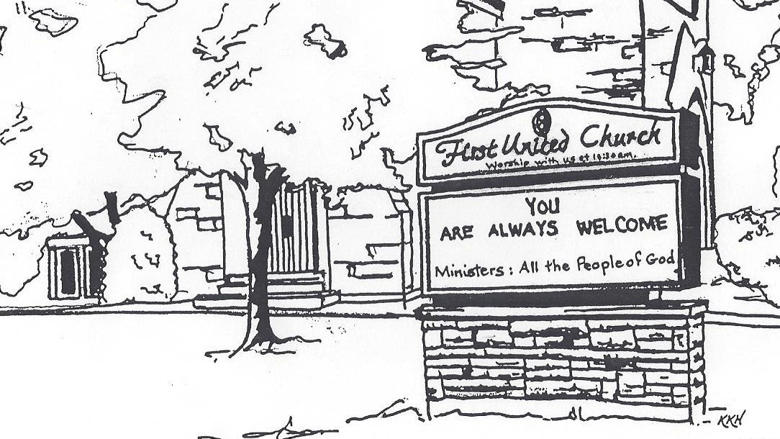

July 21, 2019 @ 10:30am

7 Curtis St., St. Thomas, ON N5P 1H3 Phone: (519) 631-7570
e-mail: office@1stunitedchurch.ca
web: www.1stunitedchurch.ca
MINISTERS: ALL THE PEOPLE OF GOD
Music Minister: Jody McDonald-Groulx
Secretary/Treasurer: Lori Hoffman
Custodian: Dave Luftenegger

Order of Service
* You are invited to stand if comfortable doing so

Musical Prelude

Choral Prelude
- MV#92 “Like A Rock” (2x)
Like a rock, like a rock, God is under our feet.
Like the starry night sky God is over our head
Like the sun on the horizon God is ever before.
Like the river runs to ocean, our home is in God evermore.

- MV#7 “Gather Us In” (2x)
Gather us in, ground us in you.
Gather us in, ground us in you.
Gather us in, gather us in, ground us, ground us in you.

Opening Prayer

Call to Worship:
One: The Creator has gathered us to this place.
All: We open our hearts to hear the word of God.
One: The Christ summons us to this place.
All: Where we can learn how to serve God without reservation or hesitation.
One: The Spirit will send us from this place.
All: Where we can put our faith into action, and be true believers
and leaders of the faith through our word and deed.

Lighting of the Christ Candle
I am the light of world, you people come and follow me.
If we follow and love, we’ll learn the mystery
Of what we were meant to do and be.

Passing of the Peace (VU #958 “Halle, Halle, Halle”)

Welcome/Life and Work of the Church

Hymn of Praise: “O God, Send Out Your Spirit” (Chorus only) (2x)
O God, send out your Spirit; renew the face of the earth.
O God, send out your Spirit; renew the face of the earth.

Prayers of the People/The Lord’s Prayer

Hymn: VU#642 “Be Thou My Vision”

Conversation with the Young People

Children may leave for the Activity Room

Offering Ourselves, Tithes & Gifts: Solo: Dawn Bilinski

Dedication Hymn: (tune “Eidelweiss”)
God of Love, hear our prayer. Bless this offering we bring you. May our lives do Your will; guide and guard us forever. Give us courage to stand for truth; help us give to others. God of Love, hear our prayer, Bless this offering we bring you.

Scripture Reading

Hymn of Preparation: VU#509 “Here I Am”

The Message: Susan Grieve

*Hymn of Response: MV#214 “May God’s Sheltering Wings”

*Commissioning/ Benediction
Closing - Sing: MV #209
Go make a diff’rence. We can make a diff’rence.
Go make a diff’rence in the world.
Go make a diff’rence. We can make a diff’rence.
Go make a diff’rence in the world.

We are pleased to welcome the following individuals to our services this summer who will share their experiences with us:
July 28 Picnic at the Lakeside Pavillion – Pinafore Park
August 4 Rev. John Brown - communion
August 11 Chris Ross
August 18 Jamie MacArthur – Promise Keepers
August 25 Community Service at Disciples of Christ (east of Elgin Mall) – roast beef catered luncheon to follow at Central United

September 1 – we are back at First United for the fall. Join us as we continue to celebrate our 185th year of service to this community.
More details to follow.

