LIFE & WORK OF THE CHURCH
July 15, 2018

Happy birthday this week to: Jean Johnson, Patrick Dawdy, Carolyn Lapare, Mary Lou Surmacz, Mike Yates.

Happy anniversary this week to: Don & Carol Gagen.

TODAY! *Faith Activity Room for children 4 & up in the Music Room.
*Join us in the Fellowship Room for refreshments following the worship service!

THIS WEEK:
Wednesday: *MOVIE NIGHT – The entire congregation is invited to a movie night on Wednesday, July 18@7pm in the Assembly Hall. The title is WAR ROOM. Please invite family, friends, and loved ones to come with you. For additional info, please contact Rev. Ofori.

Upcoming Dates & Events
If you’d like to volunteer to serve Summer Lemonade in the Fellowship Room following Sunday worship please call Ruth Zions @ 226-289-3055.

Don’t forget to register for Vacation Bible Camp!!
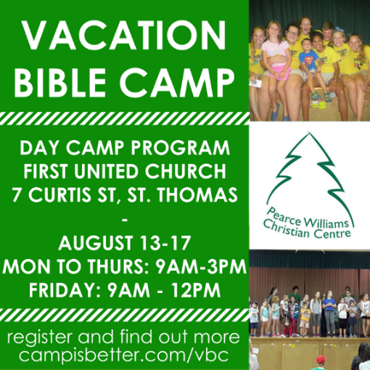

LIFE & WORK OF THE CHURCH
July 15, 2018

Happy birthday this week to: Jean Johnson, Patrick Dawdy, Carolyn Lapare, Mary Lou Surmacz, Mike Yates.

Happy anniversary this week to: Don & Carol Gagen.

TODAY! *Faith Activity Room for children 4 & up in the Music Room.
*Join us in the Fellowship Room for refreshments following the worship service!

THIS WEEK:
Wednesday: *MOVIE NIGHT – The entire congregation is invited to a movie night on Wednesday, July 18@7pm in the Assembly Hall. The title is WAR ROOM. Please invite family, friends, and loved ones to come with you. For additional info, please contact Rev. Ofori.

Upcoming Dates & Events
If you’d like to volunteer to serve Summer Lemonade in the Fellowship Room following Sunday worship please call Ruth Zions @ 226-289-3055.

Don’t forget to register for Vacation Bible Camp!!

