First United Church
Seeking to be a welcoming community of Christian faith, proclaiming and celebrating the love of God in Jesus Christ through the Inspiration of the Holy Spirit

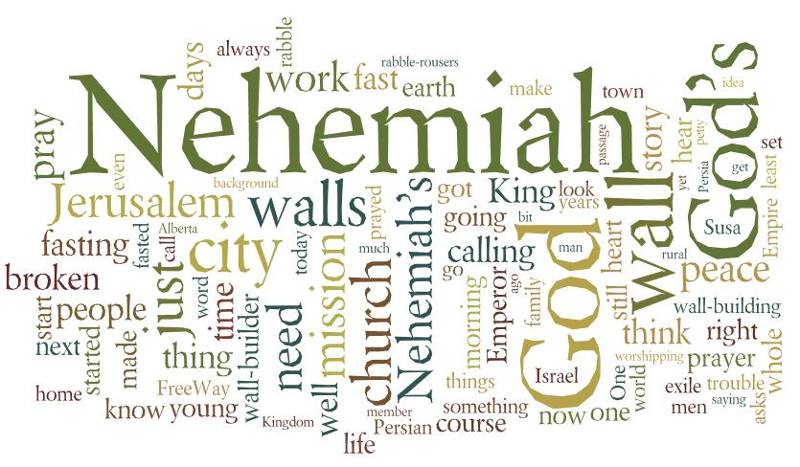

July 15, 2018 @ 10:30am

7 Curtis St., St.Thomas, ON N5P 1H3 Phone: (519) 631-7570
e-mail: office@1stunitedchurch.ca
web: www.1stunitedchurch.ca
MINISTERS: ALL THE PEOPLE OF GOD
Pastoral Minister: Rev. Emmanuel K. Ofori
Music Minister: Jody McDonald-Groulx
Secretary/Treasurer: Lori Hoffman
Custodian: Dave Luftenegger

Eighth Sunday of Pentecost Sunday
Worship Service
Sunday, July 15, 2018 - 10:30 a.m.
Preacher: Rev. Emmanuel K. Ofori

Notes: Asterisk (*) – You may stand if comfortable doing so
VU = Voices United MV = More Voices

Musical/Choral Prelude
- MV#27 “Creator God You Gave Us Life” (2x – Refrain only)
Through hands that paint majestic skies, and voices chanting melody, with words that reach beyond the page, we comprehend your mystery.
- MV#25 “O God, Send Out Your Spirit” (2x – Refrain only)
O God, send out your Spirit; renew the face of the earth.
O God, send out your Spirit; renew the face of the earth.

Opening Prayer

Call to Worship

Life and Work of the Church [see insert]

Welcoming of Visitors

Greetings: Peace of Christ (Halle, Halle, Halle)

Songs of Praise

- Majesty

Majesty Majesty
Worship His majesty Kingdom authority
Unto Jesus be all glory Flow from His throne
Honor and praise Unto His own
His anthem raise

So exalt, lift up on high Majesty
The name of Jesus Worship His majesty
Magnify, come glorify Jesus who died, now glorified
Christ Jesus the King King of all kings
2. Blessed Assurance (VU#337)
Blessed Assurance, Jesus is mine!
O what a foretaste of glory divine!
Heir of salvation, purchase of God,
born of the Spirit, washed in Christ’s blood.
This is my story, this is my song,
praising my Saviour all the day long;
this is my story, this is my song,
praising my Saviour all the day long.

Prayer

Praise and Adoration

Intercession

The Lord’s Prayer

Hymn: VU #400 “Lord, Listen to Your Children Praying” (2x)

Lord, listen to your children praying, Lord, send your Spirit in this place; Lord, listen to your children praying, send us love, send us power, send us grace!

The children may go to the Activity Room with Hannah Bosveld.
Old Testament Reading: Nehemiah 1:1-11
Reader: This is the Word of God
All: Thanks be to God

The Message: “Learning to Pray Alright”
Offertory
Hymn of Dedication
God of love, hear our prayer, bless this offering we bring you.
May our lives do your will, guide and guard us forever.
Give us courage to stand for truth, help us give to others.
God of love, hear our prayer, bless this offering we bring you.

Offertory Prayer
*Closing Hymn: VU #602 “Blest Be the Tie That Binds”
* Benediction/Sending Forth
Threefold Amen
Commissioning Hymn: MV#209 “Go Make A Diff’rence”
* Musical Postlude

TODAY’S MESSAGE
The Bible reveals many types of prayers and employs a variety of words to describe the practice. For example, 1 Timothy 2:1 says, “First of all, then, I urge that supplications, prayers, intercessions, and thanksgivings be made for all people.” Here, different types of prayers are mentioned, and we find Nehemiah demonstrating different elements of prayer in Nehemiah 1:1-11. The bad news he heard motivated him to pray and, in his prayer, he praised God, asked for pardon, and then petitioned God on behalf of his people.

So …

- What motivates you to pray?
- What events and/or issues lead to prayer

- Response to these events

- What do you normally pray for/about? How often?
- Adoration (God is awesome prayer)
- Confession (I am sorry prayer)
- Thanksgiving (Thank you prayer)
- Supplication (Asking prayer)
- Petition (asking for self or on behalf of others)
- Intercession (asking on behalf of others/situations)

Think about this:
To be effective, our prayers should be spiced with …
- Adoration – praise God for who God is.
- Confession – agree with God that you have sinned
- Thanksgiving – express gratitude for what God has done
- Supplication – petition God for self and on behalf of others.

