LIFE & WORK OF THE CHURCH
July 8, 2018

TODAY! *Faith Activity Room for children 4 & up in the Music Room.
*Join us in the Fellowship Room for refreshments following the worship service!

THIS WEEK:
Wednesday: *Bible Study/Prayer Group – Wednesday Evenings @ 7pm in the Fellowship Room

Upcoming Dates & Events
If you’d like to volunteer to serve Summer Lemonade in the Fellowship Room following Sunday worship please call Ruth Zions @ 226-289-3055.

Don’t forget to register for Vacation Bible Camp!!

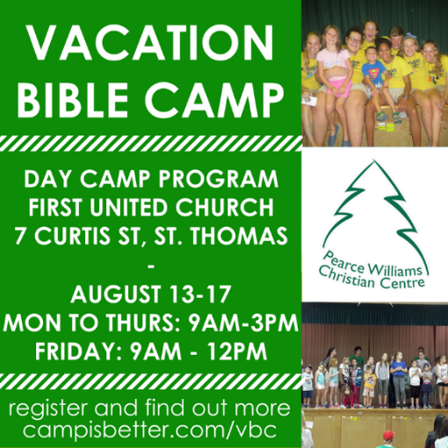

LIFE & WORK OF THE CHURCH
July 8, 2018

TODAY! *Faith Activity Room for children 4 & up in the Music Room.
*Join us in the Fellowship Room for refreshments following the worship service!

THIS WEEK:
Wednesday: *Bible Study/Prayer Group – Wednesday Evenings @ 7pm in the Fellowship Room

Upcoming Dates & Events
If you’d like to volunteer to serve Summer Lemonade in the Fellowship Room following Sunday worship please call Ruth Zions @ 226-289-3055.

Don’t forget to register for Vacation Bible Camp!!

