The Story: God sent John, the cousin of Jesus, to remind the people about how God wanted everyone to live. John told the people to search their hearts and minds. They should stop doing what God didn’t want them to do and start doing those things that God wanted them to do. John baptized people who wanted to change their life in the Jordan River.

The people came and asked if John was the one sent by God to save them. John told them that someone else was coming. One day, Jesus came to be baptized and afterwards, when Jesus was praying, the sky opened, and the Holy Spirit came down to him in the form of a dove and said “You are my Son, and I love you. I am so pleased with you. “
Story Video: https://youtu.be/-1NDVnrw2k0 The GO Project Jesus is Baptized Cartoon December 23,2021
Talk about: Baptism is a sacrament in the United Church of Canada. A "sacrament" is an action that was explicitly instructed by Jesus. Baptism uses water as a symbol of cleansing that signifies the acceptance of new life within the Christian community, the church. We believe that baptism is not a requirement of God’s love and that the gift of God’s love doesn’t depend on our ability to understand it, so we baptize people as infants right up through adulthood. When Jesus was baptized, the Holy Spirit came down to him. You don’t need to be baptized to come and be active in church, baptism is a formal joining into the church family. Did you know that Andrew, Simon Peter’s brother, was a follower of John before meeting Jesus? What do you think Andrew and the others who were at the river thought when the Holy Spirit spoke to Jesus? Were you baptised? If yes, who was part of the celebration?
Music Videos: https://youtu.be/OM9FAX8vsfc Jesus was Baptized Sep 25, 2019 SingGodsWord https://youtu.be/smkYUzrgD7A big family of god Mar 5, 2016

Family Craft Idea: Holy Spirit Dove
Materials needed:

White paper
Coloured paper for background
Glue (or tape)
Markers, pencils or crayons

Place your hand on the white paper and place the thumb wide. Trace and cut out your hand on a white piece of paper. Colour an eye on thumb. Glue or tape the hand onto the background paper. Colour in a beak. Use yellow or white to draw lines from the (like the sun’s rays). With another colour write the title: The Holy Spirit Descended like a Dove
and below: John the Baptist baptized Jesus Luke 3:22a

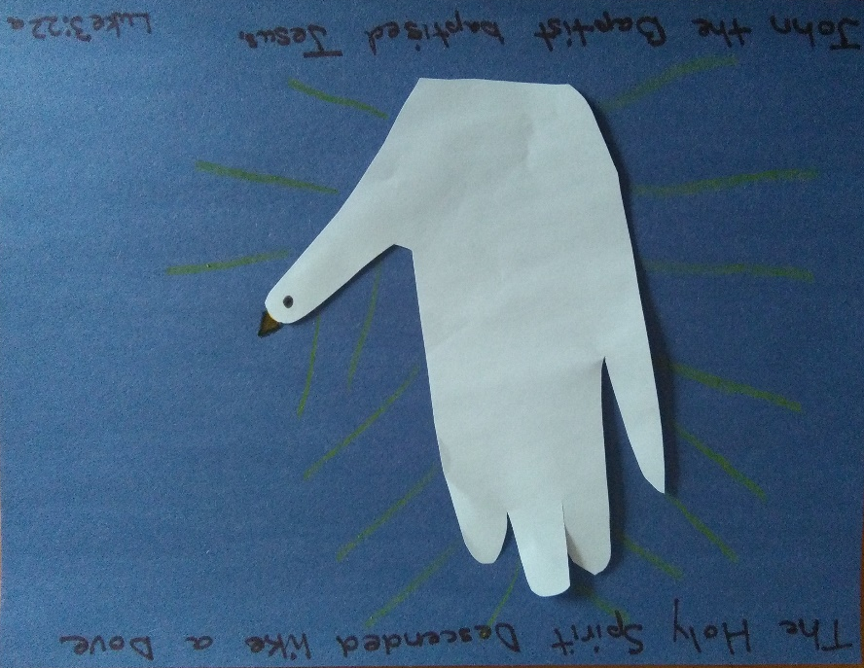
God Sightings: Think of all the wonderful things you can see; things created by God- our families you, me stars, sun, moon, animals, birds, and everything! We are looking at ways we see what God is doing or has done all around you. A God Sighting might be a hug or a beautiful sunrise or sunset. You can be a God Sighting by being kind to others. My God Sighting: ________________

Faith and Prayer: Caring God, we know that your love is for the whole world. Help us to think about how to be kind to others before we speak and act. You include everyone into your family. Amen

For Youth (grade 6 and up)

Think about: The word translated as “changing heart and life” is sometimes translated in other versions as repent. Repenting is turning away from harmful things and turning toward a new way of life. John preached a different kind of repentance to the different groups of people who came to him, because all people have something different they need to turn away from. What would repentance look like for you? Is there anything in your life that you feel God is calling you away from? Is there anything that God is calling you toward?

Music Video: https://youtu.be/U7d3fZUehMo The Baptism of Jesus Feb 13, 2014 Peg Angell

