The Story: Soon after Jesus had chosen his disciples, they all went to a wedding at Cana in Galilee. Mary, the mother of Jesus and some of Jesus’ family were also there. It was a happy time. During the party, Mary told Jesus that the wine had run out. Jesus asked Mary why she would have told him that. But Mary knew that Jesus would want to help his friends. Mary told the servants to listen to Jesus. Jesus told the servants to fill up big stone jars with water. The servants did that. When the people at the wedding drank what was in the jars, it was a much better wine that that which had been served before. The guests were surprised. The disciples knew what Jesus had done and they believed in him.

Story Video: https://youtu.be/25ZpyamvIhs Miracle performed by Jesus! | The Life of Jesus | #4 Mar 12, 2017

Talk about: In those days a wedding celebration lasted several days. Running out of supplies before the end would have been considered a disgrace. Mary was aware of the problem and turned to Jesus for help. Providing exceptional wine for the wedding party was the first of many miracles that Jesus performed during his ministry. Jesus’ action showed the importance of hospitality, sharing with others, and fun. What are some small ways that you can show kindness to your family and friends? How does your church show hospitality to newcomers and people in need? What else could the church do?

Music Videos: https://youtu.be/O9FbdS4ddjY Rend Co. Kids - FUN Aug 9, 2019 https://youtu.be/qchyD2INXzk ElevateKIDS | "Give a Little Kindness" Worship Song Feb 3, 2021

Family Craft Idea: Watercolour Painting
Jesus showed hospitality by turning water into wine. Think about ways you can demonstrate hospitality (kindness and welcome) in your daily life.

Materials Needed:
Paper
Watercolour paints and brushes (or coloured pencils/markers/crayons)

Using watercolour paint or another medium to create images and/or words that show you putting hospitality into action.

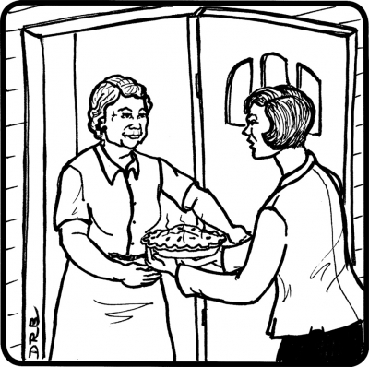

God Sightings: Think of all the wonderful things you can see; things created by God- our families you, me stars, sun, moon, animals, birds, and everything! We are looking at ways we see what God is doing or has done all around you. A God Sighting might be a hug or a beautiful sunrise or sunset. You can be a God Sighting by being kind to others. My God Sighting: ________________

Faith and Prayer: Welcoming God, thank you for showing us what it means to be generous with others. Help us to show kindness to all the people we meet. Amen

For Youth (grade 6 and up)

Think about: In the link that follows Tommy Walker uses the phrase ‘Water into Wine’ to describe a personal experience. https://youtu.be/uOXw4CvFUO0 Song of the Week - #12 - "Water Into Wine" - Tommy Walker May 12, 2016. Have you thought about the story about the Wedding in Cana in this way? What are ways that the Holy Spirit works so that you grow in your faith and love of God?

Music Video: https://youtu.be/AIvzowwGmgg Jesus, Remember Me ~ Taizé Feb 21, 2016 (A Taizé is a simple chant like song)

