First United Church
Seeking to be a welcoming community of Christian faith, proclaiming and celebrating the love of God in Jesus Christ through the Inspiration of the Holy Spirit

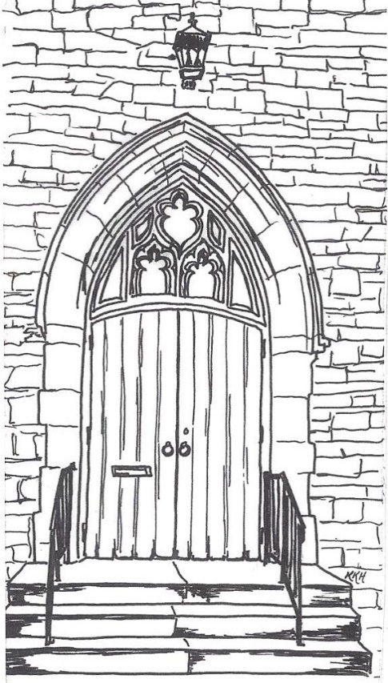

January 29, 2019 @ 10:30am

7 Curtis St., St.Thomas, ON N5P 1H3 Phone: (519) 631-7570
e-mail: office@1stunitedchurch.ca
web: www.1stunitedchurch.ca
MINISTERS: ALL THE PEOPLE OF GOD
Pastoral Minister: Rev. Emmanuel K. Ofori
Music Minister: Jody McDonald-Groulx
Secretary/Treasurer: Lori Hoffman
Custodian: Dave Luftenegger

ORDER OF SERVICE

Musical Prelude
Opening Prayer/Songs/Choruses
- “That’s Why We Praise Him” (Chorus only)
That’s why we praise him, that’s why we sing
That’s why we offer him our everything
That’s why we bow down, and worship this King
‘Cause He gave His everything
‘Cause He gave His everything.

- “Awesome God” (2x)
Our God is an awesome God, and reigns from heaven above
with wisdom, pow’r and love, Our God is an awesome God.

- “Stand By Me (My Lord)”

When the night, has come, and the land is dark

And the moon, is the only, light we see

Oh I won’t, be afraid, no I won’t be afraid

Just as long, as you stand, stand by me

Chorus: So my Lord, my Lord,

Stand by me, stand by me,

Oh stand,

Stand by me.

If the sky, that we look upon, should tumble and fall

And the mountains, should crumble, into the sea

I won’t cry, I won’t cry, no I won’t shed a tear

Just as long, as you stand, stand by men

Repeat Chorus

Call To Worship (Psalm 95 1-7) responsively
One: Come let us shout joyfully to the Lord,
ALL: Shout triumphantly to the rock of our salvation!
One: Let us enter His presence with thanksgiving;
ALL: Let us shout triumphantly to him in song.
One: For the Lord is a great God
ALL: A great King above all gods
One: The depths of the earth are in his hand
ALL: And the mountain peaks are his.
One: The sea is his; he made it.
ALL: His hands formed the dry land.
One: Come, let us worship and bow down,
ALL: Let us kneel before the Lord our Maker.

Ministry of Music: Senior Choir

Welcome/Life & Work of the Church

Offering / Offertory Hymn/ Prayer of Dedication

Songs/Choruses
- “This Little Light of Mine”

This little light of mine, I’m gonna let it shine.

This little light of mine, I’m gonna let it shine.

This little light of mine, I’m gonna let it shine.

Let it shine, let it shine, let it shine!

Hide it under and bushel? No! I`m gonna let it shine.

Hide it under and bushel? No! I`m gonna let it shine.

Hide it under and bushel? No! I`m gonna let it shine.

Let it shine, let it shine, let it shine!

Don’t let anyone put it out, I’m gonna let it shine.

Don’t let anyone put it out, I’m gonna let it shine.

Don’t let anyone put it out, I’m gonna let it shine.

Let it shine, let it shine, let it shine.

- “He Knows My Name” (2x)

He knows my name. He knows my ev’ry thought.

He sees each tear that falls, and hears me when I call,

and hears me when I call.

Circle Time

(the children may leave for Church School)

Scripture Reading: Matthew 6:5-15

Hymn of Preparation: VU#356 “Seek Ye First”

The Message: “Why & How To Pray” Chris Ross
Prayer

*Closing Hymn: VU#664 “What A Friend We Have In Jesus”

* Benediction
* Commissioning Hymn: MV#209 “Go Make a Diff’rence”
Go make a diff’rence. We can make a diff’rence.
Go make a diff’rence in the world.
Go make a diff’rence. We can make a diff’rence.
Go make a diff’rence in the world.

Musical Postlude

Thank you to Chris Ross
for sharing his message with us today!

