First United Church
Seeking to be a welcoming community of Christian faith, proclaiming and celebrating the love of God in Jesus Christ through the Inspiration of the Holy Spirit

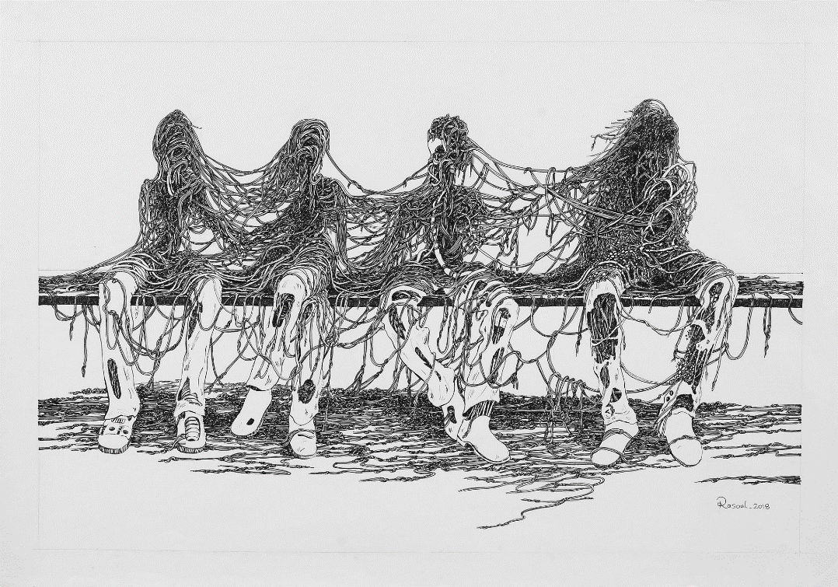

Follow me; I will make you fishers of people.
Matthew 4:19

January 26, 2020 @ 10:30am

7 Curtis St., St.Thomas, ON N5P 1H3 Phone: (519) 631-7570
e-mail: office@1stunitedchurch.ca
web: www.1stunitedchurch.ca
MINISTERS: ALL THE PEOPLE OF GOD
Intentional Interim Minister: Rev. Daryl Webber
Music Minister: Jody McDonald-Groulx
Secretary/Treasurer: Lori Hoffman
Custodian: Dave Luftenegger

Order of Service
* You are invited to stand if comfortable doing so

VU = Voices United MV = More Voices

Musical Prelude
Welcome
Choral Musical Prelude
- MV#157 “I Am a Child of God” (2x)
I am a child of God, I am a glimpse of God’s new creation.
I am a child of God, I am a child of God.

- MV#14 “Where Two or Three Are Gathered” (2x)
Where two or three are gathered in my name,
I am there, I am there.

Call to Worship
One: Winter is Divinity unfolding:
glamorous ice adorns grey tree limbs,
moon studs diamonds in a snowbank,
silence falls with the snowflakes.
All: Sacred Source, You dwell everywhere on the surface here,
and somewhere beneath this snow-cover,
you warm the root of life still.
One: Though the ground is frozen, creation is yet wild and flowing,
and we who dwell as witnesses here,
are more than vagrants
dropping our boots through the snowbanks.
All: We are the bundled children of the Earth
dusted here with belonging,
and warmed with your Divinity unfolding,
unfettered for the joy of being.
Here – we are. (Daryl Webber, 2014)

Lighting of the Christ Candle
I am the light of world, you people come and follow me.
If we follow and love, we’ll learn the mystery
Of what we were meant to do and be.
Opening Prayer
One: Gather us together, Great Spirit
All: Fill your hearts here with goodness,
your worship with creativity,
your world with new possibilities,
and your church with promised gifts.
One: Gather and fill us, Great Spirit
in these days of winter,
All: with all those things you have stored up for us.
(Daryl Webber, 2015)

Passing of the Peace
Sing: Halle, Halle, Halle, lu jah! Halle, Halle, Halle, lu jah!
Halle, Halle, Halle, lu jah! Halle lu jah! (clap) Halle lu jah!

Musical Offering: Senior Choir

Life and Work of the Church

Conversation with the Young People

Prayer/The Lord’s Prayer

Hymn: VU#567 “Will You Come & Follow Me” (v 1, 2 & 5)
- Will you come and follow me if I but call your name?
Will you go where you don’t know and never be the same?
Will you let my love be shown, will you let me name be known,
Will you let my life be grown in you and you in me?

- Will you leave yourself behind if I but call you name?
Will you care for cruel and kind and never be the same?
Will you risk the hostile stare should your life attract or scare?
Will you let me answer prayer in you and you in me?

- Christ you summons echoes true when you but call my name.
Let me turn and follow you and never be the same.
In your company I’ll go where your love and footsteps show.
Thus I’ll move and live and grow in you and you in me.

Offering Ourselves, Tithes & Gifts: Solo: Alvin Epp

Dedication Hymn: (tune “Eidelweiss”)
God of Love, hear our prayer. Bless this offering we bring you. May our lives do Your will; guide and guard us forever. Give us courage to stand for truth; help us give to others. God of Love, hear our prayer, Bless this offering we bring you.

Scripture Readings: Matthew 4:12-23
Psalm 27 (VU pg. 754)

The Message: Rev. Daryl Webber

Hymn: VU#563 “Jesus You Have Come to the Lakeshore”
- Jesus, you have come to the lakeshore
looking neither for wealthy nor wise ones;
you only asked me to follow humbly.

Refrain: O Jesus, with you eyes you have searched me
and while smiling have spoken my name,
now my boat’s left on the shoreline behind me;
by your side I will seek other seas.

- You know so well my possessions;
my boat carries no gold and no weapons;
you will find there my nets and labour. (Refrain)

- You need my hands, full of caring
through my labours to give others rest,
and constant love that keeps on loving. (Refrain)

- You, who have fished other oceans,
Ever longed for by souls who are waiting,
My loving friend, as thus you call me. (Refrain)

*Commissioning VU #918 “A New Creed”
We are not alone,
we live in God’s world.

We believe in God:
who has created and is creating,
who has come in Jesus,
the Word made flesh,
to reconcile and make new,
who works in us and others
by the Spirit.

We trust in God.

We are called to be the Church:
to celebrate God’s presence,
to live with respect in creation,
to love and serve others,
to seek justice and resist evil,
to proclaim Jesus, crucified and risen,
our judge and our hope.
In life, in death, in life beyond death,
God is with us.
We are not alone.

Thanks be to God.

Benediction

Closing - Sing: VU#209 “Go Make A Difference”
Go make a diff’rence, We can make a diff’rence.
Go make a diff’rence in the world.
Go make a diff’rence, We can make a diff’rence.
Go make a diff’rence in the world.

Musical Postlude

LIFE & WORK OF THE CHURCH
January 26, 2020

Happy birthday to: Wayne Smith, Geoffrey Auckland, Alexandra Mogk.

Happy anniversary to: Jim & June Harris

*TODAY: You are invited to join us refreshments in the Fellowship following worship.

*At First we love having a time of Fellowship after Worship on Sundays! It’s a time to greet friends, new and old, over a drink & maybe a goody!! If this is something you would enjoy hosting, you are invited to sign up on the sheet in the Fellowship Room (Drinks supplied – coffee would just need to be put on in the morning!). We’d love to have you!

*Would you be willing to participate or lead the worship service? If so please speak to Rev. Daryl, Richard Auckland or one of the worship team leaders.

This week:
Everyone is asked to email in photos from the last year or so to capture our life together (you can bring photos in to the office if you don’t email ). These photos will be shared in a slideshow on Sunday, February 9 at the Annual Meeting. Please send them to office@1stunitedchurch.ca Thank you!

Monday *Coffee with Rev. Daryl from 10-11am.

Tuesday: *EarlyON Playgroup in the Gym - 9:30 – 11:30am
*First Youth with Chris Ross & Justin Chute in Room 3/Gym from 7-8:15pm.

Thursday

*Sr. Choir @ 7:30pm! Don’t be shy – singing’s great for the soul – come and give it a try!

Next Sunday: *2019 Tax Receipts will be available following worship in Lori’s Office (available in the office up until Sunday, February 9 – then they will be put in the mail).
*Annual Reports will be available to take home – Please remember to bring them back for the Annual Meeting on February 9.

Sunday, February 9 – Annual General Meeting of the Congregation following worship in the Assembly Hall.

A Note from Lori & the Finance Committee
There are still a few sets of 2020 Offering envelopes in the Library waiting to be picked up!
REMINDER!! Please DO NOT use any old envelopes or envelope numbers! Doing so could cause your offering to be inadvertently credited to another person.
If you go to pick up a set of envelopes and there isn’t one there with your name on it, please contact Lori in the office and she can arrange to get you a set.

Church Office Hours
Monday to Thursday 8:30am to 3:30pm
(Closed from 12-1pm for lunch)

