First United Church
Seeking to be a welcoming community of Christian faith, proclaiming and celebrating the love of God in Jesus Christ through the Inspiration of the Holy Spirit

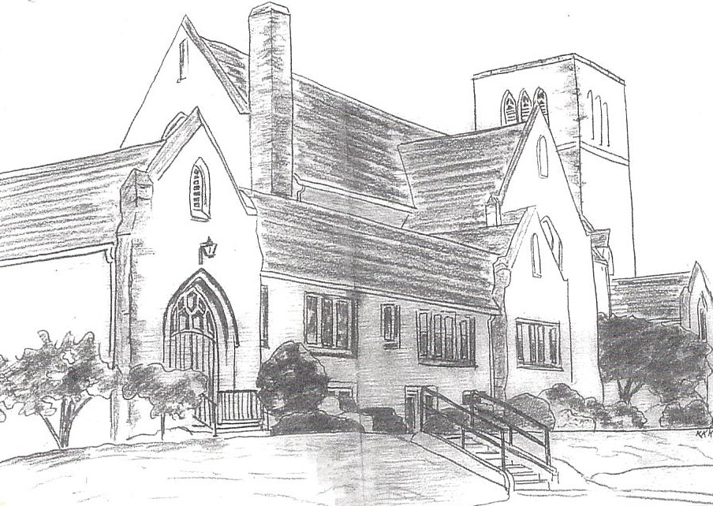

January 20, 2019 @ 10:30am

7 Curtis St., St.Thomas, ON N5P 1H3 Phone: (519) 631-7570
e-mail: office@1stunitedchurch.ca
web: www.1stunitedchurch.ca
MINISTERS: ALL THE PEOPLE OF GOD
Pastoral Minister: Rev. Emmanuel K. Ofori
Music Minister: Jody McDonald-Groulx
Secretary/Treasurer: Lori Hoffman
Custodian: Dave Luftenegger

2nd Sunday After Epiphany

PREACHER: Rev. Emmanuel K. Ofori
* You are invited to stand if comfortable doing so

VU = Voices United MV = More Voices

We Gather Together
Choral Musical Prelude:
- MV#122 “This is the Day” (2x)
This is the day that God has made; we will rejoice and be glad!
This is the day that God has made; we will rejoice and be glad!
Singing hallelu, singing hallelu, singing hallelu!
We will rejoice and be glad!
Singing hallelu, singing hallelu, singing hallelu!
We will rejoice and be glad!

- “Lord I Lift Your Name on High” (2x)
Lord, I lift Your name on high;
Lord I love to sing Your praises.
I’m so glad You’re in my life;
I’m so glad You came to save us.
You came from heaven to earth to show the way,
From earth to the cross, my debt to pay
From the cross to the grave, from the grace to the sky;
Lord I lift Your name on high!

- MV#18 “Lord, Prepare Me…” (2x)
Lord, prepare me to be a sanctuary,
pure and holy, tried and true
with thanksgiving, I’ll be a living
sanctuary for you.

Opening Prayer

Hymn: MV#182 “Grateful” (2x)
Grateful for the life you give us, thankful for your Holy Son,
joyful in your Spirit flowing over all, O God of Love.
Grateful for the Bread of Heaven, thankful for your Holy Word,
joyful in your mercy flowing, we will praise you.

Passing of the Peace (VU #958 “Halle, Halle, Halle”)

Welcome/Life and Work of the Church

We Draw Near to Worship
Call to Worship: Responsive Reading (Psalm 150) VU pg#874

Sunday School children may go downstairs
Prayers
Thanksgiving
Intercessory
The Lord’s Prayer

Ministry of Music: Senior Choir

We Respond in Love
Offering/Song Ministration: Alvin Epp
Hymn of Dedication
God of Love hear our prayer, bless this offering we bring you.
May our lives do your will, guide and guard us forever.
Give us courage to stand for truth, help us give to others.
God of Love hear our prayer, bless this offering we bring you.

Offertory Prayer

We Listen for God’s Word
Scripture Readings: 1 Corinthians 11:23-27
Reader: This is the Word of God
All: Thanks be to God.

Hymn of Preparation – “Are You Washed in the Blood”
- Have you been to Jesus for the cleansing pow’r?
Are you washed in the blood of the Lamb?
Are you fully trusting in His grace this hour?
Are you washed in the blood of the Lamb?

Refrain:
Are you washed in the blood,
In the soul-cleansing blood of the Lamb?
Are your garments spotless? Are they white as snow?
Are you washed in the blood of the Lamb?

- Are you walking daily by the Savior’s side?
Are you washed in the blood of the Lamb?
Do you rest each moment in the Crucified?
Are you washed in the blood of the Lamb? R

- When the Bridegroom cometh will your robes be white!
Are you washed in the blood of the Lamb?
Will your soul be ready for His presence bright,
And be washed in the blood of the Lamb? R

- Lay aside the garments that are stained with sin,
And be washed in the blood of the Lamb;
There’s a fountain flowing for the soul unclean,
O be washed in the blood of the Lamb. R

The Message: “Placing Christ at the Right Place” – Part 2

We Go Out to Serve
*Closing Hymn: VU#602 “Blest Be the Tie That Binds”
* Benediction
* Triple Amen
* Commissioning Hymn: MV#209 “Go Make a Diff’rence”
Go make a diff’rence. We can make a diff’rence.
Go make a diff’rence in the world.
Go make a diff’rence. We can make a diff’rence.
Go make a diff’rence in the world.

* Musical Postlude

